Chad: Lightning kills four children in Mandoul – Chad
https://tribuneechos.com/tchad-la-foudre-tue-quatre-enfants-dans-le-mandoul/
5 September 2025
By Editor in Chief
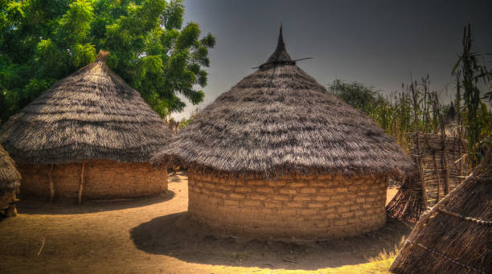
A tragedy struck the village of Bara 2, in the sub-prefecture of Bouna, Mandoul province.
On 3 September, seven children from the Evangelical Church in Chad, who were harvesting peanuts in the field of an elder of the community, were struck by lightning.
According to FM Liberté radio, four of them lost their lives instantly, while the other three survived this tragic incident.

