**August 2025 Newsletter: When is Lightning Season in South Africa? – South Africa**

<https://www.boltguard.co.za/august-2025-newsletter/>

August, 2025

By Boltguard

South Africa is one of the lightning hotspots of the world. In fact, our country experiences some of the highest lightning strike densities globally, especially across the Highveld. But when exactly is “lightning season,” and what does that mean for protecting your home, business, or farm?

**The Peak of Lightning Activity**

Lightning in South Africa is most common during the summer months, which stretch from October through March. This period is characterised by:

-Afternoon and evening thunderstorms

-Hot, humid conditions that build storm clouds

-Frequent highveld storms, particularly in Gauteng, KwaZulu-Natal, and Mpumalanga

The most active months are typically **November, December, and January**, when intense heat fuels powerful storm systems.

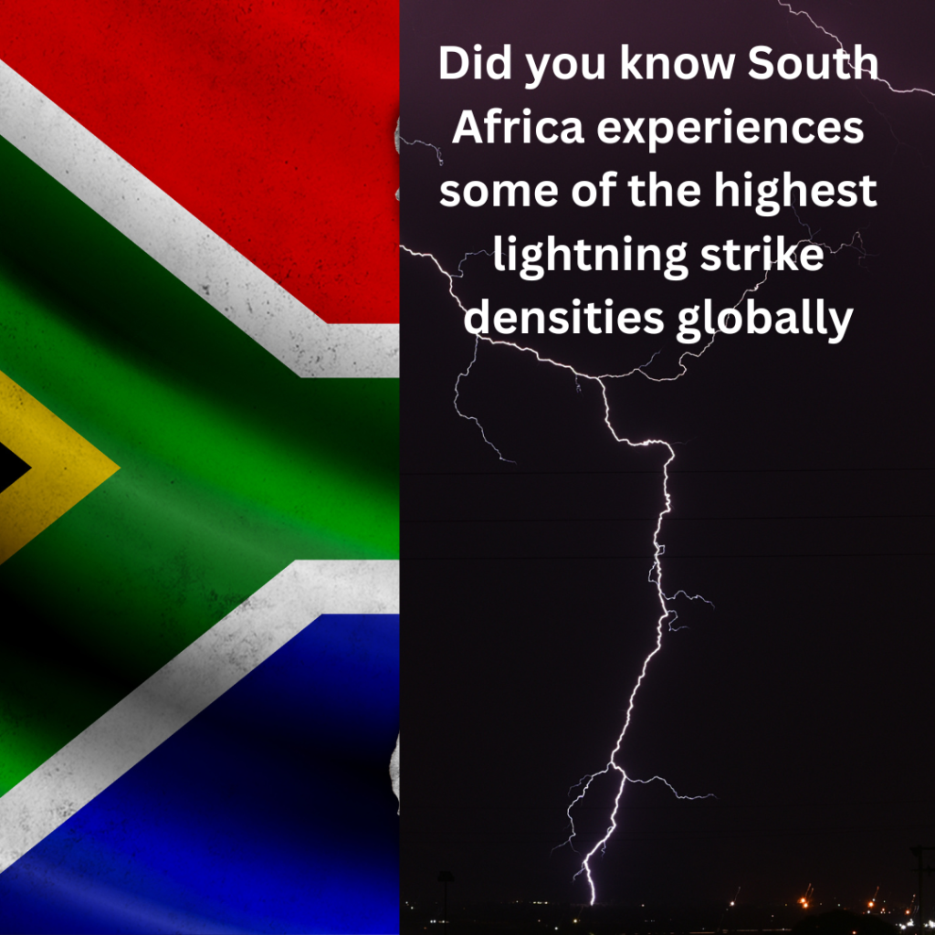

**Why This Matters**

During lightning season, risks increase dramatically:

-Property damage: Direct strikes can destroy electronics, appliances, and even roofs.

-Safety risks: Lightning is a leading cause of weather-related fatalities in South Africa.

-Operational downtime: Farms, factories, and businesses relying on equipment or power supply can face costly interruptions.

**Protecting What Matters Most**

Lightning may be natural, but damage is preventable. A professionally designed lightning protection system (LPS) ensures that strikes are safely directed to ground, keeping buildings, equipment, and lives safe.

At Boltguard, we specialise in:

-Lightning risk assessments

-Certified lightning conductor installations

-Surge protection solutions for electrical systems

-Maintenance and compliance checks

**Final Word**

If you live or work in South Africa, lightning season isn’t a matter of *if* but *when*. With storms building from October to March, now is the perfect time to ensure you have the right protection in place.