Zimbabwe Has a Big Lightning Problem and It Involves Black Magic – Zimbabwe
https://www.zmescience.com/science/physics/lightning-kills-more-people-in-zimbabwe/
Zimbabwe is one of the most lightning-struck places on Earth, and a mix of extreme weather and deep-rooted superstition is putting thousands of people in danger every rainy season.
17 November 2025
By Andrew Mambondiyani
This January, lightning struck and killed a 103-year-old grandmother while she was simply handling utensils in her kitchen hut in eastern Zimbabwe. Her tragic death is a grim, personal reminder of a shocking national statistic.
She is one of the many people killed by lightning every rainy season, which kicks off around October each year. Experts estimate that lightning kills an average of 120 people in Zimbabwe annually, though according to the country’s Meteorological Services Department, that number is underreported by 20-30%.
For a country of roughly 16 million, that’s nearly 10 lightning deaths per million residents each year. According to some estimates, the number is as high as 21 per million. By comparison, the United States averages fewer than one death per 10 million people. Neighboring South Africa reports around 2 to 3 per million. In other words, Zimbabwe’s lightning fatality rate is several times higher than that of most countries, making it one of the deadliest places on Earth for lightning strikes.
The country even holds the depressing record for the most people killed by a single lightning bolt: 21 people in the village of Chinamasa on December 23, 1975.
Yet, despite all this, many in Zimbabwe don’t even take many precautions. Instead, they turn to the traditional belief that lightning can be wielded as magic.
Many Zimbabweans, particularly in rural areas, believe that “natural” lightning doesn’t kill people. Rather, it’s evil individuals who use lightning to harm others. This belief has life-or-death consequences, leaving many people exposed to lightning strikes; some people even work on their farms during thunderstorms.
Tichakunda Bote, a traditional healer in Zimbabwe, told me how lightning can be used to harm or kill another person:
“Lightning can be used by evil people to harm others when there is a problem between people. It can be used only when there is a problem,” says Bote, who is also the legal affairs secretary for the Zimbabwe National Traditional Healers Association, an organization that professionalizes and regulates traditional healers in the country.
Bote adds that “if a person tries to use lightning to harm another person when there is no problem between the two, the lightning will return and harm the sender or his family.” So people feel protected if they haven’t done anything bad, and this can leave them vulnerable to the physical realities of lightning.
Because this “mheni” needs rainfall, it’s most common during the rainy season. “So don’t go and work on the fields when it is raining,” Bote says, conceding that natural lightning can, and does, occur alongside this “supernatural” kind.
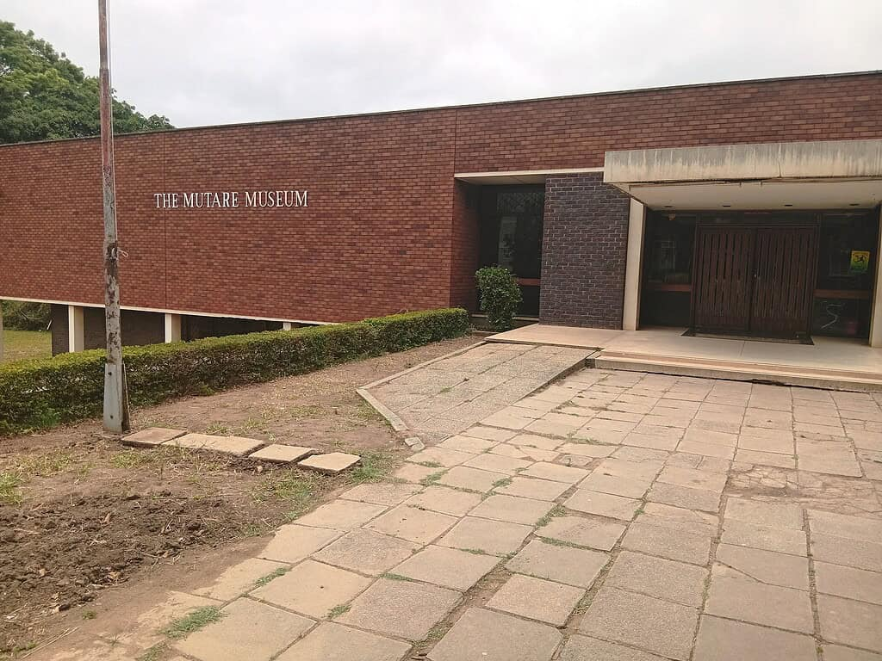
Mutare Museum in Zimbabwe. Credit: Andrew Mambondiyani.
This belief is so widespread that a local museum in Zimbabwe’s eastern border city of Mutare displays what is believed to be some paraphernalia for making a lightning bolt. These paraphernalia were collected from a traditional healer or wizard from Zimbabwe’s Nyanga district. And items which include an assortment of twigs, a small horn, and a bottle with some liquid stuff have intrigued visitors to the museum, local and international visitors alike.
“The items are now part of our collection on traditional beliefs at our museum. Many people are intrigued by this collection,” Chiedza Zharare, curator of antiquities at the Mutare Museum, tells ZME Science.
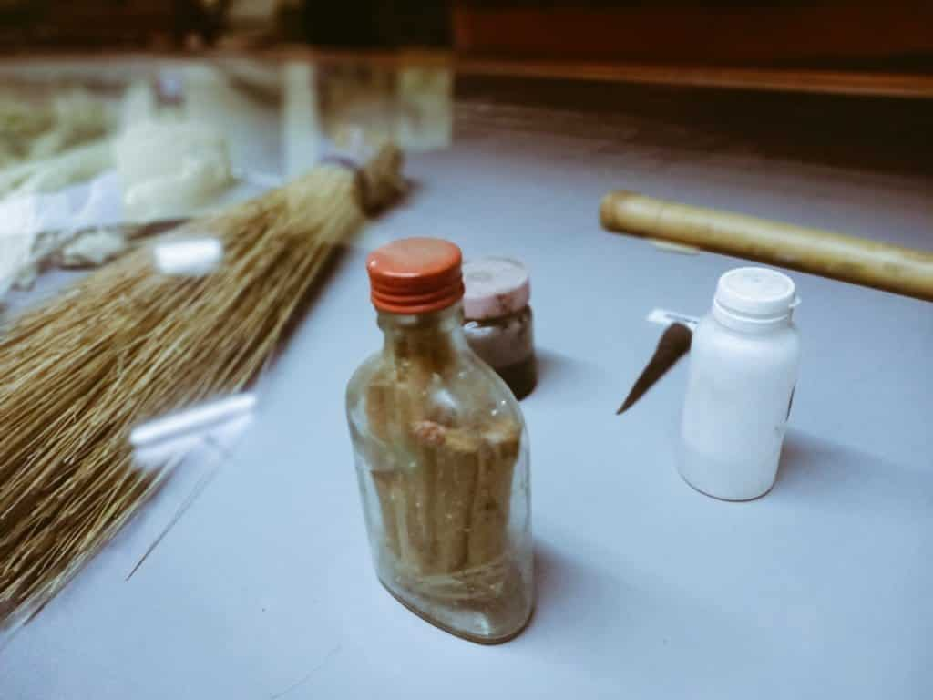

The “mheni” (lightning) collection at Mutare Museum, Zimbabwe. These objects, reportedly used in the summoning of lightning for retributive justice, were surrendered to the museum by a family in Nyanga in the early 1990s. They include a 275ml bottle with a red cap containing 10 tied wooden sticks believed to be from the ‘mutamba / Umhahli’ (Strychnos or Black Monkey Orange tree), a small kudu horn, and two small containers filled with mysterious black and clear liquids. Credit: Mutare Museum/Facebook.
Science versus Superstition
So, if it’s not “mheni,” what is really going on? Why is Zimbabwe such a lightning hotspot?
The answer is a potent mix of geography, climate, and atmospheric dynamics. At the heart of it all lies heat.
Zimbabwe sits squarely in the tropics, where the sun’s energy beats down with relentless intensity. That heat stirs the air, sending warm, moist plumes rising high into the atmosphere. As they climb, the air cools and condenses into towering thunderclouds, which scientists call massive convective systems.
Studies of African thunderstorms have shown that these convective towers produce more lightning flashes per storm than almost anywhere else on the planet. Furthermore, the Intertropical Convergence Zone — a shifting band of moist air that migrates south each summer — delivers warm, humid air from the Indian Ocean. A 2020 study published in Geophysical Research Letters found that this convergence of moist winds and searing land temperatures is one of the main reasons tropical Africa experiences such intense lightning activity.
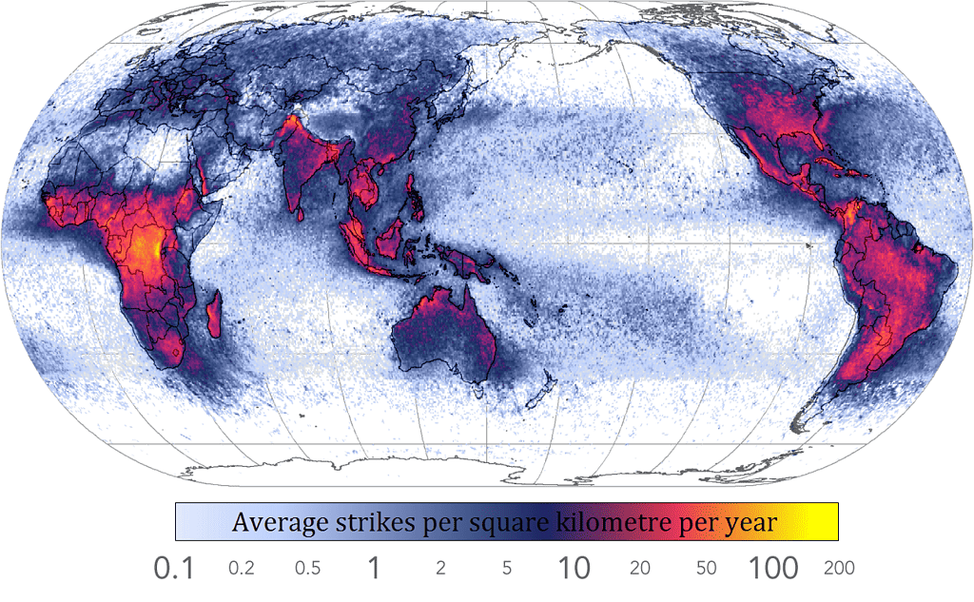
Density map of lightning strikes. Image via Wikipedia.
The landscape amplifies the effect. Much of Zimbabwe rests on a high plateau, a thousand meters or more above sea level. Elevated terrain encourages air to rise even faster, a process known as orographic lift. In neighboring Uganda, researchers have found that lightning activity increases markedly with altitude, peaking in regions above 800 meters — a pattern that almost perfectly describes Zimbabwe’s topography.
In 1987, Max van Olst, then a lecturer in the University of Zimbabwe’s electrical engineering department, carried out extensive research on why there were so many lightning-related deaths in the country. Back then, van Olst was quoted by the Associated Press as saying, “A lot of Zimbabwe’s soil is a poor conductor of electricity, meaning that the charge from a lightning bolt, instead of dispersing evenly, can stream with concentrated force hundreds of yards from the strike point as it follows narrow paths of easy conductivity.”
But as the mystery behind lightning deepened, more recently, researchers from Los Alamos National Laboratory have discovered that cosmic-ray showers seem to play a pivotal role in triggering lightning flashes.
“Scientists still don’t fully understand how lightning starts in thunderstorms,” says Xuan-Min Shao, of Los Alamos’ Electromagnetic Sciences and Cognitive Space Applications group and lead author of the new study.
Using 3D radio frequency mapping and polarisation technology, the researchers noticed an unusual pattern in how lightning begins; instead of just fast positive electrical discharge, the lightning flashes were quickly followed by an even faster, negative discharge. In general, the researchers note, lightning starts after opposing electrical charges, positive and negative, are separated in clouds, resulting in a discharge that people see as lightning.
Lightning Safety Awareness Saves Lives
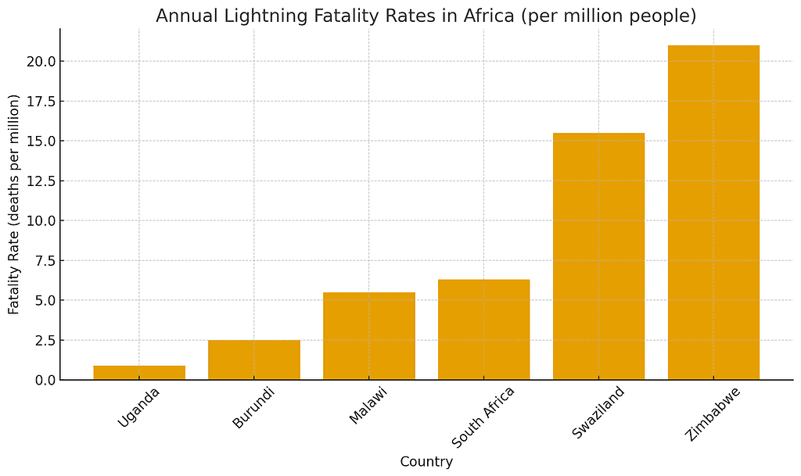

Fatalities from 2010-2017 in several African countries. Chart arranged by ZME Science.
Over the past years, Dr. Mary Ann Cooper, founder of the African Centres for Lightning and Electromagnetics Network (ACLENet), has been working to reduce lightning deaths and injuries in Africa through their outreach activities.
“Since my retirement from the University of Illinois, I have been directing a non-medical NGO, ACLENet.org. ACLENet started in Uganda in 2014, but in this decade, we are branching out to other countries, including the media, who can reach far more people than we ever could by ourselves,” Dr. Cooper tells ZME Science.
“Indeed, we are quite familiar with many Africans’ beliefs about lightning and are working with journalists and students to educate people that they can do something to decrease their risk of lightning injury.”
Unfortunately, Dr. Cooper adds, this is complicated in much of Africa due to the lack of lightning-safe structures, so it is hard to give “simple” tips.
She says that in the USA, for instance, lightning deaths decreased from 55 to 60 per year in the 1990s to under 20 per year due to the hard work the National Lightning Safety Council has done, including giving hundreds of interviews to the press with safety information.
“We concentrated on two audiences: training the government meteorologists about how they could reach the public, but also the broadcast meteorologists. They can reach millions, at least in the USA, and the online and print press can as well. In every interview, I tell the journalist, ‘Your story will save lives,’ because they do. The media spread the information,” she says.
She adds that lightning injury prevention requires two things: lightning-safe structures where people can go to avoid being struck and proper training on mitigating lightning risk; things like knowing when it’s time to head for safe structures when you hear thunder.
“When thunder roars, go indoors—when you can hear thunder, you are already in the danger zone of being hit by the next strike, so we use this as the most reliable recommendation. Unfortunately, 90 percent of sub-Saharan housing, schools, and churches are not lightning safe,” Dr Cooper says.
The clash between science and myths in Zimbabwe’s superstitious communities over lightning often has devastating consequences. It shows just how important it is to educate communities about lightning safety and to debunk myths that contribute to the number of preventable deaths.

