Lightning kills two in Vihiga, including a 10-year-old child – Kenya
https://www.the-star.co.ke/news/2025-10-08-lightning-kills-two-in-vihiga-including-10-year-old-child
8 October 2025
By KNA
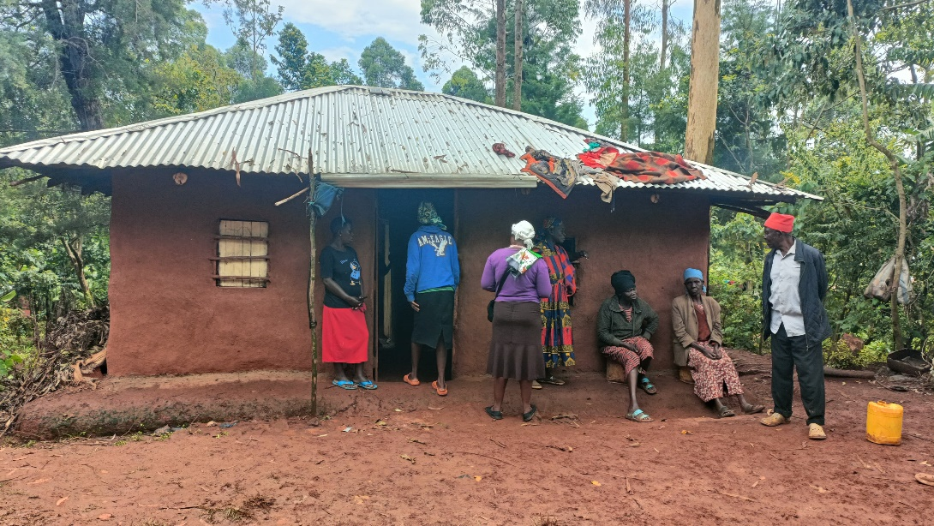
Home where two brothers, Timothy Luvai, aged 20 and Vitalis Ndondi, aged10, died after being struck by lightning, October 6, 2025. /KNA
A family in Sabatia, Vihiga county, is mourning the tragic loss of two kin who were struck by lightning during a heavy downpour on Monday evening, October 6.
The victims, identified as Timothy Luvai, 20, and Vitalis Ndondi, 10, were reportedly warming themselves around a fire when lightning struck, killing them instantly.
Their sister, Stacy Muhonja, 13, sustained injuries in the incident and is receiving treatment at Itando Mission of Hope Hospital.
The bodies of the two brothers have been preserved at the Vihiga County Referral Hospital Mortuary in Mbale.
Speaking to journalists, their grieving mother, Violet Minyoso, expressed deep sorrow over the loss of her sons and appealed to well-wishers for assistance in settling hospital bills and meeting burial expenses.
Local leaders have since sent messages of condolence to the bereaved family and urged residents to take extra precautions during the ongoing rainy season, including avoiding open spaces and switching off electrical appliances during thunderstorms.
Lightning strikes are a recurring hazard in western Kenya, particularly during the October–December short rains.
According to the Kenya Meteorological Department, the region records some of the country’s highest lightning densities, with dozens of deaths reported annually in Vihiga, Kakamega, Bungoma and Kisii counties.
Experts advise residents to remain indoors during thunderstorms, avoid open fields and tall trees, and disconnect electrical appliances. They also encourage the installation of lightning arrestors in schools and homes to minimise risk.
Local leaders have sent messages of condolence to the bereaved family and urged residents to take extra precautions during the ongoing rainy season.

