Eastern Cape Farmers’ Livelihoods Hit as Lightning Kills 11 Cows – South Africa
https://centralnews.co.za/eastern-cape-farmers-livelihoods-hit-as-lightning-kills-11-cows/
8 February 2026
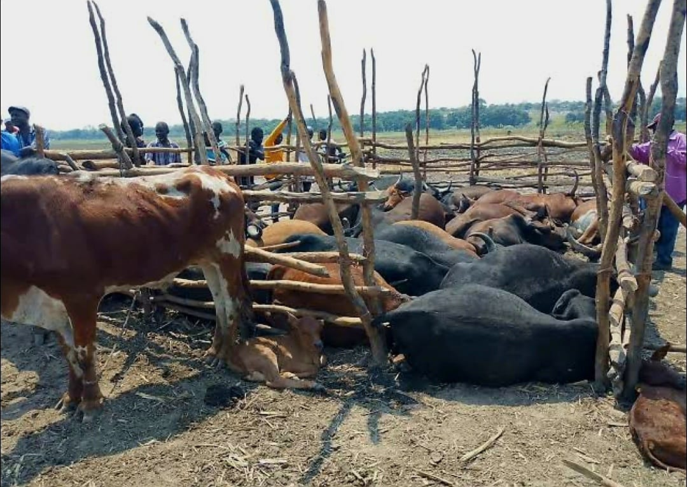
Port St Johns, Eastern Cape – A devastating lightning strike has left small-scale farmers in Caguba Village reeling after it killed 11 of their cows while they grazed in an open field during a thunderstorm, wiping out what many call their “bank” for emergencies like paying school fees or lobola, and sparking urgent calls for government help to protect livestock in rural areas prone to severe weather.
The Tragic Lightning Strike Incident
The bolt hit on Thursday morning, 5 February 2026, as heavy rains pounded the area. The cows, belonging to two local farmers, were out grazing when the storm turned deadly. Mthandazo Mthimkhulu lost three of his animals, worth about R30,000, while Thandazile Mjokovana saw eight of hers die in an instant. Witnesses described a loud crack followed by the sight of the fallen cattle, some still smoking from the strike. No people were hurt, but the loss cut deep for families who rely on these animals for survival.
In rural spots like Caguba, cows are more than just livestock—they are a lifeline. Farmers like Mthimkhulu explained, “Our bank is gone,” highlighting how they sell or trade cows for big needs, like weddings or education. Without insurance, which many cannot afford due to high premiums and low incomes, the hit is total. Mjokovana shared her heartbreak, saying the cows were her main source of money, leaving her family in a tough spot to recover.
This incident is not rare in the Eastern Cape, where thunderstorms roll in often during summer, bringing lightning that strikes open fields. Data shows over 200 livestock deaths from lightning in the province last year alone, with small farmers bearing the brunt because their animals graze freely without shelters.
Impact on Farmers’ Livelihoods and Rural Economy
For these farmers, the loss goes beyond money—it shatters plans and dreams. Cows provide milk for home use, meat for special times, and manure for fields. Selling one can pay for a child’s school year or medical bills. In a province where over 60% of people live in poverty, livestock acts as a safety net without banks or loans. Mthimkhulu, who farms on a small plot, said he might have to sell other assets to rebuild his herd, delaying his family’s progress.
The rural economy feels the ripple too. Fewer cows mean less trade at local markets, hurting butchers, transporters, and even cultural events like weddings where lobola involves cattle. In Port St Johns, where farming and fishing keep many afloat, such strikes add to woes from droughts and floods tied to climate change. Warmer weather brings more intense storms, increasing lightning risks by up to 12% per degree rise, according to climate studies. This leaves small farmers vulnerable, with no fences or lightning rods to protect herds.
Without help, some give up farming altogether, moving to cities for work and leaving land idle. This drains rural areas of people and skills, worsening poverty cycles. Community leaders call for subsidies on insurance or low-cost shelters to shield animals during storms.
Government and Community Responses
Local authorities have stepped in with short-term aid, like feed for remaining livestock and counselling for affected families. The Eastern Cape Department of Rural Development and Agrarian Reform has promised to assess the damage and offer support through its disaster fund. But farmers want more: training on storm safety, like building kraals with lightning protection, or early warning systems via apps or radios.
In past similar cases, like a 2023 strike in the Amathole District that killed 15 sheep, government provided replacement animals through breeding programmes. Here, calls grow for the same, plus long-term plans like planting trees as natural barriers or installing grounding rods. The National Disaster Management Centre classifies lightning as a hazard, unlocking funds for prevention, but rollout in remote spots like Caguba stays slow due to budget limits.
Communities rally too, with neighbours sharing milk or helping rebuild fences. Local churches and NGOs offer food parcels, showing the tight bonds in these areas. But without bigger fixes, farmers fear more losses as summer storms continue.
Climate Change and Increasing Lightning Risks
Experts link the rise in deadly strikes to climate shifts, with warmer air holding more moisture for stronger thunderstorms. In the Eastern Cape, storms have grown fiercer, with lightning hitting livestock more often. Studies show a 10-15% jump in strikes over the last decade, tied to global warming. This hits small farmers hardest, as they lack resources for protection like insured big operations.
Globally, lightning kills thousands of animals yearly, but in South Africa, rural herders feel it most. Programmes like the Livestock Improvement Scheme aim to help, offering better breeds and health tips, but coverage stays low. Calls for weather insurance tailored for smallholders grow, with subsidies to make it affordable.
Broader Implications for Rural South Africa
This tragedy spotlights wider woes for small-scale farmers, who make up 70% of the sector but face big barriers like weather risks and poor support. In the Eastern Cape, where farming drives the economy, losses like this deepen poverty, with over half the population below the line. Government pushes for climate-smart farming, like drought-resistant crops, but livestock needs more focus.
For families in Caguba, rebuilding means starting small, perhaps with community loans or government grants. But the emotional toll lingers, with farmers like Mjokovana saying, “It’s like losing family.” As calls for help echo, hope lies in collective action to shield livelihoods from nature’s fury.
This incident serves as a wake-up for better preparedness, turning grief into steps for safer farming. In a land where weather shapes lives, protecting livestock protects futures.

