Lightning kills two in Mukwe Constituency – Namibia
https://neweralive.na/lightning-kills-two-in-mukwe-constituency/
13 November 2025
John Muyamba

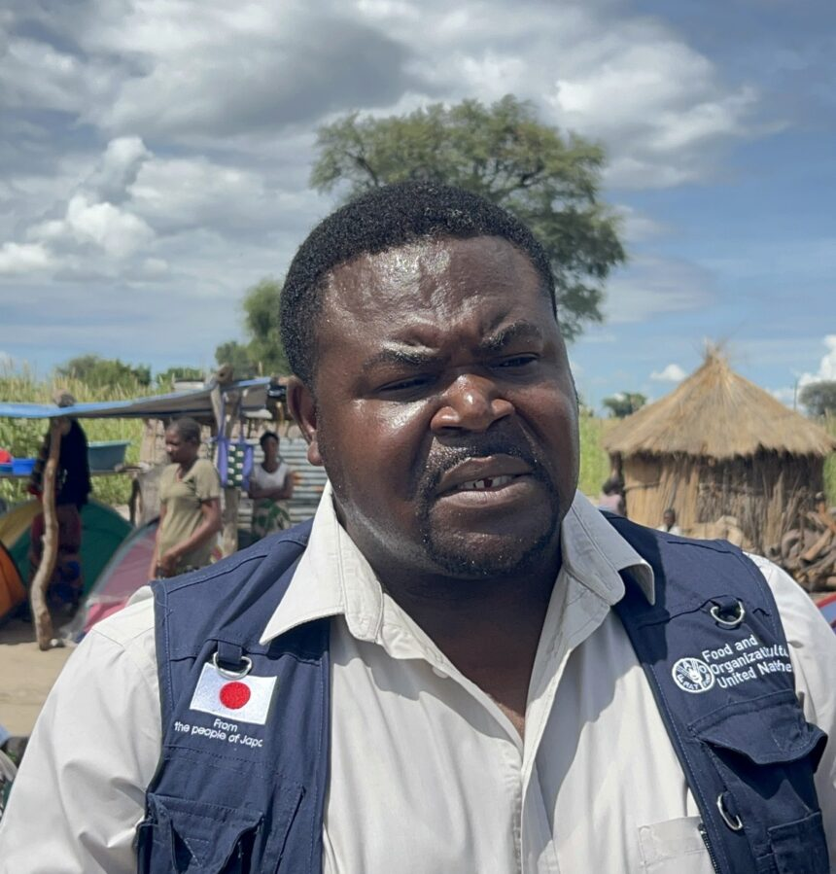

MUTANGOVILLE – Two people were on Tuesday evening struck dead by lightning at Shakashondo village, in the Kangongo area of Mukwe constituency, Kavango East region.
According a police report, about nine people were in a hut keeping themselves safe from rain showers when lightning hit the hut killing two on the spot and leaving some slightly injured.The deceased where identified as Christine Thihawa Moyo a 30-year-old woman and Kambathi Edward Muronga Kambathi a 9-year-old boy. Two minors, Sandrina Kunyima (9) and Angeline Thimango (11) escaped with slightly burned wounds and were rushed to Andara hospital where they are currently receiving medical attention.
The other five who were in the hut with them miraculously escaped unscathed. “My deepest condolences to the family. Our team will be on the ground to assess the situation and see to it that as government we assist the family.
This is a natural disaster and there’s nothing we can do about it, but what we can do for now is console the family and request community members to render their support and be there for the family while government finds a way in which to assist the affected family,” said the Mukwe constituency councillor Damian Maghambayi.

