Lightning in Ouénou: a farmer loses four oxen during a violent storm - Benin
https://lanatayaise.com/foudre-a-ouenou-un-eleveur-perd-quatre-boeufs-lors-dun-violent-orage/?amp=1

18 April 2026

By Editorial
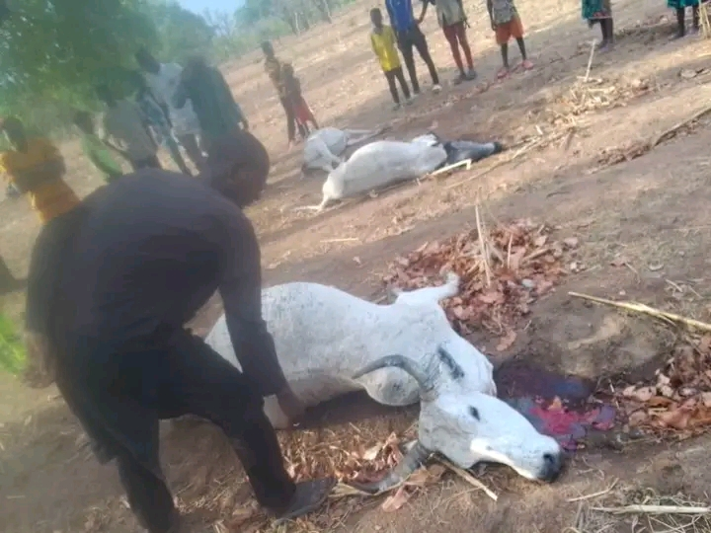
A particularly intense storm that occurred on the evening of Saturday, April 18, 2026 caused damage in northern Benin. In Gnel-Keridji, a hamlet of Fombawi located in the district of Ouénou (Nikki commune), four oxen were killed after being struck by lightning.
According to information relayed by a local radio, the animals belonged to the same breeder, which was severely affected by this sudden loss. The electric shock occurred in the middle of the rain, leaving no chance for the herd.
Following the incident, the animals were slaughtered, a practice that raises questions among local populations. Concerns arise in particular about the destination of meat, between private consumption and possible placing on the market, against the backdrop of health risks.
Informed of the situation, the veterinary services went to the site to assess the circumstances and to take the necessary measures to prevent any danger to public health.

