FACT DIVERSE- When the sky strikes: in Koumbia, lightning reminds us of the fragility of our lives – Guinea
https://www.lindependant.org/fait-divers-quand-le-ciel-frappe-a-koumbia-la-foudre-rappelle-la-fragilite-de-nos-vies/
28 June 2026
BY The Independent

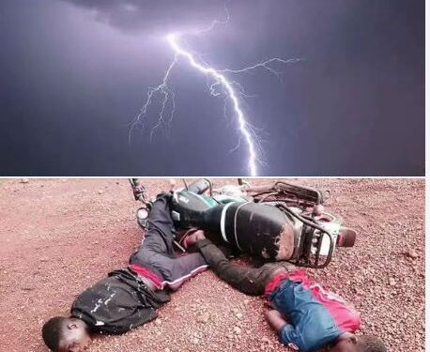

Rain is often a matter of hope in our countryside. It announces seeds, land fertility and the promise of crops. But sometimes, in a few seconds, it turns into a tragedy.
This Friday, June 27, 2026, around 7 p.m., the center of the sub-prefecture of Koumbia was the scene of an upsetting drama. While a violent storm was hitting the locality, several people were fatally struck by lightning. The electric shock left them no chance. They died on the spot.
Beyond the emotion aroused by this catastrophe, this drama recalls with striking brutality that man remains powerless in the face of certain manifestations of nature. In a few moments, families have lost a father, brother, sister, child or relative, plunging a whole community into grief.
While lightning is an unpredictable natural phenomenon, it nevertheless calls for increased awareness among populations of the behaviours to be adopted during thunderstorms. Avoiding open spaces, insulated trees or electrical installations during the weather can sometimes save lives.
Today, Koumbia mourns his missing. Their disappearance leaves an immense void and recalls how precious every existence is.
To their families, to their loved ones and to the entire population of Koumbia, we extend our sincere condolences. May the victims rest in peace and their loved ones find the strength to overcome this painful ordeal.

