Achidiocese of Bukavu (Luhwindja): One dead and three wounded after a torrential rain
accompanied by lightning – DRC
https://diacenco.net/achidiocese-de-bukavu-luhwindja-un-mort-et-trois-blesses-apres-une-pluie-torrentielle-accompagnee-de-foudre/
November 14, 2025
By Benjamin MUKANIRE
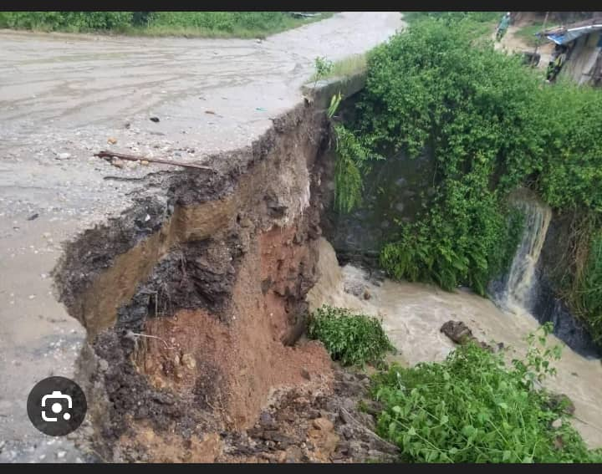
A tragedy occurred in the evening of Wednesday, October 12, 2025 in the chiefdom of Luhwindja, Mwenga territory, following a torrential rain accompanied by violent lightning. The provisional toll shows one dead and three survivors, all members of the same family.
The tragedy occurred at the home of Mr. Kalimba Nacongwe, a resident of the Karhundu group. According to the testimonies gathered on the spot, a lightning struck the house, killing his brother-in-law, Bashebereka Lufayo, while his children survived with injuries.
The three survivors were rushed to the Kakoma Health Centre, where they receive appropriate care.
It should be noted that Mr. Kalimba Nacongwe is the coordinator of the singers of the parish of Saint-Esprit Cibanda Mulagi, located in the same chiefdom.
This tragic incident revives the question of the vulnerability of homes to natural phenomena in this mountainous region of South Kivu, often exposed to the weather.

