Flood toll rises to 21 dead – Mali
https://sahel-intelligence.com/39760-mali-le-bilan-des-inondations-salourdit-a-21-morts.html
19 August 2025
By Samuel Benshimon
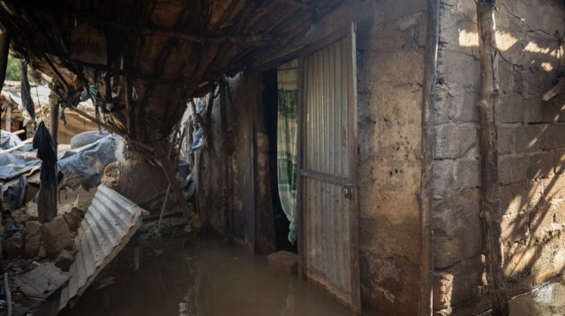
In Mali, floods caused by heavy rains, strong winds and lightning strikes killed 21 people, 33 injured and caused the collapse of 495 houses, according to a statement issued on Monday, 18 August 2025 by the Inter-Ministerial Crisis Management Committee.
Since the start of the wintering in June, the country has recorded 31 cases of flooding, 5 cases of lightning and 4 strong winds. A total of 803 households, or 9,155 persons, were affected. The previous death toll, which was halted on 31 July, claimed 12 to be killed and 30 injured.
The Committee stresses that the weather situation remains worrying, with persistent stormy rains planned in most of the territory, with the exception of the extreme north.
To mitigate impacts, anti-cipatent measures are under way with the strengthening of rapid response teams, the deployment of emergency kits in the regional social development directorates and the mobilization of volunteers under the “Citizen Months” project.
By 2024, the floods had already caused 76 deaths, 148 injured and more than 259,000 people throughout the country, with 649 cases in 19 regions and Bamako. In the face of the recurrence of these disasters, the authorities are calling for vigilance and strengthening the coordination of humanitarian response.

