**Seven die in Aweil lightning strike – Sudan**<https://www.sudanspost.com/seven-die-in-aweil-lightning-strike/>

1 May 2025  
  
By Sudan Post

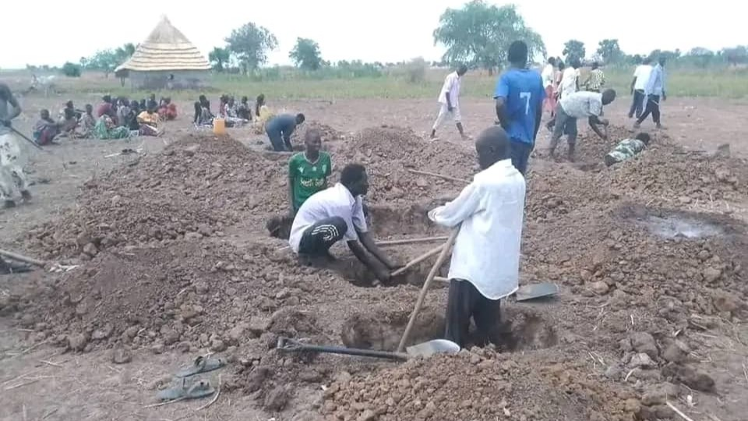  
  
Victims of lightning are being buried in a mass grave in Aweil. [Photo: Courtesy]

AWEIL – At least seven people were killed by a lightning strike at Awuluic village in Aweil Centre in South Sudan’s Northern Bahr El Gazal State, leaving the community in shock.

The victims were struck on Tuesday while taking shelter in a locally thatched hut after leaving their work as part of a group of vegetable growers at Awuluic farms.

The incident occurred as a thunderstorm hit the area, with rain beginning to fall for the first time in Aweil. Local authorities identified the victims as Akec Diing Athian and her two children, aged approximately 7 and 4, 33-year-old Akuol Thiik and her two children, and a girl only identified as Ajak.

Dut Bak, the local chief in the village, described the event as a horrific incident that caught the community off guard.

“I am appealing to the people of Aweil to take heart. There is a need for support as they are buried in a mass grave. We are calling upon the government to do what is needed as this shook us in amazement,” Mr. Dut stated. He noted that the young girl, Ajak, was a visitor to the area, making the tragedy even more shocking.

Simon Dut Lual, the Awuluic payam administrator, confirmed the incident occurred around 4:00 PM. “As they were at the vegetable farm, they ran to seek shelter, and God took them in such a manner. Let’s all take heart as people of Aweil, as such a death is uncommon,” he added.

Lightning is a flash of light produced by a short-duration, high-voltage discharge of electricity within clouds or between a cloud and the earth.

It is primarily caused by the buildup of electrical charges in storm clouds, typically cumulonimbus clouds, due to the collision of water droplets, ice particles, and other particles in turbulent air.

This charge separation creates a powerful electric field, leading to a rapid discharge in the form of lightning. Factors such as strong updrafts, temperature differences, and atmospheric instability contribute to the conditions that generate lightning, making thunderstorms a common setting for such events.

In regions like Aweil, where seasonal rains mark the onset of wet conditions, the risk of lightning strikes can increase during early storms.