Salama-: A National Guard agent dies struck by lightning – Tchad
https://tchadvision.com/foudre-a-salamat-un-mort-un-blesse-grave/
7 June 2026
By tchadvision.com

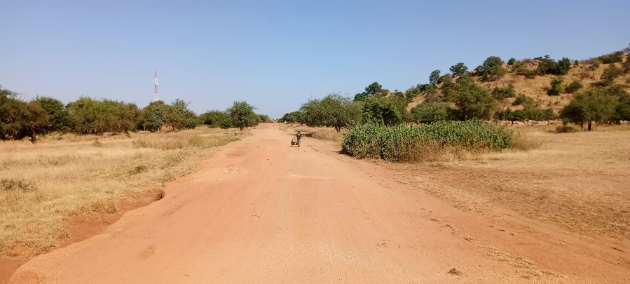
Salamat: A National Guard agent dies struck by lightning
Bichara Djiddi, postman of the National Guard and Nomad of Chad (GNNT) in Siheb, tragically lost his life on Sunday, June 7, 2026 after being struck by lightning. This tragic event occurred when Bichara Djiddi was returning from the locality of Alkouk, located about 50 kilometers east of Am-Timan, to join the sub-prefecture of Siheb.
During his journey between these two localities, a violent electric shock hit him mortally. Another officer, who accompanied him, was also hit and is currently in critical condition. The first aid arrived on the scene had to face a devastating scene, the force of lightning having left little chance to his victims.
Siheb’s sub-prefect, contacted by phone, confirmed the incident. He said that Bichara Djiddi's body was on his way to Am-Timan, where he will receive an appropriate funeral. Meanwhile, the injured officer was rushed to a medical center to receive intensive care.
This incident highlights the risks associated with the violent weather that regularly hit the region during this time of year. Lightning is a common natural phenomenon that poses a serious threat, especially in rural areas where prevention infrastructure is often inadequate.
Local authorities expressed their support for the families of the victims and encouraged the population to increase their vigilance during the thunderstorms. They are also exploring measures to improve safety, including by installing lightning rods in the most exposed areas.
The death of Bichara Djiddi has aroused a strong emotion within the community. Known for his dedication and commitment to security, he leaves behind a legacy respected by his colleagues and the people of the region.
Meanwhile, the injured agent’s relatives hope for a rapid recovery, while the entire community gathers in memory of Bichara Djiddi, a man who gave his life in service to his nation.

