Tahoua: A violent rain causes significant material damage in Garhanga (Keita) – Niger
https://anp.ne/tahoua-une-violente-pluie-fait-dimportants-degats-materiels-a-garhanga-keita/
8 June 2026
By Hamza Harouna Adamou
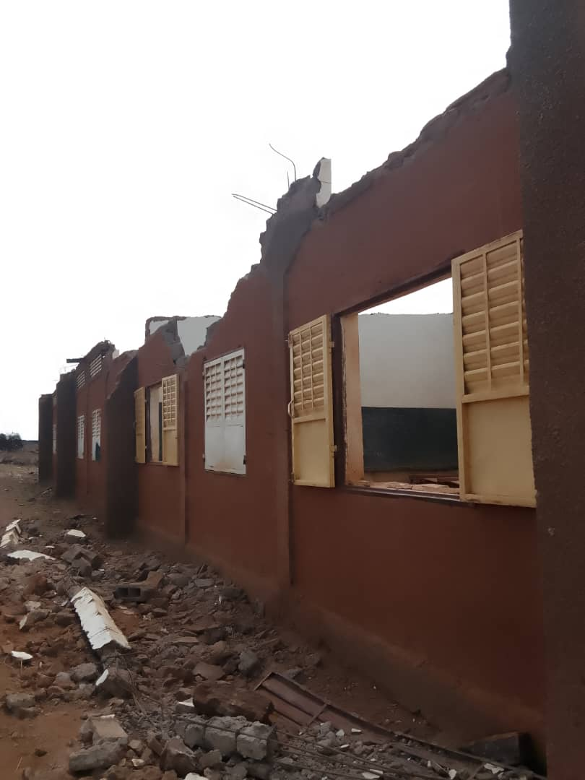
Tahoua, June 8 (ANP) – In a rain accompanied by a strong wind that fell on Friday, June 5 in the village of Garhanga, Rural Municipality of Garhanga, Department of Keita, Tahoua Region, lightning struck and killed 59 small ruminants (caprines and sheep), learned the ANP from local official sources.
This 26 mm rain, which began around 18 hours (local time), also caused significant other material damage. Of the 9 households whose homes collapsed, 68 people were affected and one was injured. However, there is no loss of life.
In addition, 3 classroom roofs were blown away by the wind at Garhanga 2 school.
