10-Year-Old Dies After Being Struck By Lightning In Chasefu – Zambia
https://diamondtvzambia.com/10-year-old-dies-after-being-struck-by-lightning-in-chasefu/
1 December 2025
By Samuel Khwawe

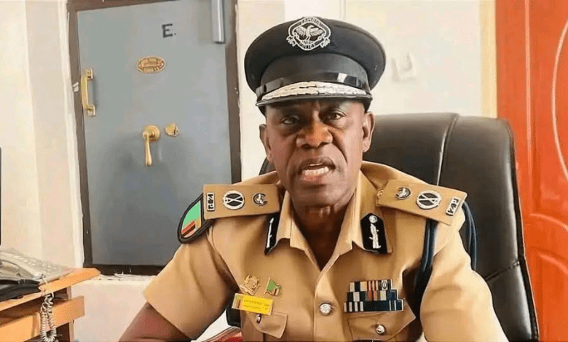
A ten-year-old boy has died after being struck by lightning while seeking shelter under a tree from a rainstorm in Chasefu District, Eastern Province.
According to Eastern Province Police Commanding Officer Robertson Mweemba, the incident occurred on Saturday, November 29th, 2025, at around 14:00 hours in Chilwayo Village.
The juvenile, identified as Moses Nali, was herding cattle in nearby fields when the weather turned.
As the rain began, the young cattle herder took refuge beneath a mango tree, where he was hit by a lightning bolt.
The strike impacted the boy on the head and traveled through the left side of his chest, partially burning his clothes.
Police suspect no foul play, and the body has since been released to his family in Chilwayo Village for burial.

