Lightning Kills LC1 Chairperson, Injures Three in Rukungiri – Uganda
https://thesource.co.ug/national/lightning-kills-lc1-chairperson-injures-three-in-rukungiri/
23 February 2026
By Aine Kevin
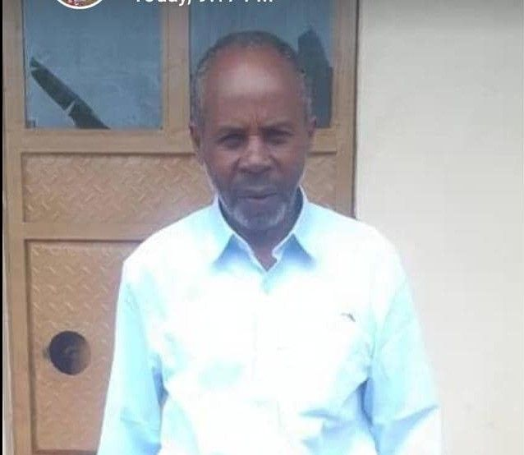
The Chairperson LC1 for Nyakabungo Cell, Katonya Parish in Nyakishenyi Subcounty, Rukungiri District, Emmanuel Tumuhamye, has been struck and killed by lightning.
Tumuhamye was reportedly struck while grazing his cows on Saturday evening during a thunderstorm.
The LC3 Chairperson for Nyakishenyi Subcounty, Wednesday Twinomujuni, confirmed that three other people were also struck by lightning during the same incident. They were rushed to Kisiizi Hospital in critical condition for urgent medical attention.
Speaking about the tragedy, Twinomujuni expressed concern over the rising lightning incidents in the area and urged residents to seek shelter during thunderstorms.
The Mayor of Akagaana Town Council in Nyakishenyi Subcounty, Backer Ahimbisibwe, described the late Tumuhamye as a development-oriented leader who always encouraged young people to work hard and pursue self-sustainability.
He noted that Tumuhamye had served as LC1 Chairperson for Nyakabungo Cell for over 30 years.
Meanwhile, on February 19, 2026, another lightning incident in Bushenyi District left two pupils dead. The incident occurred when lightning struck pupils of St. Mary’s Primary School Kyamuhunga as they walked home after having lunch near St. Mary’s Catholic Church in Kyamuhunga.
Police identified the deceased pupils as Maria Ainembabazi, 7, a Primary One pupil, and Augustine Ainomukama, 10, a Primary Five pupil. Both were residents of Gongo Cell, Kyamuhunga Ward in Bushenyi District.
About Lightning
Lightning is a high-voltage electrostatic discharge that occurs during thunderstorms. A single lightning bolt can heat surrounding air to extremely high temperatures, causing rapid expansion that produces thunder. Lightning also travels at very high speeds compared to most terrestrial objects.

