Senior six student killed by lightning in Oyam – Uganda
https://dailyexpress.co.ug/2026/03/26/senior-six-student-killed-by-lightning-in-oyam/
26 March 2026
By Geoffrey Omara
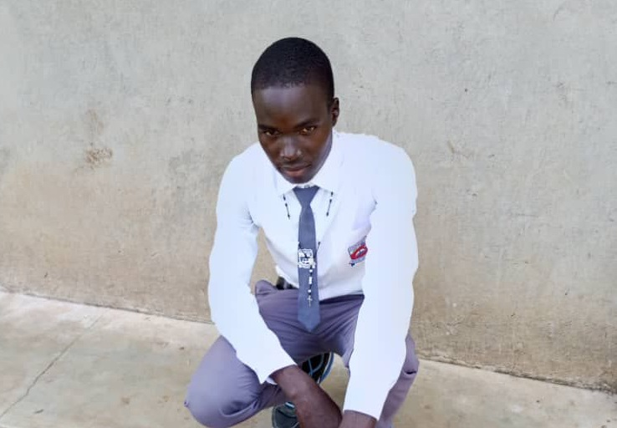
OYAM, UGANDA Shock and grief have engulfed Atapara Secondary School following the tragic death of a Senior Six student, Akona Isaac, who was struck by lightning during a heavy storm on Tuesday evening.
The incident occurred at around 6:00 pm as students carried on with routine activities. According to school authorities, Isaac had gone to serve supper when a sudden downpour accompanied by thunder and lightning hit the area.
He was rushed to Aber Hospital but was pronounced dead on arrival, according to head teacher Osenda Godfrey.
“We reported the matter to the police, and investigations are ongoing. A postmortem will be conducted before the body is handed over to the family,” Osenda said.
The sudden death has left the school community in shock, with students and staff describing Isaac as disciplined, humble, and academically focused.
“It is very painful to lose him in such a way. He was a good friend and a role model to many of us,” said the school head girl, Robina Agilo.
Students recounted scenes of panic as the storm intensified, saying the lightning strike came without warning. “The rain started abruptly with heavy thunder. When we heard he had been struck, everyone panicked,” said Senior Five student Peter Okello.
For his classmates, the loss is particularly devastating as they prepare for final examinations. “We were studying together and preparing for exams. He had big dreams. Losing him like this is heartbreaking,” said fellow Senior Six student James Ongom.
The tragedy has also reignited concerns over lightning safety in schools, especially in rural areas where protective infrastructure remains limited.
Students have called for clear safety guidance during storms, while parents and local leaders are urging authorities to install lightning arresters in schools. “We are now living in fear when it rains. The school should guide us on how to stay safe,” said student Mercy Aber.
Police in Oyam have launched investigations into the incident, though preliminary findings point to natural causes.

