TSIROANOMANDIDY - Lightning falls on two sisters – Madagascar
https://www.lexpress.mg/2026/01/tsiroanomandidy-la-foudre-sabat-sur.html
19 January 2026
By Gustave Mparany
On Saturday, a violent storm bereaved Tsiroanomandidy. Four children from the same family were struck down, and two sisters lost their lives.
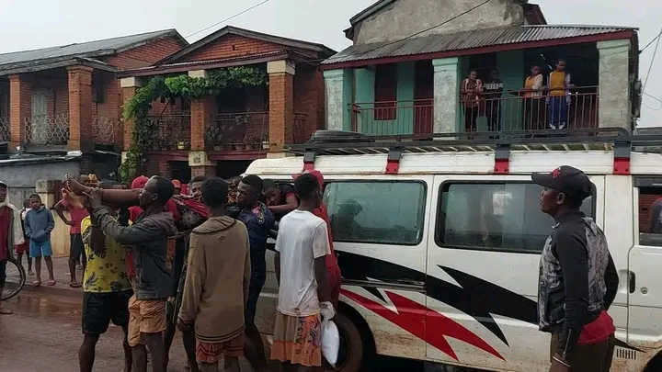
Last home for the victims.
A deadly storm struck the commune of Tsiroanomandidy on Saturday. Four children from the same family – three sisters and their nephews – were struck down as they returned from the fields in Adabo Analatsifaka West to return to their home in Mangarivotra. Two sisters died instantly. The survivors of this tragedy are hospitalized.
The eldest of the sisters who survived the tragedy, burned with her neck, as well as the seven-year-old boy, hit under the armpit, were evacuated in an emergency to the Regional Reference Hospital (CHRR) in Bongolava. They always receive care for burns related to the electric discharge.
Under the shock
According to testimony gathered on the spot, the lightning first struck the 17-year-old elder and then touched her junior before reaching the other two children. The teenage girls, aged 15 and 16, did not survive.
The four children were walking on the way home, homeless nearby, when the storm fell on the area. In the evening, the inhabitants, still in shock, expressed their compassion to the bereaved family.
The municipality of Tsiroanomandidy is regularly affected by this type of accident.
As of January 2022, three people, including two children, had already been struck down in Ankerana Avaratra. Archives of local colleagues also recall that during Christmas Eve, eleven victims had been recorded during similar episodes.

