Rains cause havoc, kill 4 – Malawi
https://mwnation.com/rains-cause-havoc-kill-4/
4 December 2025
By Our Reporter
Four people have died while some property has experienced extensive damage from the impact of stormy rains that hit parts of the Southern and Northern regions on Wednesday night.
Mzimba and Mangochi districts each recorded two deaths caused by lightning.
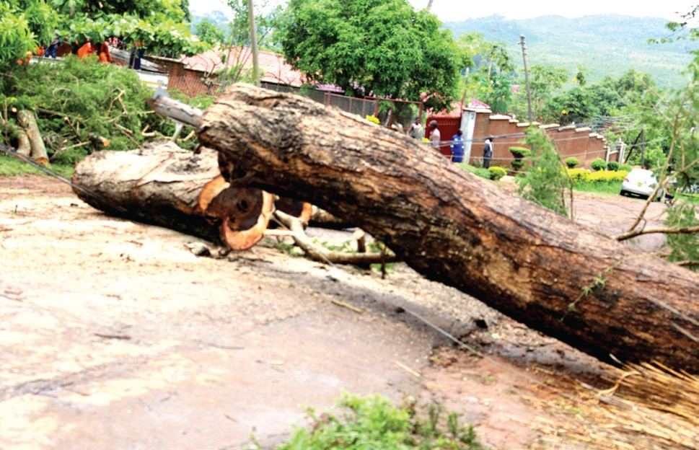A fallen tree blocks the road in Manyowe,
Blantyre.
In Mangochi, several houses collapsed due to strong winds that accompanied the heavy rains.
Mangochi District Council spokesperson Bishop Witmos said: “We can confirm that two lives have been lost due to lightning in Traditional Authority [T/A] Jalasi and a number of houses have been destroyed by the stormy rains. Our disaster response team is on the ground gathering more details.”
In Mzimba, lightning struck a group of young men who wanted to play football at Ewombeni football ground, killing two and injuring several others.
Embangweni Mission Hospital senior medical officer Mike Bonongwe confirmed receiving four victims from Kalikumbi Mission Hospital that were in critical condition.
“As of now, two victims are still in critical condition, one has mild pains and the other is relatively well and able to speak,” he said
On the same day, stormy rains destroyed 43 houses in T/A Katunga in Chikwawa District.
The Nation also visited several areas in Blantyre, including Manyowe where heavy rains fell trees which in some cases affected electricity lines and blocked roads.
During the checks, Electricity Supply Corporation of Malawi (Escom) staff were seen working to restore power.
In an update posted on its website, Escom said: “We want to assure you that our dedicated technical teams are already on the ground, working diligently and tirelessly to clear the debris, repair the damaged infrastructure and restore power supply safely.”
On December 2, the Department of Climate Change and Metrological Services announced that rainfall would occur in December, especially in the Southern and Central regions, with normal to above-normal rainfall amounts.

