Libreville: a disabled sixty-year-old woman loses her house in a fire caused by lightning in Belle-Vue 1 – Gabon
https://gabonmediatime.com/libreville-une-sexagenaire-handicapee-perd-sa-maison-dans-un-incendie-cause-par-la-foudre-a-belle-vue-1/
8 May 2025
By Blandine Biloghe
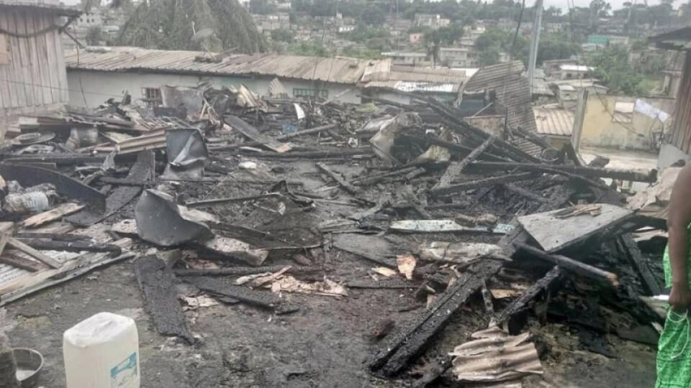
A view of the house reduced to ash
On Sunday, May 4, 2025, a fire triggered by lightning reduced the home of Simone Moulongou Mbadinga, a disabled six-year-old living in the Belle-Vue 1 district, in the 3rd arrondissement of Libreville, reports our colleagues from the daily newspaper L’Union. This tragedy comes as this Gabonese woman derived most of her income from this modest house, now totally ravaged by the flames.
A drama against a background of precariousness. Victim of a physical disability, Simone Moulongou Mbadinga lived in a premises loaned by the Ministry of Social Affairs. This house, the fruit of many years of effort, served as a refuge for her, but also as a means of subsistence for her, her children and grandchildren. In the night of the disaster, while a violent thunderstorm hit Libreville, lightning fell on an electric pole near his home, before spreading to the roof. “The impact of lightning on the electrical installation and roof of my home was such that the flames suddenly invaded the house and everything ravaged,” she said with emotion.
A call for solidarity from the authorities and the presidential couple
Now homeless, this compatriot calls for the compassion of the Gabonese authorities, including the presidential couple and the Ministry of Social Affairs, to help him rebuild his life. It also praised the speed of intervention of firefighters and the valuable help of neighbors who made it possible to avoid a spread of fire to neighboring dwellings.
This dramatic incident highlights the vulnerability of people with disabilities and the challenges related to the safety of electrical installations in certain neighborhoods of Libreville. He asked about the need for a rapid and supportive response of the institutions to this kind of humanitarian situation.

