Late-October Storms Threaten Country with Floods and Landslides – Rwanda
https://rwandadispatch.com/late-october-storms-threaten-country-with-floods-and-landslides/
23 October 2025
By John Mugisha
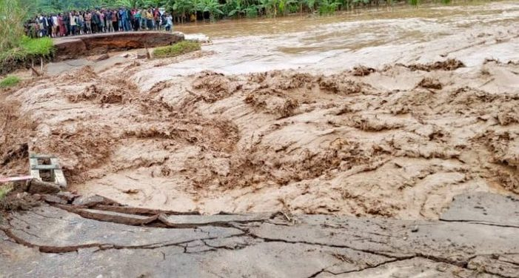

The Ministry of Emergency Management (MINEMA) has warned of heavy rainfall expected at the end of October that could trigger floods, landslides, and lightning, urging residents to take precautions and follow official guidance.
Through text alerts, the ministry said that from Oct. 23 to 31, intense rains are forecast in several parts of Rwanda, posing risks to lives and property. Citizens are advised to avoid low-lying areas and adhere to instructions from local authorities.
The National Meteorology Authority (Meteo Rwanda) reported that rainfall in the first and third weeks of October is expected to be above average, while the second week may see slightly below-normal precipitation. The rainy season is predicted to continue until December, with rainfall ranging between 250 and 300 millimeters in the Western Province, excluding the Bugarama Plain in Northern Province and southern parts of Gicumbi, Rulindo, and Gakenke districts.
Other areas expecting heavy rain include northern Muhanga District and western parts of Nyamagabe and Nyaruguru districts. Rainfall of 200 to 250 millimeters is forecast in remaining parts of Northern Province, Southern Province (excluding Kigali’s southern, northern, and western areas), and parts of Nyagatare and Gatsibo districts.
Meteo Rwanda urged residents to remain vigilant against strong winds and other weather hazards and to follow safety instructions from disaster prevention authorities.
A Ministry of Environment report shows that over the past nine years, up to 2023, disasters killed 1,595 people and injured 2,368 others. Floods killed 307 and injured 101; landslides killed 425 and injured 187; lightning killed 538 and injured 1,338; heavy rainfall killed 315 and injured 612; and strong winds killed 10 and injured 128.
MINEMA’s alert highlights the need for heightened awareness as Rwanda braces for potentially severe weather at the end of October.

