Telimélé: three people killed by lightning in Sinta and Gougoudjè – Guinea
https://guineematin.com/2025/10/19/telimele-trois-personnes-tuees-par-la-foudre-a-sinta-et-gougoudje/
19 October 2025
By Guineaematin

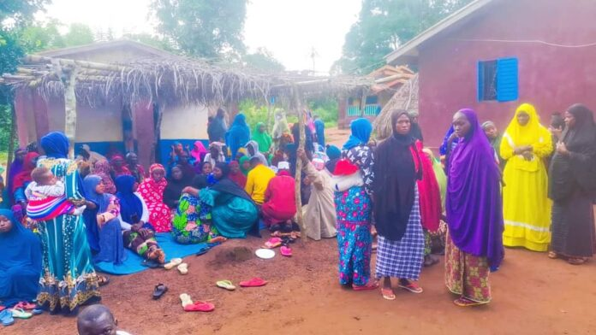
A series of dramas struck the prefecture of Télimélé on the day of Saturday, October 18, 2025. In the space of a few hours, lightning killed three people in the sub-prefectures of Sinta and Gougoujjè, leaving their inhabitants between sadness and questioning.
Among the victims, Ibrahima Sory Sylla, commonly known as “Dimbaye Sârè”. A traditional healer, married to four women and father of nine children. He was riding a motorcycle when he was broke by lightning around 15 hours.
“He was going to Tourkoun (in the sub-prefecture of Sogolon) to reconcile two parents. Arrived in Bowal Kontine (locality located on the border between Sinta and Sogolon), lightning killed him on the spot when it was not even raining,” explained Amadou Yéro Diallo, DSEE of Sogolon and close to the victim, reached by phone by a journalist from Guinea-emain.
According to him, the dump also hit women who were in a pasture not far from where the young man fell. The latter were saved thanks to the rapid intervention of the inhabitants. “We caught their tongues to prevent them from swallowing it,” says Mr. Diallo.
The second case occurred in the district of Bakolo, under the sub-prefecture of Gougoudjè. “There, two milk brothers were killed at the same time by lightning. They were under a shed where they were sheltering from the rain. And contrary to what some say, no one was manipulating their phone. They were in their pockets,” says our interlocutor.
These three deaths are in addition to two others caused by lightning last Monday in the sub-prefecture of Kollet. A mother and her 17-year-old son had been in this other locality of Télimélé, while they were eating the evening meal in their living room.

