14 Students Hospitalized After Lightning Strike at St. Paul’s Rugarambiro S. S in Kisoro – Uganda
https://kigezitv.com/news/story/14-students-hospitalized-after-lightning-strike-at-st-pauls-rugarambiro-secondary-school-in-kisoro/
October 3, 2025
Ahimbisibwe Nelson
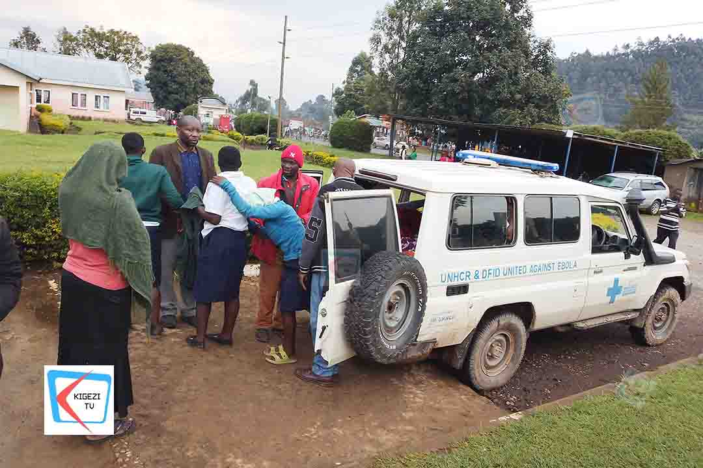
Fourteen students from St. Paul’s Rugarambiro Secondary School in Nyundo Sub-county, Kisoro District, were on Thursday evening admitted to Kisoro Hospital after being struck by lightning.
The incident occurred at around 2:30 PM during a heavy downpour when lightning struck the Senior One and Senior Two classrooms, throwing the school into panic as terrified learners scattered for safety.
Speaking to the press at Kisoro Hospital, the school’s headteacher, Emmanuel Obiyari, confirmed that 14 students were rescued, six of them in critical condition. He noted that the exact number of affected students is still being verified, as teachers continue to account for all learners.
Obiyari explained that most of the critically injured students were not wearing rubber shoes at the time of the incident, which could have increased their vulnerability to the lightning strike. He appealed to parents to ensure their children have proper rubber footwear, especially during the rainy season, to minimize risks of such tragedies.
“We ask parents to provide their children with rubber footwear and discourage them from wearing open shoes at school during the rainy season. It’s one of the simple ways to reduce such dangers,” Obiyari emphasized.
All 14 students are currently admitted to Kisoro Hospital’s emergency ward, where medical teams are providing urgent treatment.

