Malawi storms: Over 40 dead, 163,000 others affected – Malawi
https://apanews.net/malawi-storms-over-40-dead-163000-others-affected/
23 January 2026
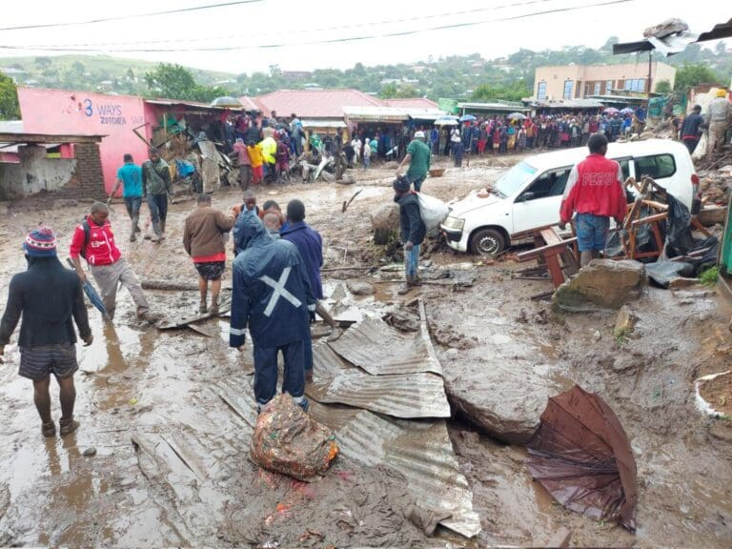
By APA-Lilongwe (Malawi)
At least 40 people have died and more than 36,000 households have been affected as Malawi reels from a series of devastating rain-related disasters during the 2025/26 rainfall season, the Department of Disaster Management Affairs said on Thursday.
Head of Disaster Management Affairs Wilson Moleni said thunderstorms, strong winds, flash floods and lightning have battered 29 districts across the country, affecting 36,283 households – roughly 163,000 people.
In a statement, Moleni said 209 people have been injured, while 23 deaths were caused by lightning and 17 by collapsing walls.
The scale of destruction underscores Malawi’s growing vulnerability to extreme weather.
In recent years, the country has suffered repeated climate-driven disasters – including Cyclones Idai, Ana and Freddy – which have left lasting damage to infrastructure, agriculture and livelihoods.
The current season has continued that pattern, with widespread flooding and storm damage stretching emergency response systems.
In Nkhotakota District, where flash floods in December displaced more than 2,100 households, the department has begun decommissioning temporary camps as part of early recovery efforts.
Thirteen of the 14 camps have already closed, with families receiving return-home packages that include food and basic supplies.
The department has appealed to international donors, UN agencies, non-governmental organisationss, the private sector and faith-based groups to support ongoing recovery efforts.

