**Lightning kills eight cows in Ondo community – Nigeria**  
  
<https://newsexpressngr.com/news/257198/lightning-kills-eight-cows-in-ondo-community>

8 April 2025  
  
By News Express

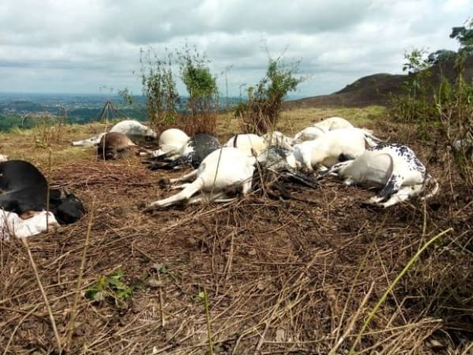

A similar incident happened in 2019 in Ijare, Ifedore Local Government Area of Ondo State, where thunder and lightning killed 36 cows on a hill in the community.

The incident which was said to have occurred on Sunday evening during a heavy downpour has left the residents of the community in panic.

The spokesperson of Ondo State Police Command, Olayinka Ayanlade, confirmed the incident to our Channels Television in a telephone conversation.

He expressed dismay at the unfortunate incident, noting that it was a natural occurrence.

Ayanlade added that police authorities have reached out to the community heads to ensure the incident does not lead to controversy.

A similar incident happened in 2019 in Ijare, Ifedore Local Government Area of Ondo State, where thunder and lightning killed 36 cows on a hill in the community.