**Tragedy on the Field: Nandi Student Killed by Lightning During Rugby Practice – Kenya**

<https://kassdigital.co.ke/latest/tragedy-on-the-field-nandi-student-killed-by-lightning-during-rugby-practice/>

24 May 2025

By Nelson Tarbei

A somber mood has engulfed Samoei Boys Secondary School in Nandi Hills, Nandi County, following the sudden death of a Form Four student who was struck by lightning on Saturday evening while playing rugby.

The student was part of a group preparing for an upcoming tournament scheduled for Sunday when the tragic incident occurred.

According to Nandi East Police Commander Jeremiah Leariwalla, the student died on the spot. Fortunately, none of the other students sustained injuries.

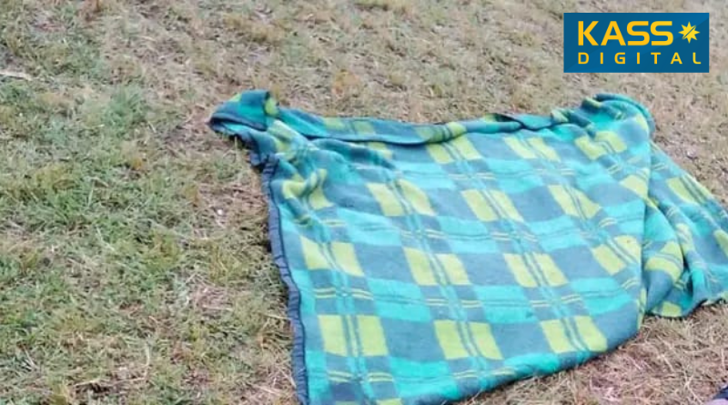

The body was moved to Nandi Hills Farewell Home, and the student’s parents—residents of Aldai Constituency—have been informed by the school administration.

The incident has sparked concern among parents and the public, as the school is equipped with lightning arrestors.

Questions are now being raised about their effectiveness in preventing such tragedies.

Commander Leariwalla confirmed that investigations will be launched to determine whether the lightning arrestors were functional or if the strike was an unavoidable natural disaster.

Calm has since returned to the school. Special prayers are scheduled for Sunday at the school grounds in memory of the student.

Nandi County Governor Stephen Sang and Tindiret MP Julius Melly—who also chairs the Parliamentary Committee on Education—have sent their heartfelt condolences to the bereaved family and the entire school community.