San: 4 women in the Gaza Strip of Sanékuy – Mali
https://www.studiotamani.org/192316-san-4-femmes-foudroyees-dans-la-commune-de-sanekuy
1 August 2025
By msindebou
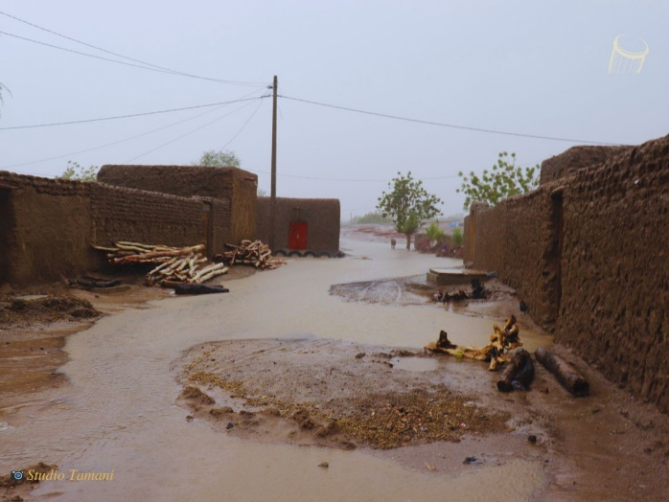
Two women from the villages of Magnan and Dokorokuy in the municipality of Sanékuy, Tominian Circle were struck down on Sunday (27 July 2025). The lightning strike had resulted in two other victims (a woman and her child) last May in the village of Sanékuy in the same commune. No explanation is given for these lightning-related dramas. The population of the commune is becoming increasingly concerned.
In San, listen to the Tamani Studio programmes from 5 p.m. to 7 p.m. on the San 100.6 FM Parana radio.

