**Lightning strike claims two lives at Kawambwa boat accident scene – Zambia**<https://www.zambiamonitor.com/lightning-strike-claims-two-lives-at-kawambwa-boat-accident-scene/>

25 March 2025  
  
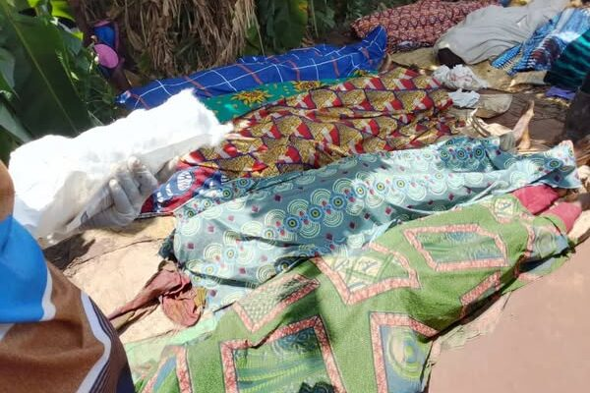

By Kenneth Lutena

Two out of five people struck by lightning at the site of a boat accident in Kawambwa have died.

According to a report from Lukwanga FM, the lightning struck the group of onlookers while they were witnessing the recovery of victims from a boat which capsized on the Kabanda River.

“A lightning strike hit five people, killing two on the spot,” an eyewitness said.

On Monday, 13 people were feared dead after the boat capsized in the Kabanda River.

Kawambwa District Commissioner Godfrey Chibuye confirmed that nine bodies had been retrieved, with a search ongoing for the remaining four.

Sources indicate that four more bodies are yet to be recovered.

WARNING! All rights reserved. This material, and other digital content on this website, may not be reproduced, published, broadcast, rewritten or redistributed in whole or in part without prior express permission from ZAMBIA MONITOR.