Warning after lightning kills two, injures more than ten at festival – South Africa
https://www.ofm.co.za/article/centralsa/340139/warning-after-lightning-kills-two-injures-more-than-ten-at-festival
05 January 2026
The South African Weather Service has issued a serious warning for Monday (05/01) of severe thunderstorms over the central and eastern parts of the country.
The warning, affecting the Free State, eastern parts of the Northern Cape, and North West, follows the incident in which two people died, and more than ten were injured when lightning struck the Dertig sports ground during the Mphebatho Troop Festival in North West on Saturday. Medical teams confirmed that two people died at the scene, said the Moretele local municipality.
Other injured individuals were taken for medical care. Following the strike, officials stopped the festival immediately to ensure the safety of performers, community members, and guests.
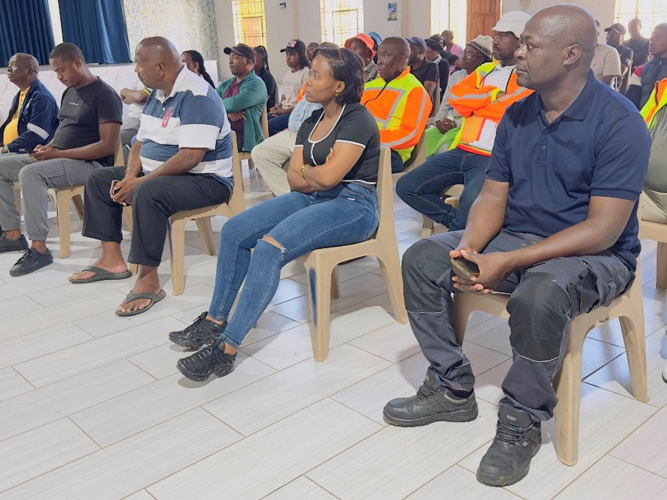
Community members are attending a meeting on the tragedy at Mathibestad municipal hall on Sunday. Photo: Moretele local municipality
Moretele mayor Masango George Manyike held a meeting on Sunday (03/01) at the Mathibestad municipal hall, attended by ward councillors and troop leaders, to hear updates on the tragedy. A report is expected from the department of health regarding the status of those who have not yet been released from the hospital, the municipality said.
After the meeting, Manyike visited the families of the deceased. He went to the Mashishi family in Lefatlheng to pay tribute to Kenoshi Mashishi (35), a teacher who leaves behind a young son. He also visited the Shekwambane family in Dertig to mourn the loss of Koketso Shikwambane (28).

The two deceased. Photo supplied
“The municipality is working closely with emergency services and local authorities,” said the municipality.
North West premier Lazarus Mokgosi planned to visit the families on Monday (05/01). He was scheduled to arrive at the Mathibestad municipality hall at 11:00 before going to the homes of the bereaved.
The community was urged to stay alert as more rain and storms have been forecast for the region today. The Weather Service has activated a cautionary alert for the northeast section of the Northern Cape, as well as the western reaches of the Free State and North West.

Residents should prepare for weather that is highly likely to cause minor disruptions, such as brief localised flooding or slight travel delays, due to potentially heavy rain or wind, the service said. Residents in the Free State, North West, and Northern Cape can, however, look forward to a spell of sunnier weather.
Meteorologists forecast that conditions will stabilise from Tuesday, with clear skies and warmer daytime temperatures spreading across much of the interior.
In the Free State, scattered showers are expected to taper off, giving way to bright sunshine and highs in the upper 20s to low 30s. North West will also enjoy mostly clear skies, with temperatures climbing steadily through midweek.
The Northern Cape is set to remain dry and sunny, with daytime highs exceeding 35 °C in some areas.

