Bad weather: three children die, several people rescued – Algeria
https://lalgerieaujourdhui.dz/intemperies-trois-enfants-decedent-plusieurs-personnes-secourues/
26 September 2025
By Ouamar Benmokhtar
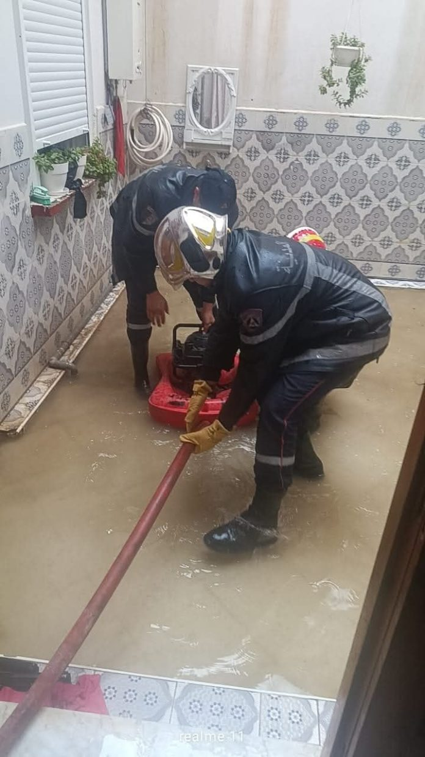
Three children were killed on Friday following the last bad weather recorded in various wilayas in the country. Several people were also rescued by firefighters, the civil protection department said in a statement.
Two of the three deceased children were registered in the locality of Sidi Aissa, in the wilaya of M’sila. The bodies of the two victims, a boy and a girl, aged 3 and 5 respectively, were transported to the morgue of the local hospital, the same source said.
17 people surrounded by water, in their homes for some, following the last rains have been rescued in the same locality, says the civil protection.
A child struck by lightning?
The other child who lost his life this Friday, September 26 because of the bad weather is a 13-year-old boy who will have been the victim of a love at first sight in the commune of Salah Bey under the wilaya of Sétif, according to the same source.
In the wilaya of Meda which also experienced heavy rainfall, two citizens were rescued after being surprised by the floods of a wadi.

Three children were killed on Friday following the last bad weather recorded in various wilayas in the country. Several people were also rescued by firefighters, the civil protection department said in a statement.
Two of the three deceased children were registered in the locality of Sidi Aissa, in the wilaya of M’sila. The bodies of the two victims, a boy and a girl, aged 3 and 5 respectively, were transported to the morgue of the local hospital, the same source said.
17 people surrounded by water, in their homes for some, following the last rains have been rescued in the same locality, says the civil protection.
A child struck by lightning?
The other child who lost his life this Friday, September 26 because of the bad weather is a 13-year-old boy who will have been the victim of a love at first sight in the commune of Salah Bey under the wilaya of Sétif, according to the same source.
In the wilaya of Meda which also experienced heavy rainfall, two citizens were rescued after being surprised by the floods of a wadi.

