**NAMISINDWA: Lightning Strikes Mourners at Funeral Service, Critically Injuring Two – Uganda**<https://eastnews.co.ug/2025/05/06/namisindwa-lightning-strikes-mourners-at-funeral-service-critically-injuring-two/>

6 May 2025

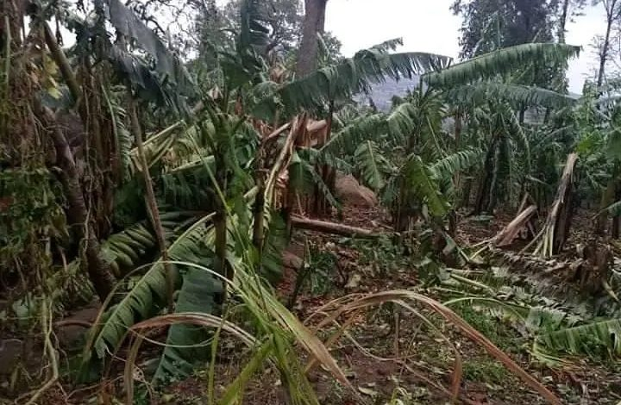 *Effects of the heavy rains in Namisindwa district*

By Weswa Ronnie

A devastating lightning struck mourners during a funeral service at Bumwali 2 village, Kamusayi Parish in Bumbo Sub County, Namisindwa district, injuring two people.

The Monday, 5th May, 2025 incident happened during heavy rains that have also caused widespread destruction in the area.

The victims, Sunday Watuwa and Peter Wambete, residents of Bupoto Sub County, were rushed to Bupoto Health Center III for treatment.

According to LC2 Vice Chairperson of Kamusayi parish, Simon Wefunya, the heavy rains have destroyed crops, including onions, cabbages, bananas, and coffee, in several villages, such as Bumwali 2, Natsekhe, Bumwali 1, Kololo Trading Centre, Bukimatya, and Butindui in Kamusayi Parish, Bumbo Sub County.

The rains also caused flooding of River Namabaya, resulting in the drowning of a 10-year-old boy in Nambaya Sub County. According to James Nakhaima, the LCIII Chairperson, six houses were also destroyed, leaving families without shelter.

Namisindwa District LC5 Chairperson, Jackson Wakwaika, urged sub-county chairpersons and LC1s to register affected individuals and submit reports to the CAO’s office and the district head of disaster.

He says this would enable the district to seek support from the Ministry of Disaster Preparedness.