Ivory Coast: Drama in Mayo, lightning strikes a mother and her daughter in the middle of rice field
https://www.koaci.com/article/2025/06/21/cote-divoire/societe/cote-divoire-drame-a-mayo-la-foudre-frappe-une-mere-et-sa-fille-en-pleine-riziere_187883.html
21 June 2025
By Koaci
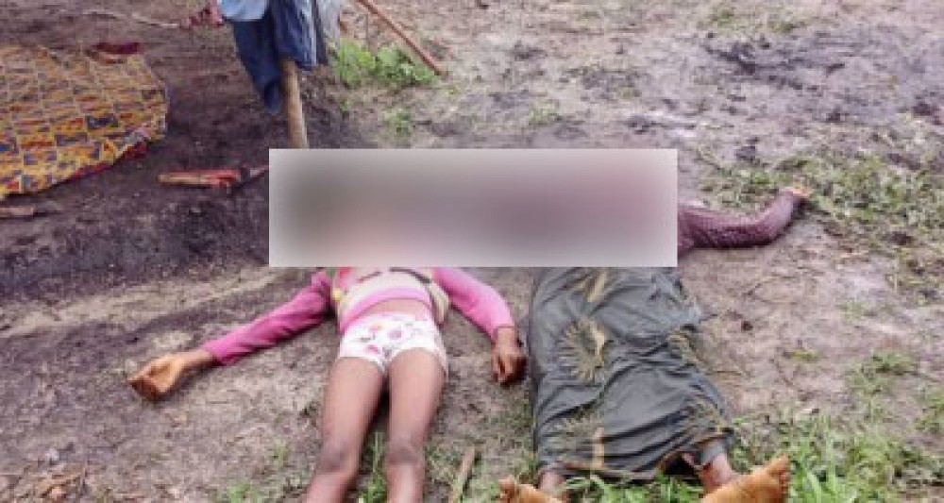
The lifeless bodies of lightning victims (Ph KOACI)
Mayo, a town in the Soubré department, has been living for a few days to the rhythm of mourning and stupor. The village, renowned for its vast irrigated rice field, has become the scene of a drama as sudden as it is tragic, which occurred on Wednesday, June 18, 2025.
That day, Gené, a well-known housewife, had gone as usual to her field, accompanied by her 13-year-old daughter, on school holidays after leaving Abidjan to find the calm of the village. Both monitored crops, watching for pest birds, a daily gesture that became reflex for rice farmers in the region.
But the weather, unpredictable in this season, has deteriorated rapidly. A black sky, a bright wind, then the storm. In this region where we have become accustomed to brave the rain so as not to abandon the crops, the danger was not always perceived to his right measure. Yet on Wednesday, a lightning bolt of a rare intensity struck the stagnant waters of the lower bottom, instantly electrifying the ground. The mother and daughter, caught head-on by the dump, died instantly.

A nearby grower, spared thanks to the unexpected protection of his rubber boots, was violently thrown to the ground but survived. Disoriented, he thought for a moment that Gene had simply moved away. It is by approaching their field that he discovers the irreparable. Alerted by unusual silence, he rushed to the village to warn relatives. When the rescue and gendarmerie arrived, there was nothing left to do.
The girl was buried in discretion, according to the wishes of the family, while her mother's body was transferred to the Yabayo morgue. Since then, the village remains marked by this double loss, a cruel symbol of the unpredictability of the elements. In Mayo, the rice field is now silent, as if frozen by the memory of this fatal day.

