WEATHER - Heavy rains lead to sixteen deaths – Madagascar
https://www.lexpress.mg/2026/01/intemperies-les-fortes-pluies.html
13 January 2026
By Mialisoa Ida

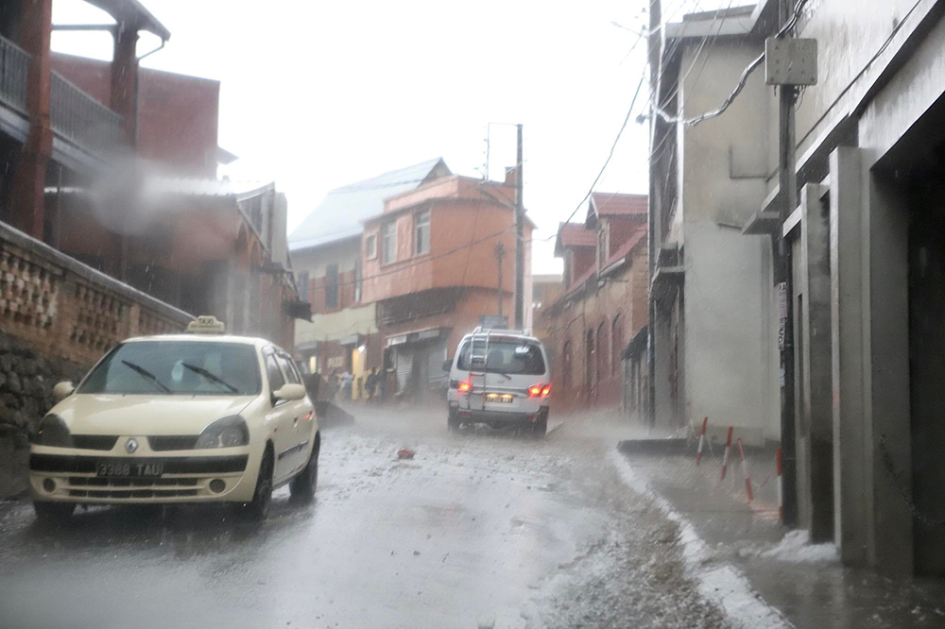
Deaths have been reported as a result of the collapse of homes.
Heavy rains have bereaved the country. Sixteen people lost their lives in four regions, according to the latest report released yesterday by the National Office of Disaster Risk Management (BNGRC).
This episode of heavy rains affected four regions, thirteen districts and fourteen communes. Roads and homes have been invaded by water, turning neighborhoods into devastating torrents and causing widespread collapses and flooding.
The Analamanga region is the most affected, with twelve deaths recorded. In Anjozorobe, five people were killed, including four victims of lightning and another buried after his home collapsed. One death was also reported in Bemasoandro Itaosy, four in Soavina and two in Antananarivo Renivohitra. Outside of Analamanga, one death was recorded in Morondava, one in Betioky Atsimo and two in Ihosy. No cases of disappearance are reported at this time.
Material damage
The death toll also reports 13 injuries. Six victims were taken care of in Antananarivo Renivohitra, three others in Antananarivo Atsimondrano and four in Ihosy.
In total, five thousand eight hundred and thirty-three people, from a thousand five hundred and eighteen households, are affected. Of these, one thousand two hundred and forty-six persons, belonging to two hundred and fifty households, had to be rehoused. Six official accommodation sites were opened, while one hundred and twenty-two victims found refuge with relatives or neighbors. The material damage is considerable: one thousand two hundred and twenty-three dwellings are flooded, thirty-three are damaged and one hundred and twenty-three are completely destroyed.
Faced with the extent of the damage, the authorities call for national solidarity and urge the population to strictly respect the security instructions. Infrastructure clean-up and rehabilitation operations are underway, while rescue services remain mobilized to help the most vulnerable populations.

