WEATHER GURU | Thunder clap puts many Bay residents on edge
Lightning flash density in SA highest at Piet Retief – South Africa
https://www.theherald.co.za/opinion/columnists/2026-02-13-weather-guru-thunder-clap-puts-many-bay-residents-on-edge/
13 February 2026
By Garth Sampson
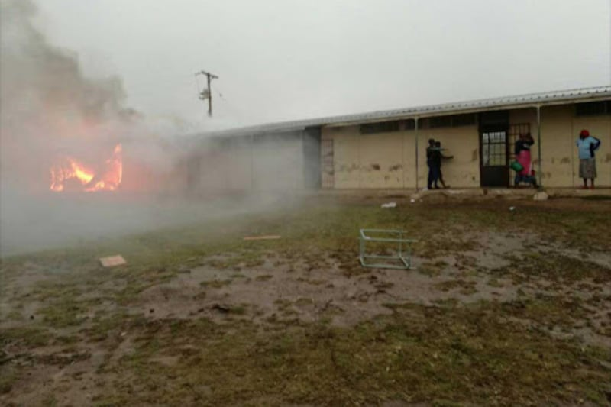
Lightning can cause major destruction, such as this storm in 2017 which destroyed a classroom and a staffroom at Vulingcobo Senior Secondary School in Dutywa. Picture:
That serious crack of thunder last week in Gqeberha had many spilling their sundowners and reset some pacemakers.
Older folks were scurrying to close curtains and the superstitious were covering mirrors.
I almost dived for cover as I thought something had exploded close by.
Just like the previous storm last year, this crack of thunder had a distinctive sound.
As the name suggests, it sounded like the heavens were cracking open.
This usually suggests that it was an intra-cloud event.
Cloud-to-ground usually has a very sharp, explosive crack, followed by rolling thunder and an explosive thud.
I could swear that it occurred directly over my house, a sentiment expressed by many a resident in the city.
I do not think my nerves could handle living on the highveld where, at this time of the year, it is almost a daily occurrence.
Residents there have been complaining that afternoon thunderstorms are now extending into the early hours of the morning.
This often disturbs their peaceful night’s sleep.
Imagine sleeping peacefully and you are awoken by a crack of thunder like we had last week.
Then just as you start dozing off again, another crack of thunder rudely awakens you.
No way, I am a happy chappie living in the Bay.
If we compare the lighting flash density in Gqeberha we can see that lightning is a rare phenomenon, with a density of only 0.5 flashes per square kilometre per year.
Johannesburg sits at 11.7 flashes, while one of the highest densities occurs at Piet Retief, at 15.1.
At the other end of the scale are Paarl, Hermanus and Riversdale, which only have 0.1 flashes per year.
These are cloud-to-ground strikes and exclude cloud-to-cloud activity. Add this up and you have a lot of noise occurring in those high-risk areas.
That is why many insurers require the installation of lightning rods in the high-risk areas, although their efficiency has been greatly debated.
Besides giving us the scare of our lives, keeping many out of sleep and giving insurance companies nightmares, we must bear in mind the number of injuries and fatalities caused by lightning each year.
South Africa has a staggering lightning fatality rate of ranging from approximately 100 to more than 260 deaths annually.
This apparently makes us one of the most lightning-prone countries in the world, with fatalities often underreported.
Experts estimate that for every death, four to seven times as many people are injured or survive lightning strikes.
Most of these fatalities occur in the Eastern Cape, especially the former Transkei and Ciskei region, as well as KwaZulu-Natal.
The rural areas with their rolling hills and valleys and villages perched on hill tops are at high risk.
Add to that no electrification and adequate earthing, and you have a recipe for disaster.
The lightning was not all bad and brought a slight bit of relief in the form of a nice little thundershower.
The airport reported 12mm, although other areas in the metro measured up to just under 20mm.
This is incidentally the highest rainfall that the airport has received since 26 October 2025 when 27mm was measured.
Residents were so hungry for this rain that they posted pictures and videos of themselves under overflowing gutters celebrating the occasion.
No wonder our residents were disappointed in the forecast models which predicted 50 to 120mm over the weekend, which did not materialise.
Apparently the tin brains decided to delay it, but I will only discuss this after the event, if it does, in fact, occur.
On the positive side, places in the Langkloof and especially Bo-Kouga/The Loop measured more than 50mm in an hour on Tuesday evening.
Although this is a bit late for the soft fruit farmers who have had a dismal season with low rainfall, it should give some inflow into the Kouga dam.
Weather Safety Tips:
If the hair on the back of your neck or on your arm rises suddenly during a thunderstorm, run for your life. A lightning strike is highly likely to hit where you were standing.

