Côte d’Ivoire: 6 Children Struck By Lightning, Including 3 Deaths In Boundiali - Côte d’Ivoire
https://afriksoir.net/cote-divoire-6-enfants-frappes-par-la-foudre-dont-3-deces-a-boundiali/
23 April 2025
By Afrik Soir
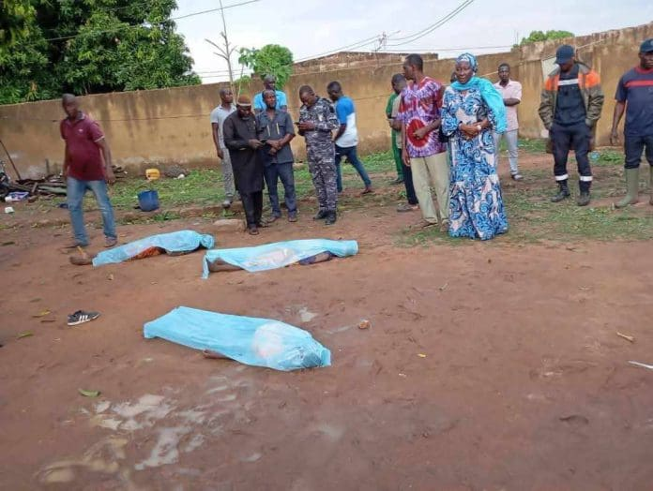
According to the Boundiali Flash News platform, on Tuesday 22 April 2025, six children were struck by lightning, killing three people in Bélé, in Boundiali, in northern Côte d’Ivoire.
A tragedy upsets the town of Boundiali, in northern Côte d’Ivoire. On Tuesday, April 22, 2025, six children were struck by lightning while they had sheltered under a mango tree to protect themselves from heavy rain in the Bélé neighborhood. The death toll is tragic: three of them died there, while the other three were evacuated in emergency to the city’s general hospital by firefighters.
The shock is immense among the population, plunged into stupor and pain. The emotion is all the more intense since the victims are all children, caught unprepared by the sudden violence of the storm. The Minister of National Education and Literacy, Mariatou Koné, also a deputy mayor of Boundiali, reacted with deep sadness on her social networks. “The ways of the Lord are unfathomable. Happy travel my little angels," she wrote on Facebook, paying tribute to the missing young people.
An investigation was opened to shed light on the exact circumstances of the incident. Meanwhile, Boundiali mourns his children, in an atmosphere of grief and meditation.

