Gungu: one person killed by lightning and two other wounded – DRC
https://acp.cd/province/gungu-une-personne-tuee-par-la-foudre-et-deux-autres-blessees/
By ACP
24 July 2026
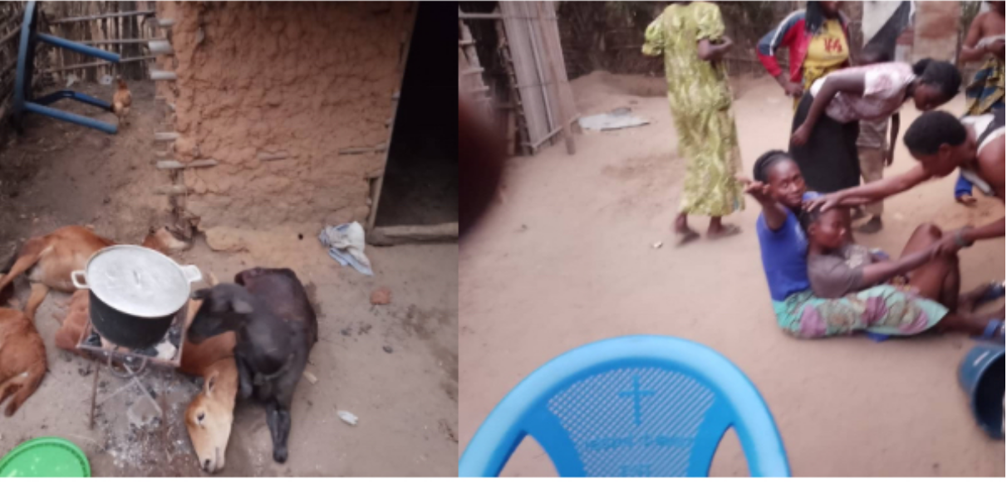
Three people all of the female sex were struck down Thursday in the Lumumba district of Kwilu, in the southwest of the Democratic Republic of Congo, during a torrential rain accompanied by a thunderstorm that fell in this city of Gungu, learned Friday the ACP from administrative source.
“We are surprised by this torrential rain accompanied by a thunderstorm that fell while we are still in the dry season, these three women from the village to celebrate the collation of the academic ranks of a member of the family, were surprised by the lightning, one between them died on the spot, while the other two wounded, were transferred to a health structure of the place for care,” said Arm
This is the second time that lightning has mourned this family. This situation plunges the inhabitants of this neighborhood into total emotion.

