Haut-Uélé: a lightning journalist in Durba - DRC
https://7sur7.cd/2026/07/19/haut-uele-un-journaliste-foudroye-durba
19 July 2026
By Reagan Bin Kakani, Bunia
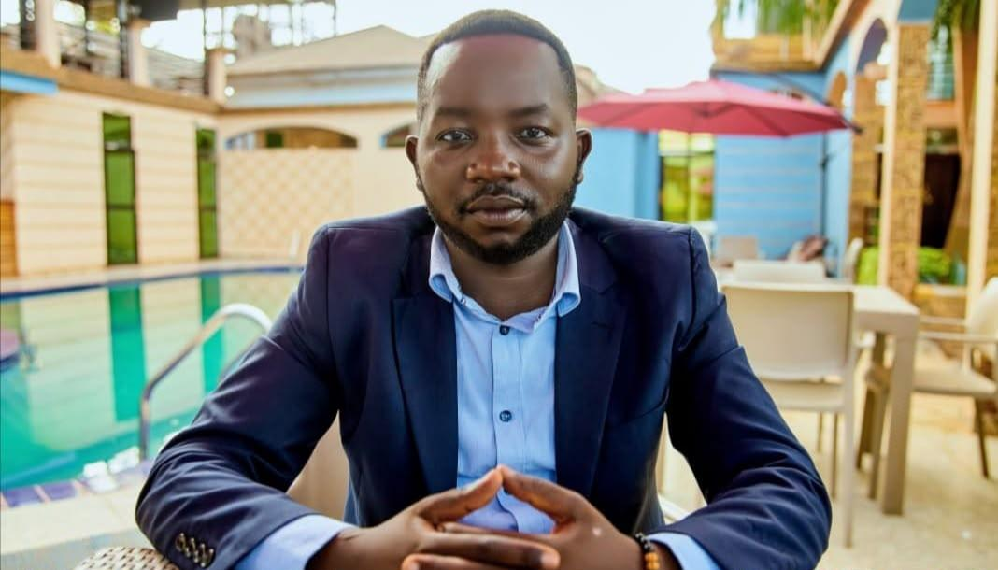
The journalist Xavier Tereka of Radio Rhinocéros and correspondent of the Congolese Press Agency (ACP) in Faradje, in the province of Haut-Uélé, died in the afternoon of Saturday, July 18 after being struck by lightning.
The information was confirmed at 7SUR7. CD by Trésor Agoyo, President of the National Press Union of Congo (UNPC), sub-section of Faradje. According to him, the journalist was the victim of a violent thunderbolt in Durba before being evacuated to the Kibali Hospital Center (CHK), where doctors could only note his death.
"I arrived around 4 p.m. when I was already in Durba when a colleague from Faradje called me to find out about the situation. I immediately took the direction of the hospital where he was transported, unfortunately he had already passed away. He was struck down,” he testified.
The precise circumstances of this accident related to the weather remain to be documented. Meanwhile, several colleagues and media officials in the region pay tribute to the memory of a journalist described as devoted to his profession.

