Vigil 2025 in Mali: torrential rains, collapsed houses, broken lives – Mali
https://saheltribune.com/hivernage-2025-au-mali-pluies-diluviennes-maisons-effondrees-vies-brisees/
30 August 2025
By Sahel Tribune
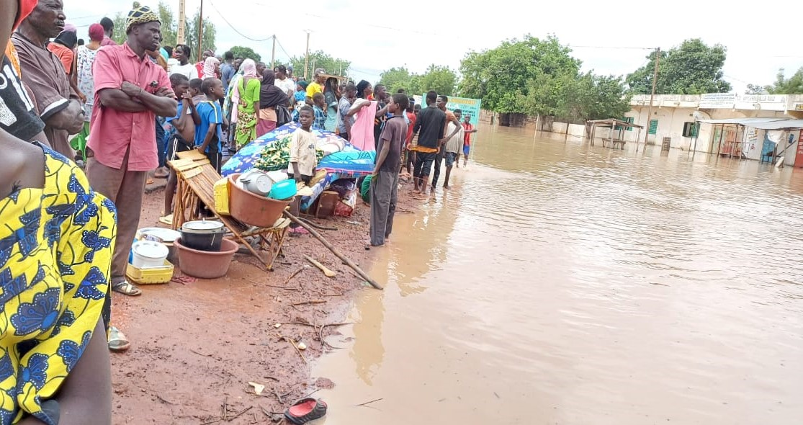
In Mali, the 2025 wintering is a nightmare: 23 dead, 34 injured and more than 16,000 hiteurostage since June. Between torrential rains, collapsed houses and anarchic urbanization, the country is facing a tragedy that goes beyond climate inequality alone.
There are the figures, implacable. And then there are faces, invisible behind the columns of an official communiqué, but that anyone guesses: homeless families, barefoot children in the mud, villages engulfed by floods. By making public, on August 29, its ninth communiqué of the season, the Interministerial Committee for Crisis and Disaster Management only confirmed what all Bamako already feared: the 2025 wintering is being established as a new national tragedy.
A disaster that spares no region
In a single week, from 19 to 25 August, four cases of flooding and the collapse of 438 houses were recorded. Since the beginning of the season, the cumulative tolls have reached 38 floods, 6 cases of lightning and 4 cases of strong winds. As a result, 23 people were killed, 34 wounded and more than 1,105 houses destroyed. The icy figure of 16,437 people, grouped into 2,017 households, shows the measure of a disaster that spares no region of the country.
The words of the Government are intended to be compassionate - condolences to the grieving families, wishes for recovery to the injured - but they are also pragmatic. The authorities are putting forward a series of emergency measures: strengthening civil protection brigades, building stocks of medicines and health inputs, continuing work on the Banconi collector, awareness-raising campaigns relayed to the SOS Security application. The “Citizen Months” project, involving brigaders and volunteers, is presented as a close response to a multi-faceted disaster.
The pedagogy of urgency
But behind institutional mechanics, another truth is needed. Mali pays not only the price of a capricious sky, but also the cost of its precarious planning. The Bamako marigots, saturated from the slightest thunderstorm, testify to the chronic absence of urban drainage. The hydrometric stations sound the alarm: by 22 August, the level of yellow vigilance had already been reached in the capital. The basins of Niger, Senegal and Bani are ploid in higher-than-normal rainfall.
In this context, the list of precautionary statements – not to engage on a flooded road, avoid trees in the event of a thunderstorm, do not touch electrical cables, report any aquatic animals – resemble a survival catalogue. A pedagogy of urgency, which the authorities are repeating tirelessly.
Several ongoing initiatives
Each year, the same scenario is repeated. Torrential rains, collapsed houses, deaths, and hope, every season, that the next will be less cruel. But as the climate goes out of order and infrastructure struggles to keep up with, Malian wintering stops being a mere weather cycle to become a national resilience test. And this test, so far, is more like a permanent ordeal than a future victory.
It should be remembered that, as a result of last year’s floods, the transitional authorities, on the instructions of General Assimi Goita, adopted several measures to mitigate the floods this year. These measures go to support last year’s disaster victims with the demolition of buildings on the roads crossing the waters.

