Lightning kills two children in Pader - Uganda
https://observer.ug/news/lightning-kills-two-children-in-pader/
3 November 2025
By URN
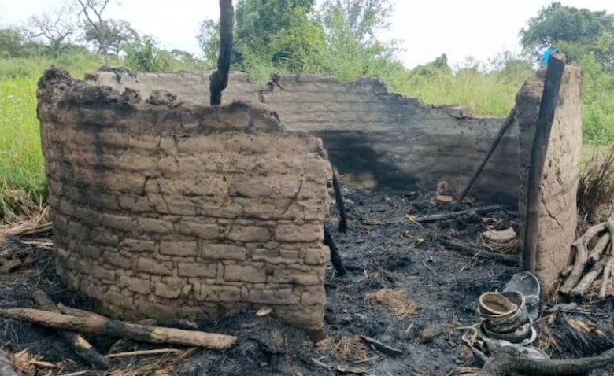
The aftermath after lightning strike
Two children were struck and killed by lightning on Saturday evening in Alipan East village, Pajule sub-county, Pader district in northern Uganda.
The victims, Emily Amaro-rwot, aged 3, and Jacob Omara, aged 8, died instantly around 6 p.m. after lightning struck their grass-thatched house during a heavy downpour. Their mother, Dorcus Adokorach, 25, said she was outside at the time of the incident.
She said that the children had run into the house to take shelter from the rain just moments before tragedy struck. The lightning also ignited a fire that destroyed the family’s modest belongings including four sacks of harvested maize, two sacks of beans, household clothing, cooking utensils, and Shs 500,000 she had earned from selling produce.
Adokorach, who is divorced, now faces the painful task of rebuilding her life from scratch. Pajule sub-county councillor Charles Komakech described the incident as tragic and warned that lightning strikes have become increasingly common in the area.
“Since 2021, we have lost more than three people and five animals to lightning,” Komakech said.
He cautioned residents against taking shelter under trees or in grass-thatched houses during storms. He also called for the installation of lightning arresters in public places and homes.
Officials from Pader district said they currently lack funds to support the bereaved family but appealed to well-wishers and humanitarian organisations to extend assistance to Adokorach.
They urged government agencies to prioritise lightning protection measures in northern Uganda, where communities continue to face severe weather hazards each rainy season.

