**Lightning Strikes, Kills 36 Cattle worth 12 million in Fundong - Cameroon**<https://www.observer237.com/2025/04/lightning-strikes-kills-36-cattle-worth.html>

25 April 2025

By the observer

Over 36 cattle have been struck by lightning in Fundong subdivision of Boyo Division.

The herd of cattle that died instantly is estimated at 12 million Francs.

The lightning strike that came after a heavy downpour, saw the population of Mbongkisu quarter, where the incident happened, go into immediate feasting, with people fighting over the carcasses of the cows.

The Muslim community, owners of the cattle could only watch as it is forbidden for them to eat of such meat. Questions have risen on the safety of meat eaten after such an incident.

While no public statement has been made by the Administrative, municipal and health officials of Boyo, the Division has been known for frequent lightning attacks.

[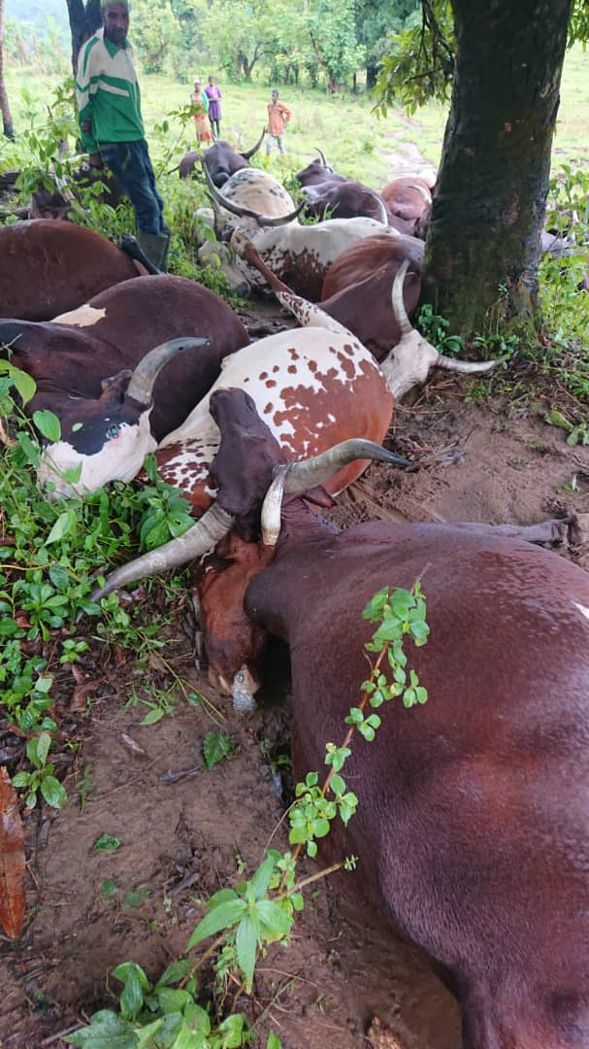](https://lh3.googleusercontent.com/--0vB1uzWUnM/aAs_INl37QI/AAAAAAAAVCc/HK4jNFUTuBgYTB8_VjxBDbHN96sgvp-xACNcBGAsYHQ/s1600/1002244374.jpg)

The lightning strike of Thursday 24th April 2025 comes just few days after a previous lightning strike occurred at Fundong three corners on April 19th with no casualties recorded.

The herd of cattle have been identified to belong to the Ardo of Mentang, Alhadji Idrissu and his partner, Alhadji Hassana.