Mandji: he dies after being struck by lightning - Gabon
https://www.union.sonapresse.com/index.php/fr/mandji-il-decede-apres-avoir-ete-frappe-par-la-foudre
5 April 2026
By The Editorial Board
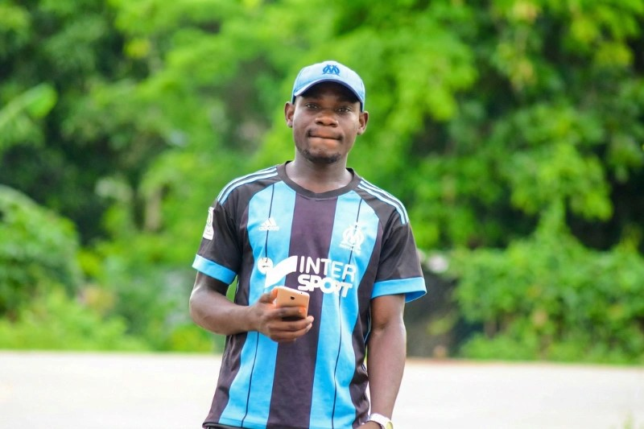
An unusual tragedy left in stir the town of Mandji-Ndolou, Thursday, April 2, 2026, around 2 p.m. Indeed, while he went to the bush for a fishing trip, in the company of two friends, Pachely Gray Kabou Nzamba, a 34-year-old Gabonese, went from life to death after being struck by lightning.
According to a source close to the file, that day, Pachely Gray Kabou Nzamba, Claude Pambou, 30, and Mouloungui Mouloungui, 12, a student in an institution in the square, decide to go to the lake for a part of artisanal fishing. Once at the chosen place, a torrential rain falls in the area accompanied by violent lightning. Anything that then forces the three fishermen to turn back.
But Pachely Gray Kabou Nzamba, who is unfortunately hit by lightning, collapses. While his two accompanying persons, more fortunate, will manage to crawl to the village to alert the parents.
Emergency transport... to a wheelbarrow at the medical center of Mandji Ndolou, the thirty-year-old who is badly burned in the back and fingers, finally goes from life to death. A death confirmed by the doctor. As for Claude Pambou and Mouloungui Mouloungui, they are currently in intensive care in the same health structure.

