14 people killed, 34 injured as lightning strikes church -Uganda
https://www.tv47.digital/14-people-killed-34-injured-as-lightning-strikes-church-76117/
November 3, 2024
By TV47 Kenya
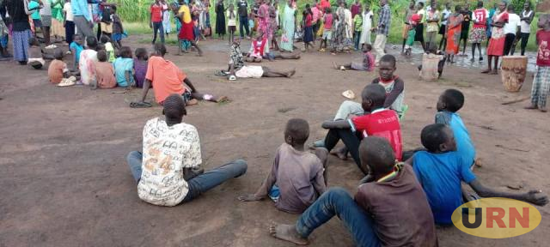
Fourteen people were killed and 34 others seriously injured on Saturday November 2, 2024 after lightning struck a church in Lamwo District, Northern Uganda.
According to Uganda’s police spokesperson Kituuma Rusoke, the incident occurred at around 5:30p.m when the victims had gathered for a prayer service.
“The incident happened during a prayer service at a church in Zone 8, Block 2. in Palabek settlement camp,” Rusoke noted in a statement on Sunday.
“The victims, yet to be identified, had gathered for prayers when the rain started around 5:00 p.m., and the lightning thunder struck (sic) at 5:30 p.m,” he added.
The church is located at the Palabek refugee camp.
In June 2024, a similar incident happened at a school in the Northern Nebbi District, when 77 pupils were injured.
The pupils from different schools were playing in an open field during a games competition when they were struck by lightning.

