REPORT ON THE INSTALLATION OF A LIGHTNING PROTECTION SYSTEM AT BUMANGI PRIMARY SCHOOL, KALANGALA
Date: 04 November 2024

Project Details
- Project Name: Lightning Protection System Installation at Bumangi Primary School
- Location: Kalangala District
- Dates: 28th September - 4th October 2024
- Installer: Isaac Tumuhimbise, Chief LPS Installer
- Project Manager: Omara Martin
Introduction
This report provides a detailed account of the installation of a lightning protection system (LPS) at Bumangi Primary School, located in Kalangala District. The installation was conducted by Isaac Tumuhimbise, Chief Installer, and Omara Martin, Project Manager, under supervision of Barnabas Akantambira, country coordinator ACLENet. The project was completed from September 28th, 2024, to October 4th, 2024, with the primary objective of safeguarding the school buildings and enhancing the safety of both students and staff during thunderstorms.
Lightning poses a significant threat to educational institutions like Bumangi Primary School, often resulting in severe damage to infrastructure and posing risks to life. Recognizing the urgent need for lightning protection, ACLENet undertook this project to install an effective Lightning Protection System (LPS) that would provide comprehensive protection and peace of mind to the school community.
We extend our deepest gratitude to Professor Ken Nixon for his tireless efforts and incredible flexibility in supporting the staff during the installation of the lightning protection system at Bumangi Primary School. His unwavering commitment, expert guidance, and ability to adapt to challenging circumstances were instrumental in the successful completion of this installation project. Thank you, Professor Nixon, for your invaluable contribution and dedication to ensuring the safety and well-being of our school community.
Objectives
The key objectives of the project were:
- Protection from Lightning Strikes: To protect the school buildings and occupants from the harmful effects of lightning strikes. This includes preventing physical damage to structures and ensuring the safety of students and staff during thunderstorms.
- Compliance with Standards: To ensure the installation meets the specifications outlinedin the Thompson Lightning Protection, Inc. drawings. Adhering to these standards guarantees the highest level of safety and effectiveness for the installed system.
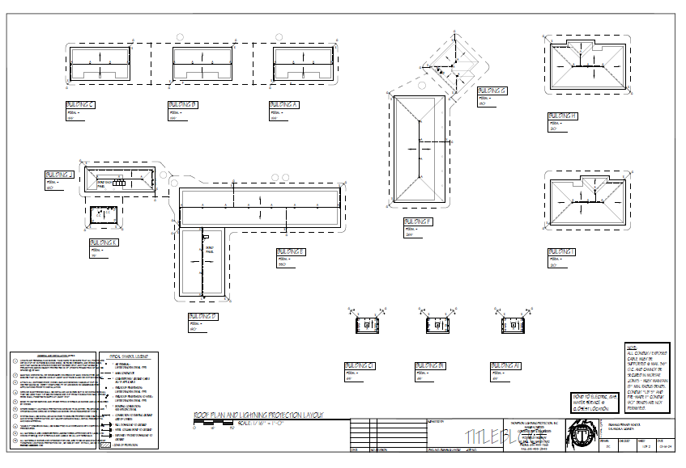Scope of Work
The scope of work for this project encompassed the installation of lightning protection measures across multiple school blocks. Specifically, the protected blocks included:
- Blocks: A, A1, B, B1, C, C1, D, E, F, G, H, I, J, and K.
Each of these blocks was fitted with the necessary components to form a comprehensive lightning protection system. The installation process involved careful planning and execution to ensure all structures within the school premises were adequately protected.
The planning and preparation phase included:
- Initial Site Survey: Conducting a thorough survey and assessment of existing roofing and ground conditions to determine the optimal installation strategy.
- Review of Drawings: Reviewing the Thompson Lightning Protection Inc. drawings and ensuring all regulatory standards and safety protocols were met.
Installation Process
The installation process involved several key steps:
- Air Terminals: Installed according to Thompson Lightning Protection Inc. drawings, ensuring strategic placement to maximize protection.
- Conductors: Laid 10mm² copper-coated wires with precise bending to accommodate the school’s infrastructure, despite challenges with the earth wire.
- Roof Conductor Holders: Fixed to the roof, which presented challenges due to the steep angles.
- Trenching: Dug 0.7m deep trenches for grounding conductors, overcoming obstacles such as rocks in certain areas.
- Testing Joints: Ensured all connections were secure and complied with regulatory standards for maximum safety and efficiency.
Challenges Encountered
The team faced several challenges during the installation:
- Steep Roofing on Blocks F, H, and I: Making it difficult to secure roof conductors.
- Limited Casual Labor: Hiring laborers at a higher cost due to limited availability in the area.
- unfavorable Weather: Rain disrupted the installation schedule.
- Stony Trenches: Difficult digging due to rocks in the trenches.
- Old Chimney on Block K: Required special consideration for installation.
- Straightening Conductors: Difficulty in straightening galvanized conductors.
- Absence of TV Dishes: Initially identified TV dishes were no longer present, necessitating plan adjustments.
- Safety Concerns: No casual laborers willing to climb the steep roofs, highlighting a need for enhanced safety measures.
Results
The installation of the lightning protection system at Bumangi Primary School was successfully completed. The system now ensures a safe learning environment for both students and staff, effectively mitigating the risks posed by lightning strikes.
Recommendations
- Schedule Installations During the Dry Season Conducting installations during the dry season minimizes disruptions caused by adverse weather conditions. This ensures that work can proceed smoothly without delays, reducing the risk of incomplete installations and enhancing the safety of both the installation team and the school community.
- Engage Local Community Helpers It's crucial to select a suitable helpers from the localschool community to assist the chief lightning protection installer with tasks such as clipping lightning conductors on the roofing. This not only provides much-needed support to the installation team but also fosters community involvement. Providing a reasonable allowance for their support ensures fairness and encourages participation.
- Provide Insurance for Installers Given the inherent risks involved in climbing roofs and handling installation tasks, it is imperative to allocate insurance coverage for the installers. This ensures that, in the event of an accident, the installer receives adequate compensation. This measure not only protects the well-being of the workers but also demonstrates a commitment to their safety.
- Ensure Sufficient Funding for Casual Laborers Adequate funds should be allocated for the welfare and allowances of casual laborers. This includes fair wages, proper accommodation, and other necessary support to maintain their well-being throughout the installation process. By ensuring that casual laborers are well-compensated and looked after, the quality and efficiency of the work can be significantly improved.

Installation Details
Materials Used:
- 24x14 ca Alum conductor braided
- Alum adhesive saddle base
- Alum cone /dome saddle base
- Alum flat surface base
- Alum vertical connector point base
- ½” x 12” solid Alum pt blunt tip w/adapter
- ½” x 24 solid Alum pt blunt tip w/Adapter
- Alum adhesive cable holder
- Moisture core sealant
- Alum loop fastener 5/8” wide w/1/4” hole
- No. 14x3/4” SS Hex head Tek screw
- ¼” x 1” SS Nail in anchor
- Alum standard parallel splicer
- Alum bus terminal lug heavy duty
- Alum hinged swivel point to base connector
- Bi metal cu to Alum splicer SS
- Alum small size finger clamp
- Galvanized conductors (Cape electric/ Dehn)
Tools used:
- Wrenches
- Pliers (pumping pliers)
- Screw drivers
- Hammers
- Tap measures
- Levels
- Hack saw
- Cordless drill
- Electrical drill
- AL Ladder
- Grinder
- Glue guns
- Hoes
- Pickaxes
- Spade
Photo Journal
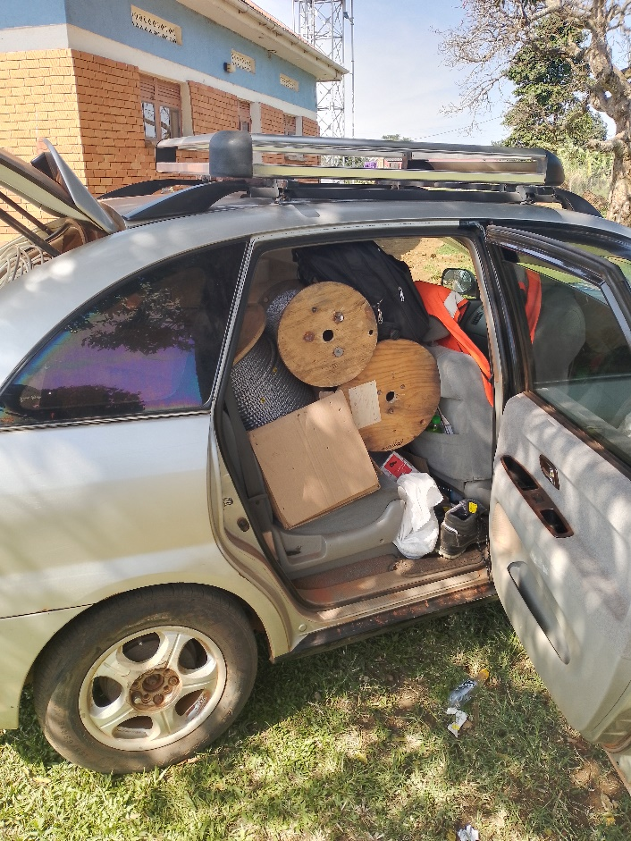
Vehicle loaded with LPS material to Bumangi
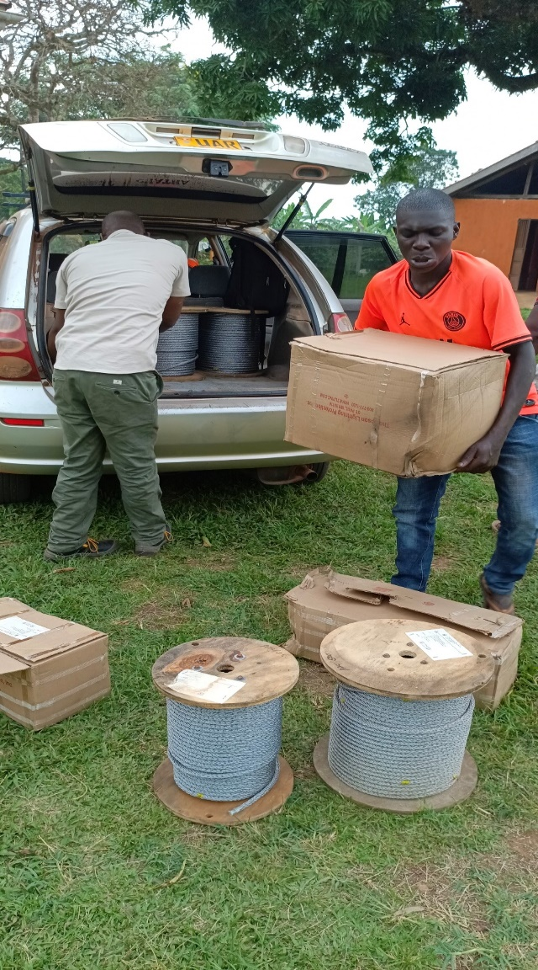
Team offloading LPS materials
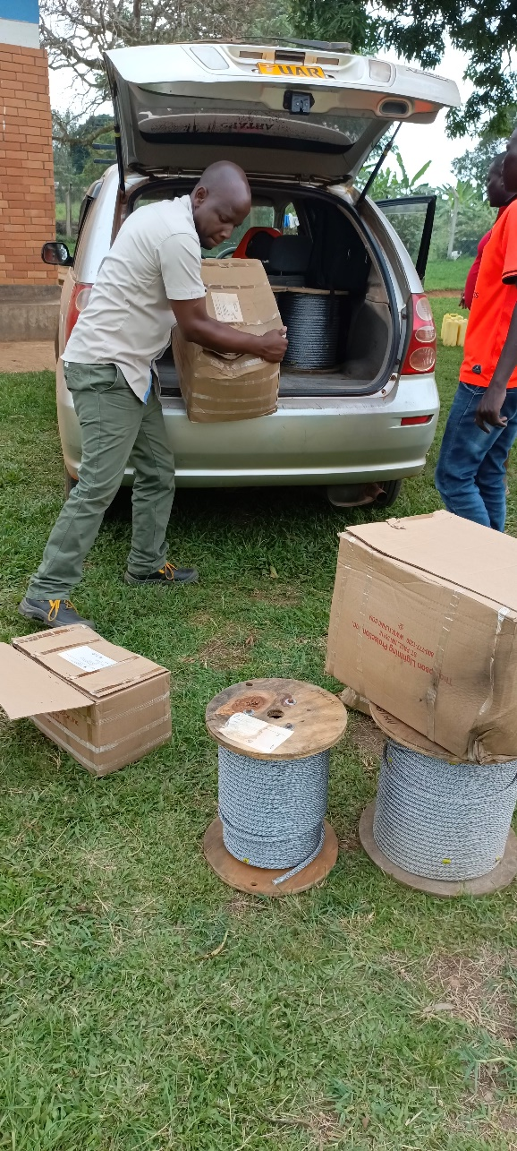
Chief LPS installer offloading materials

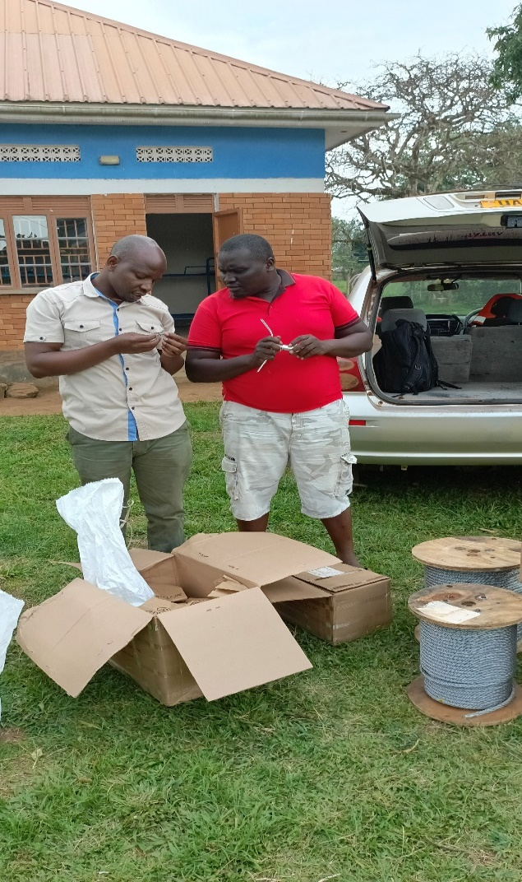
Team verifying LPS materials

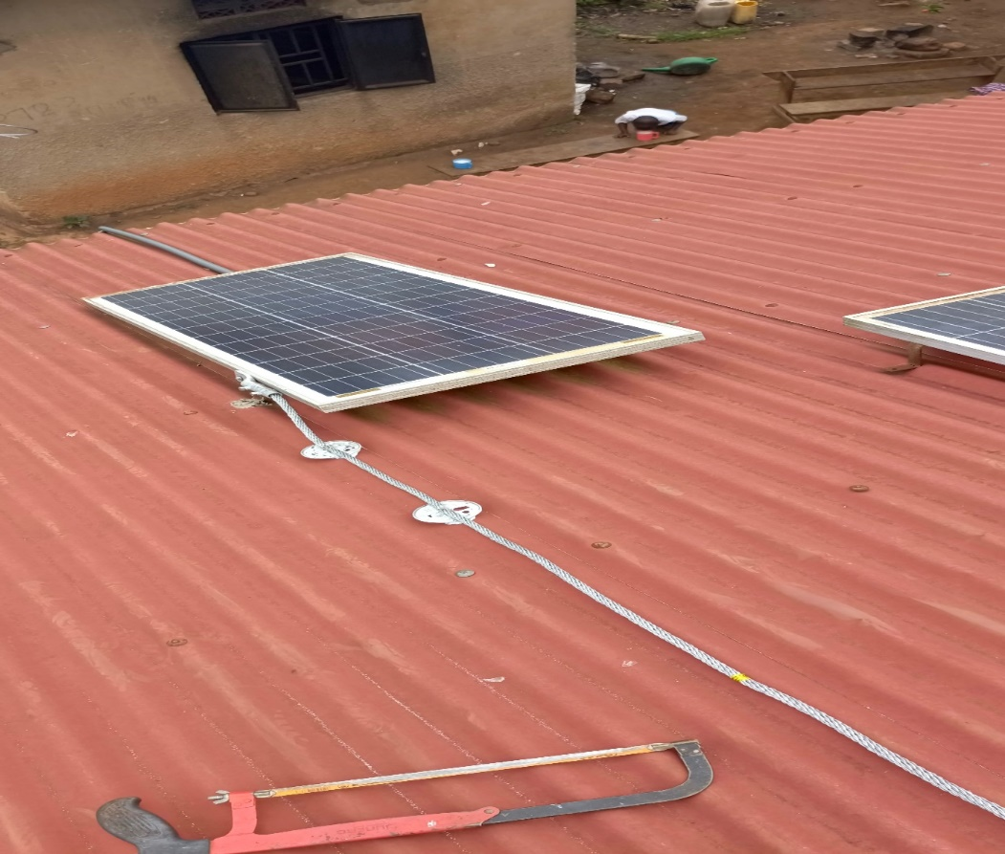
Bonding solar panels on building J

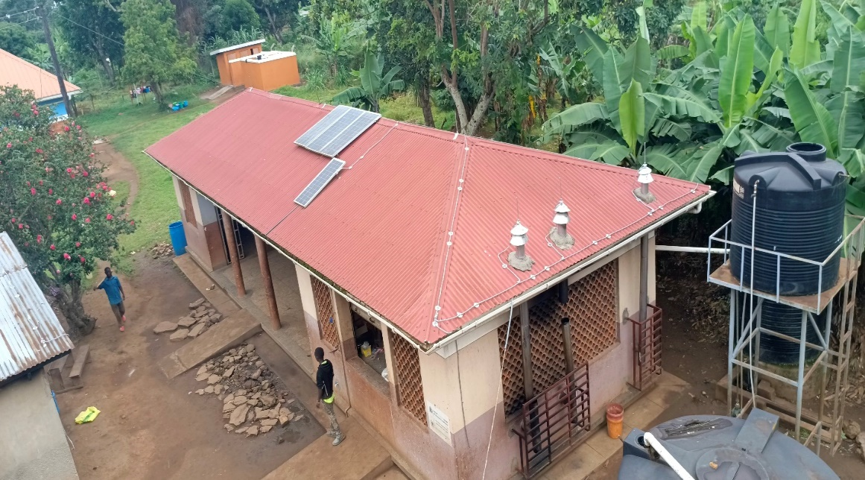
North and Eastern side of building J (Kitchen) after installation.

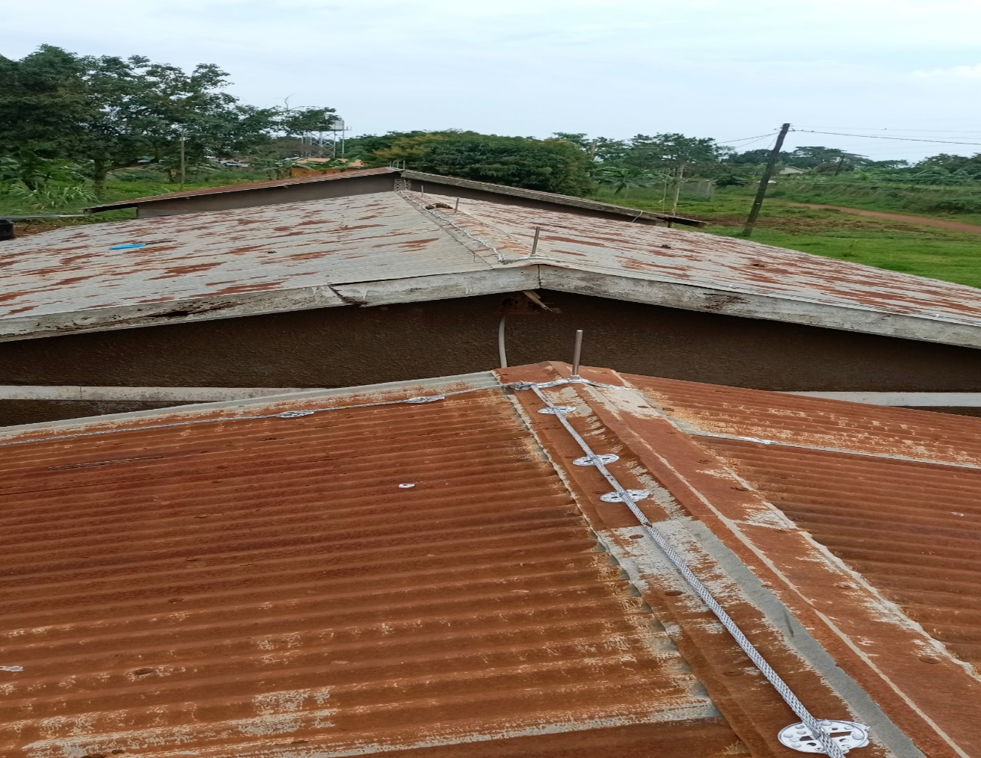
Roof of building A, B and C (staff quarters)

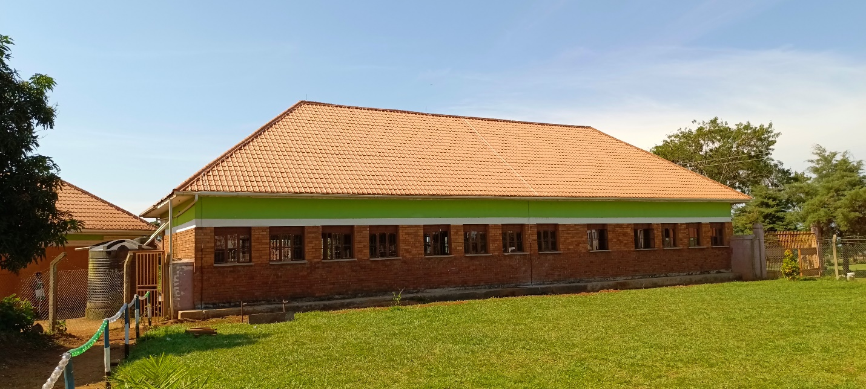
south side of building F (Nursery building)

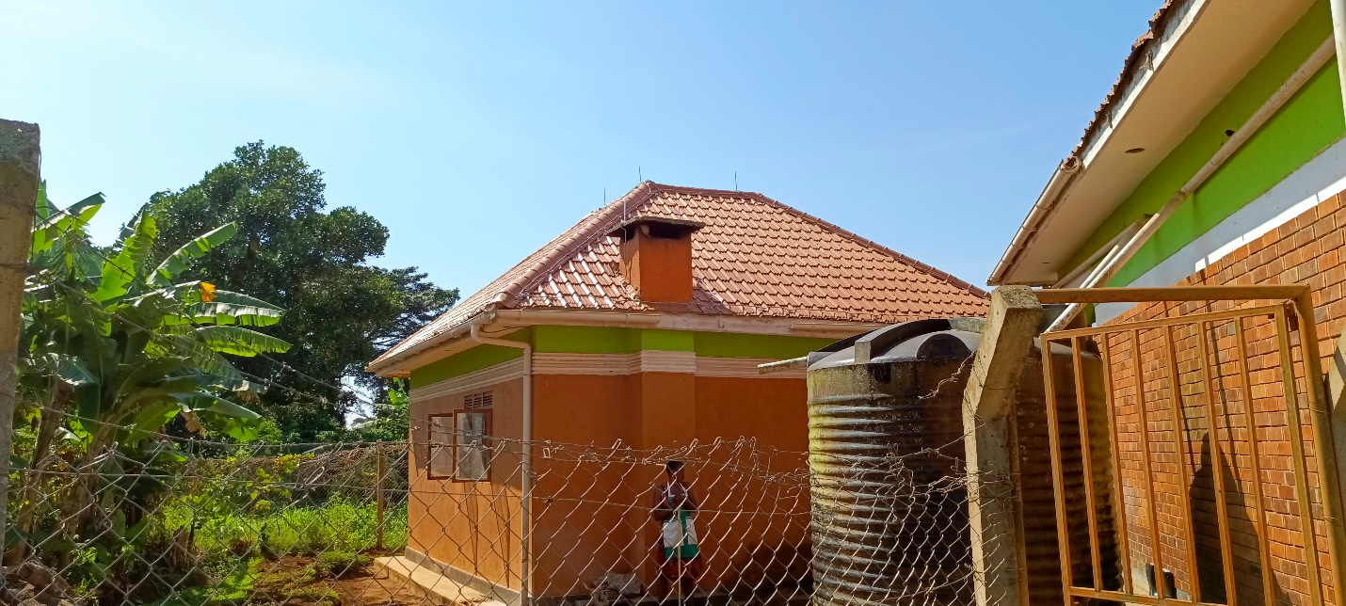
southern side of Building G (Kitchen)

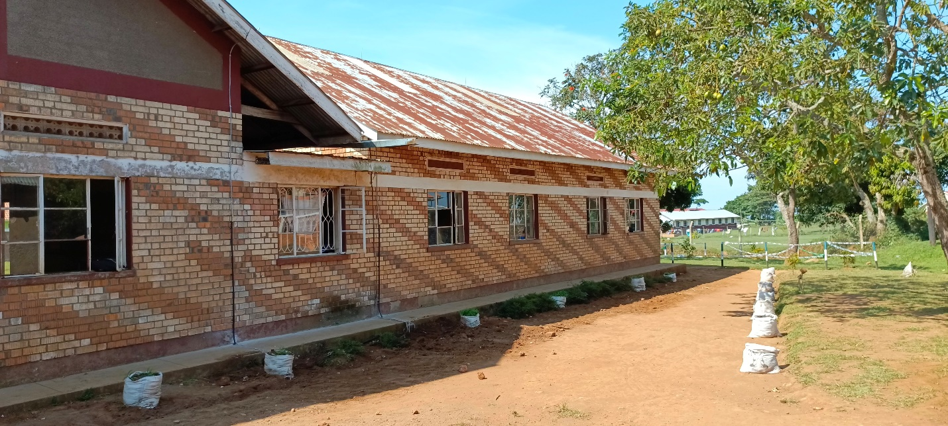
southern side of building E & D

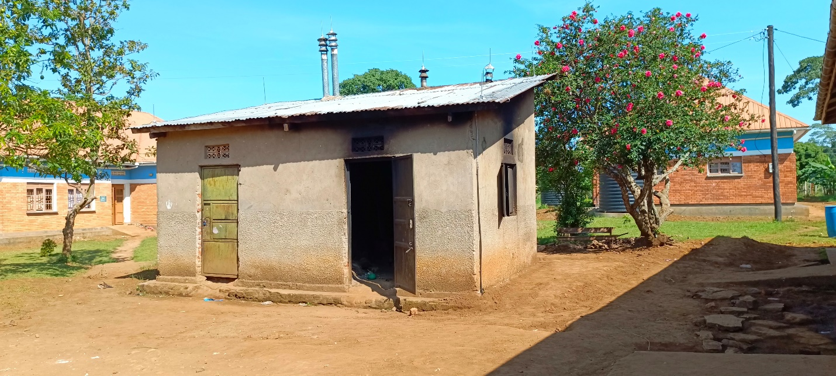
west & Northern direction of building K (Kitchen)
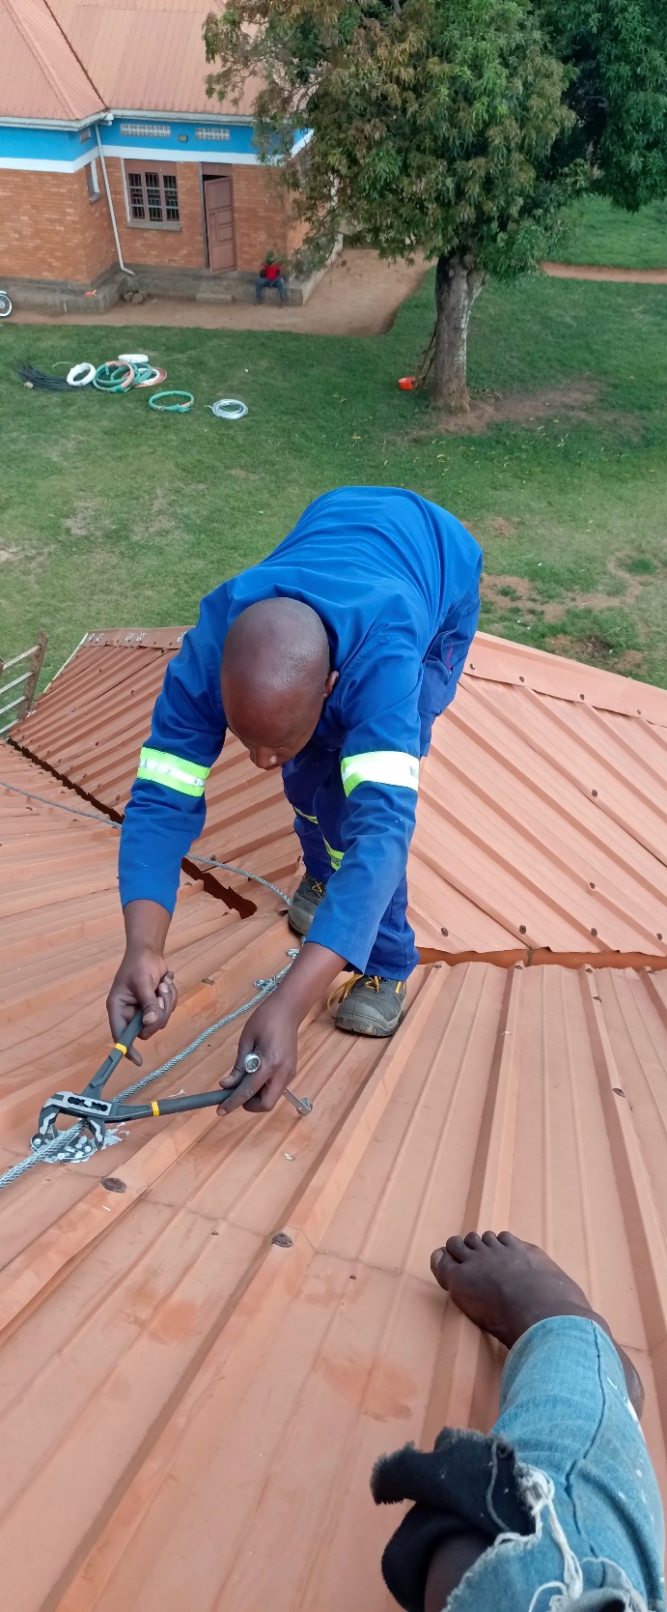
Chief LPS installer clipping roof conductor on H,

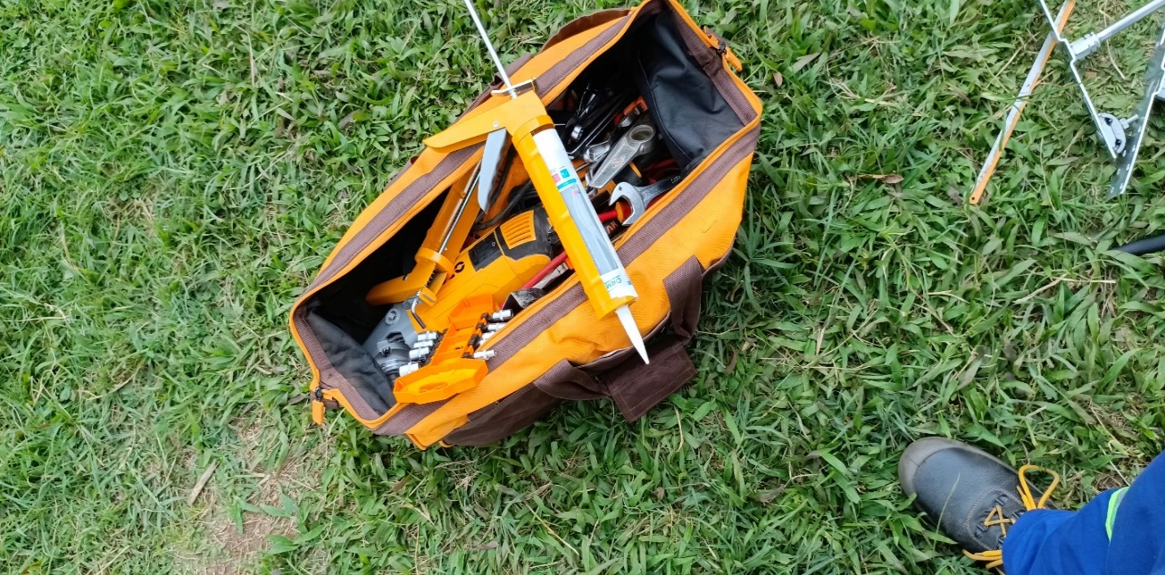
Bag of Tools

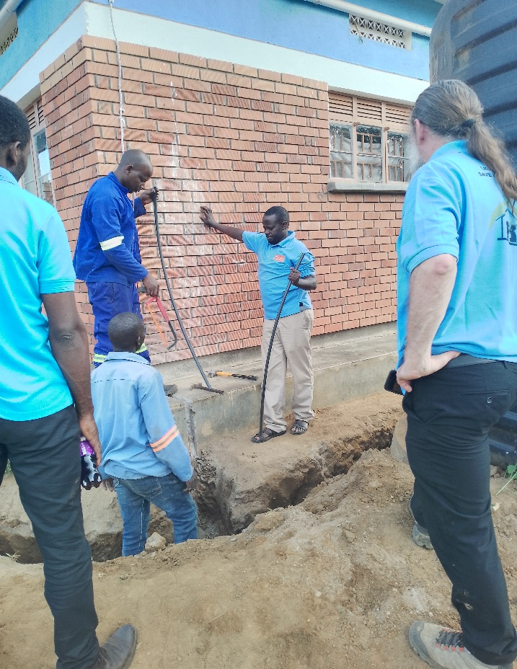

Ken Nixon inspecting installation works

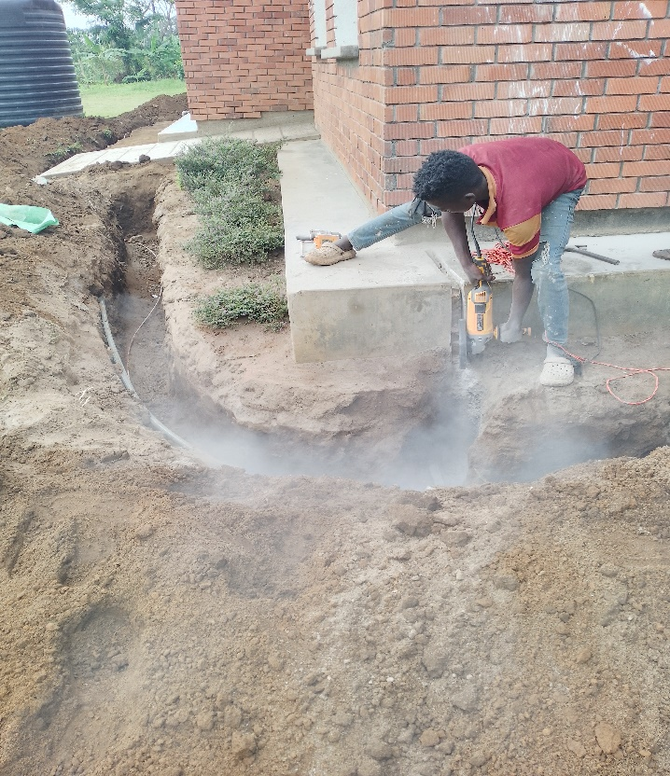
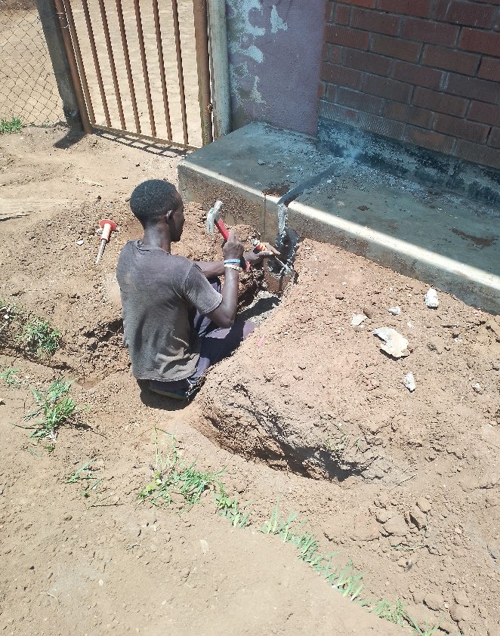
Casual laborers cutting the veranda
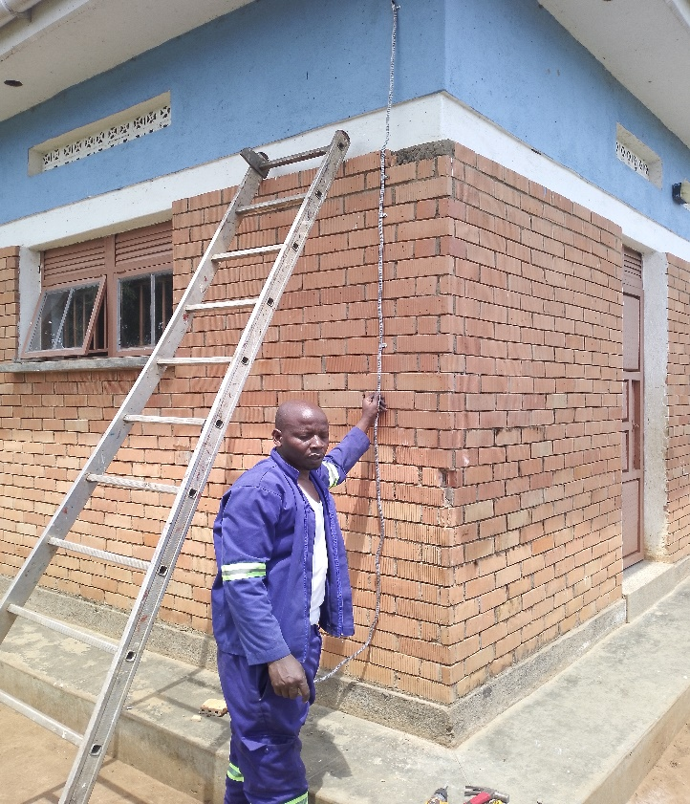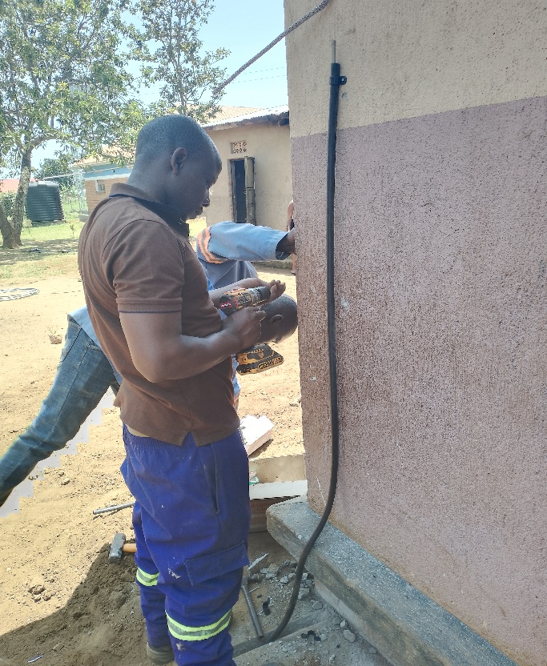
Chief installer fixing down conductors

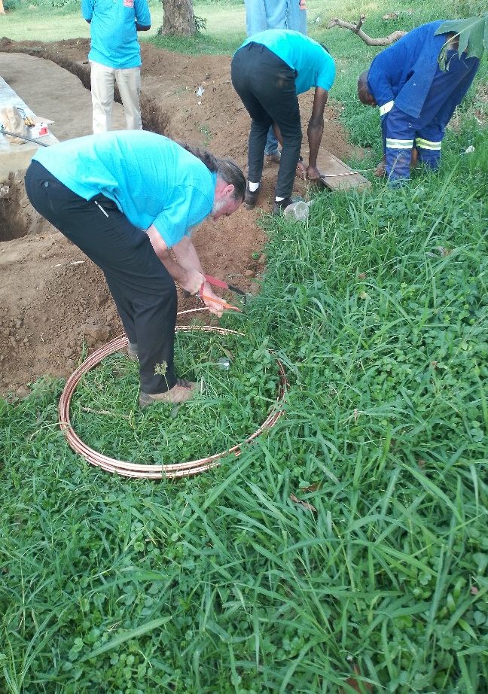
Ken Nixon trying to bond earth ring together with electric earthing
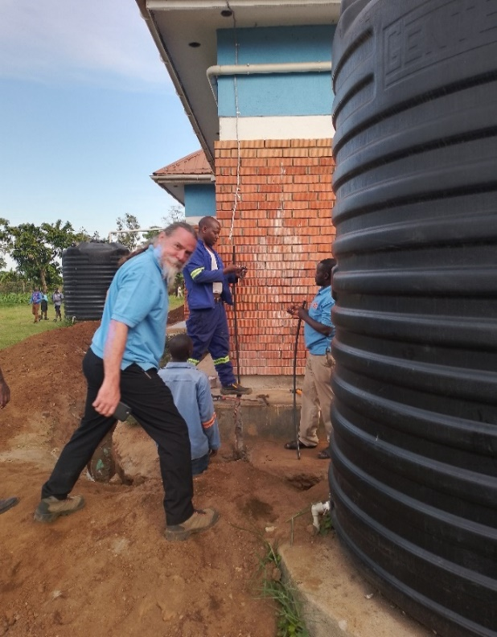
Ken Nixon inspecting installation works
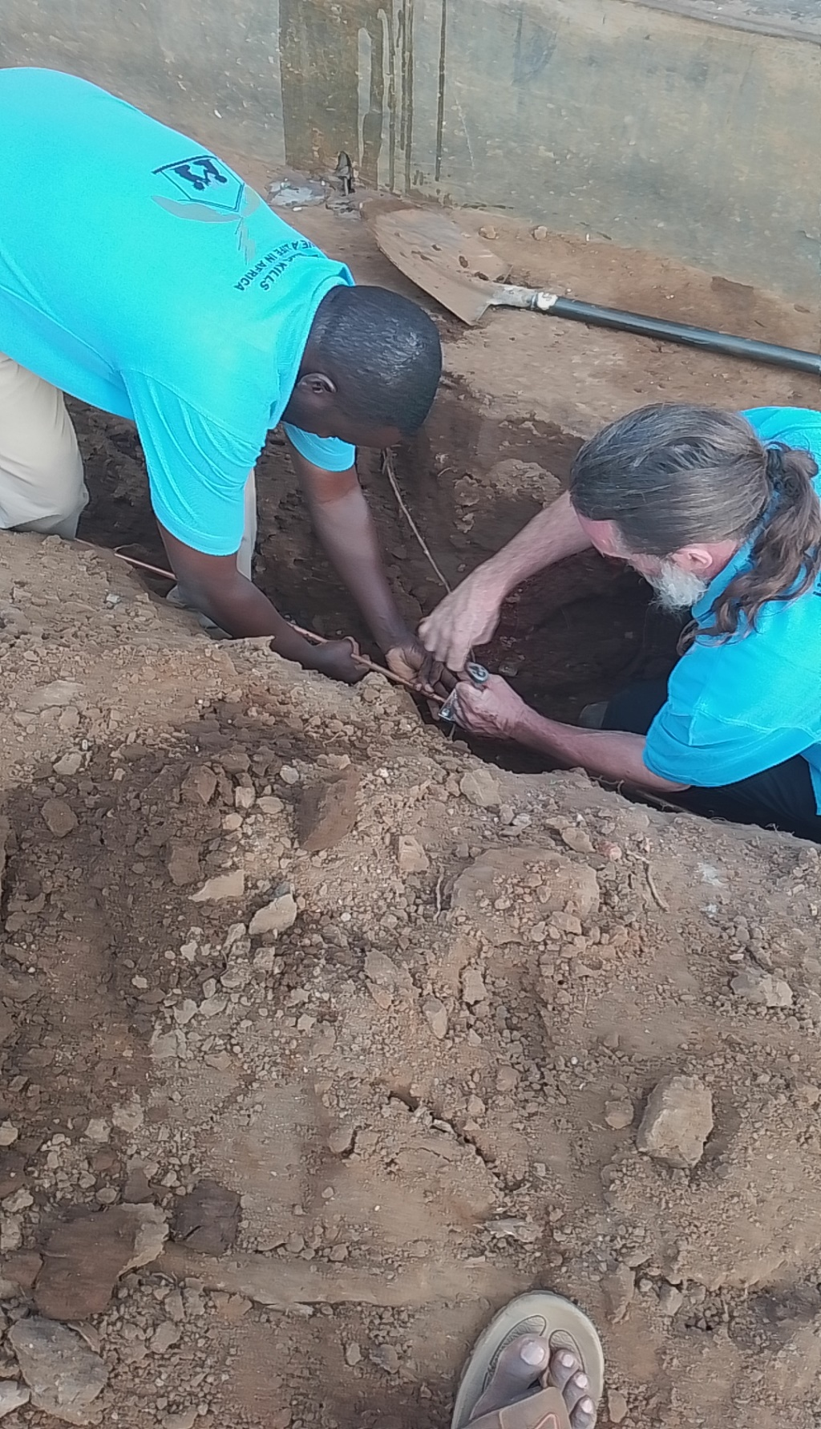
Ken Nixon and Barnabas bonding earth wire with earth ring

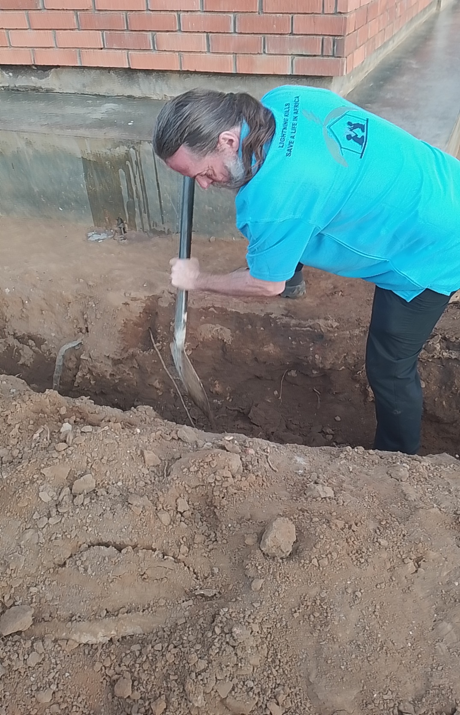
Ken Nixon is trying to widen space for bonding earth ring with earth wire from the building

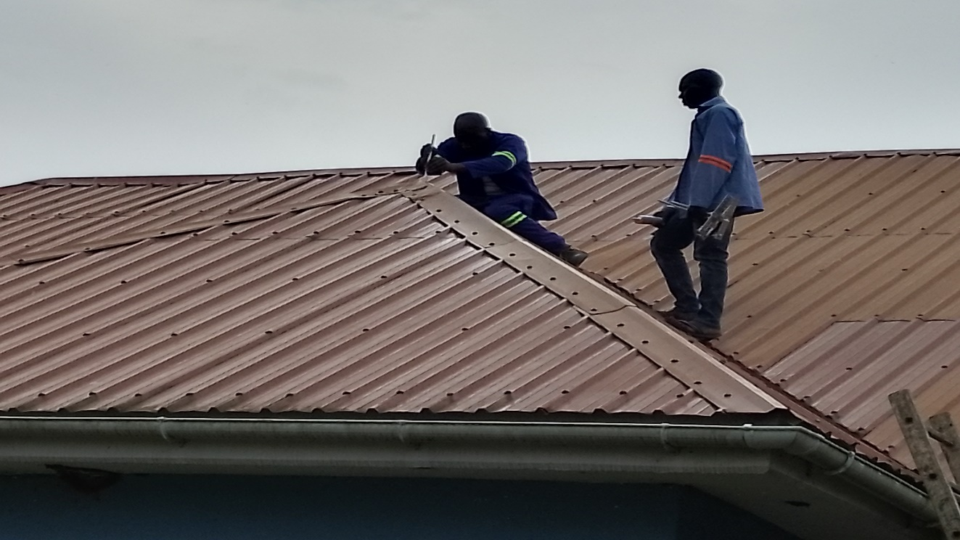
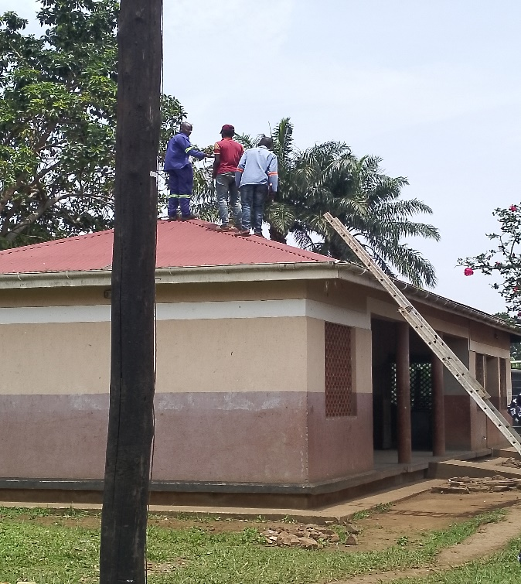
Chief installer with one of the skilled casual laborers on top of the roof

Chief installer with some skilled casual laborers on the roof

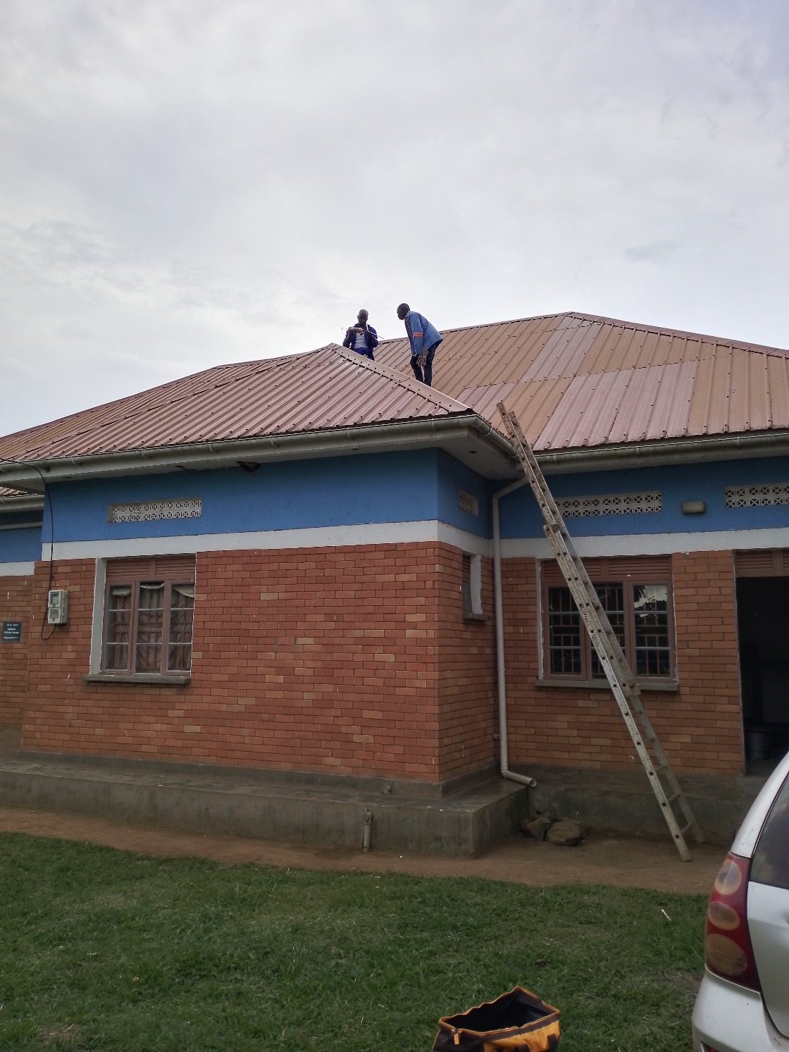
Isaac (Chief installer) and casual laborer on the roof top

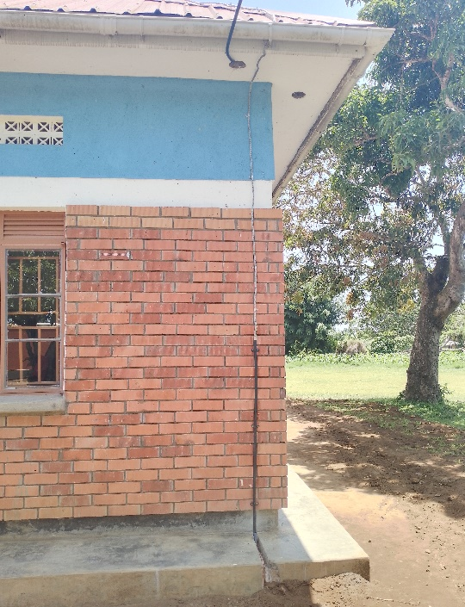
fully installed down conductor on one of the blocks
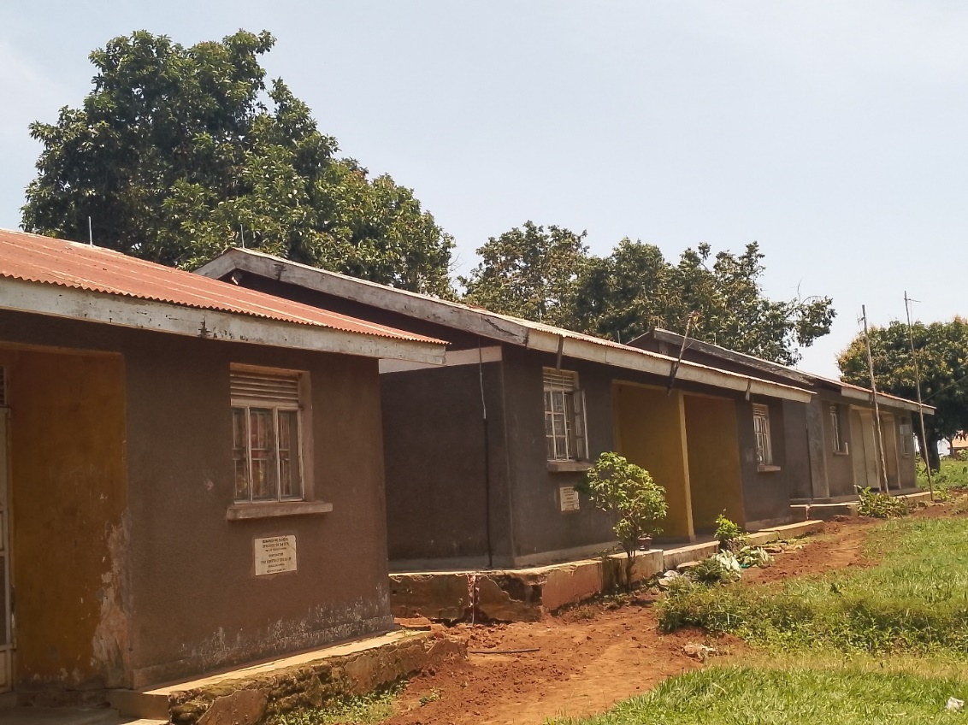
Fully installed staff quarters (front side)
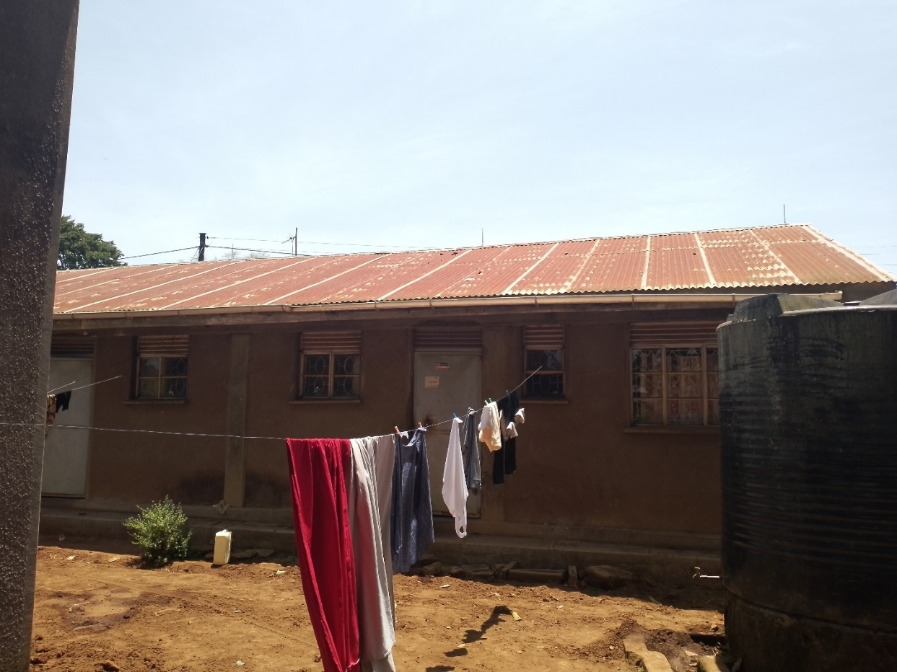

Fully installed Staff quarters (behind side)

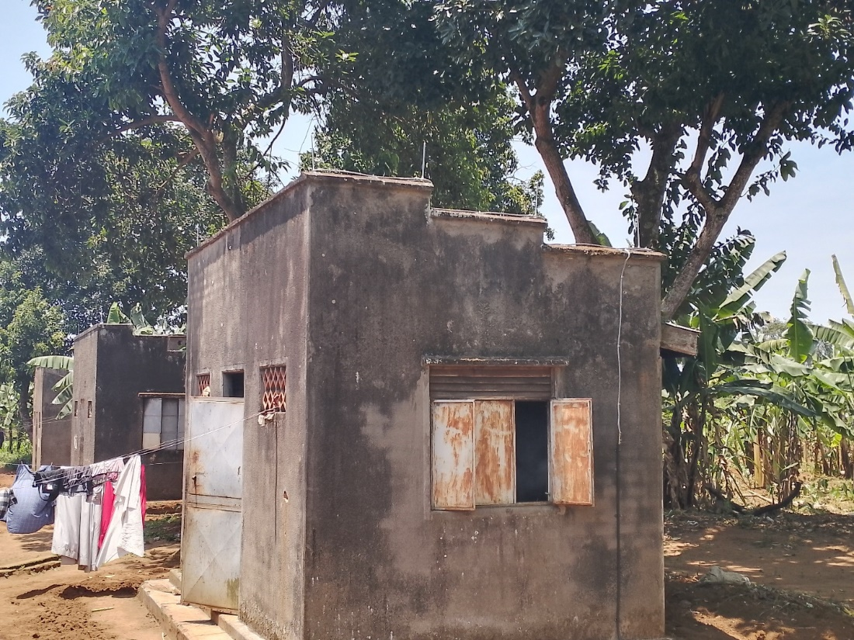

Front side of Staff Quarter Kitchen
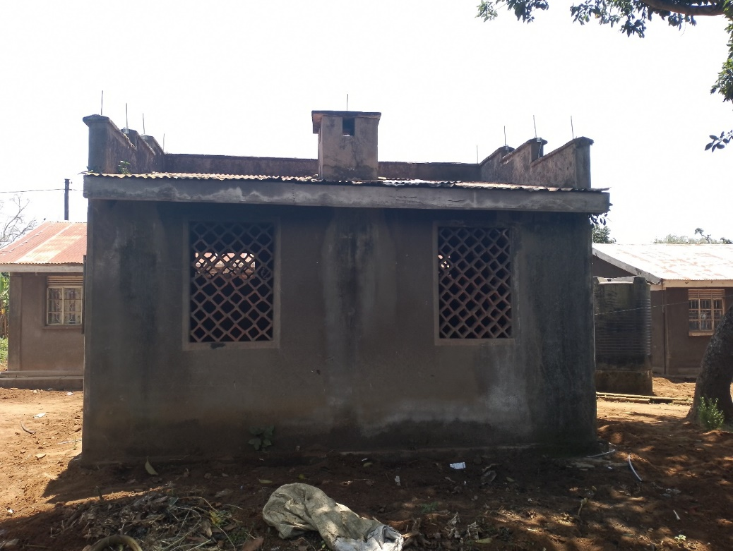

Back side of Staff Quarter Kitchen

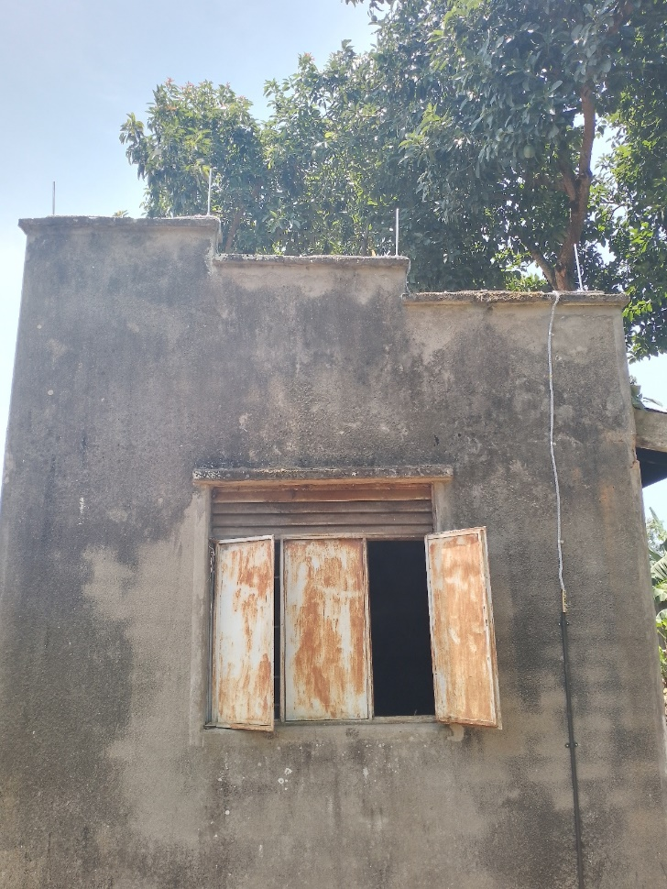

Fully installed Staff kitchen (western side)

Certification
I, Isaac Tumuhimbise, Chief LPS Installer, certify that the lightning protection system at Bumangi Primary School was installed in full compliance with Lizardo’s design and specifications.
Conclusion
The installation of the lightning protection system (LPS) at Bumangi Primary School in Kalangala District has significantly enhanced safety during thunderstorms. Conducted by ACLENet from September 28th to October 4th, 2024, this project protected the school's infrastructure and ensured the safety of students and staff.

Key Highlights:
- Thorough Planning: Comprehensive site survey and adherence to Thompson Lightning Protection Inc. standards ensured a smooth installation.
- Effective Execution: Despite challenges like steep roofing and adverse weather, the team successfully installed high-quality materials and equipment.
- Community Engagement: Training sessions for parents, staff, and students were well-received, fostering a culture of safety.
- Recommendations: Future projects should consider dry season scheduling, local helpers, insurance for installers, and adequate funding for labourers.

A huge thank you to Thompson Lightning Protection Inc. for their invaluable support and exceptional design standards, which were instrumental in the successful installation of the lightning protection system at Bumangi Primary School.

Compiled By

- Chief installer - Isaac Tumuhimbise

- Project manager - Omara Martin

Edited/ Reviewed By
- Country Coordinator - Akantambira Barnabas.

