Lightning Strike Kills Young Man & Horse In North Bank – Gabon
https://jollofnews.gm/lightning-strike-kills-young-man-horse-in-north-bank/
11 September 2025
By Ousman A. Marong
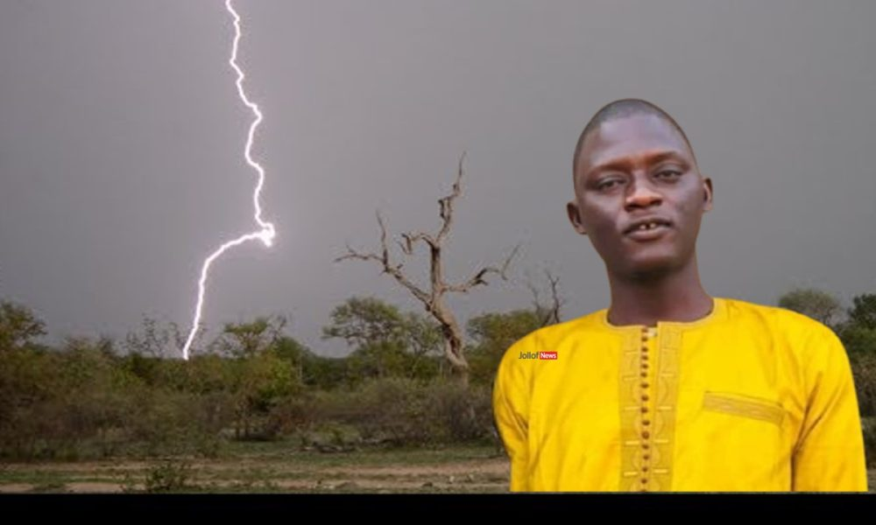
A deadly bolt of lightning tore through Madina Sering Mass in Gambia’s North Bank Region, killing a young man, Papa Jobe, and his horse in an instant.
The storm rolled in without warning, unleashing sheets of rain and violent thunder. Jobe was riding home through the bush when the lightning struck, electrocuting both him and the animal on the spot. The sudden death has shocked the village, leaving family members and neighbours in mourning. “It was terrifying. Nobody expected it to happen so fast,” one resident told JollofNews.
Local authorities confirmed the incident was caused by a lightning strike and described it as a natural disaster. Funeral arrangements are under way as the community rallies around the grieving family.
This is not the first time The Gambia has witnessed such a tragedy. In recent years, lightning has claimed several lives across the country, particularly in rural communities. In 2022, three people were killed in the Upper River Region when lightning struck a village during a heavy downpour. Similar cases have been reported in Central River Region and the West Coast, often during the peak of the rainy season.
Experts warn that The Gambia, like many parts of West Africa, is highly prone to severe thunderstorms between June and October. With little infrastructure to provide lightning protection in rural areas, communities remain vulnerable.
For residents of Madina Sering Mass, the death of Papa Jobe is a painful reminder of how quickly nature can turn deadly. As one villager put it: “The rain gives us life, but it also takes life away.”

