11 killed by rain-induced disasters in February – Rwanda
https://www.africa-press.net/rwanda/all-news/11-killed-by-rain-induced-disasters-in-february
25 February 2026
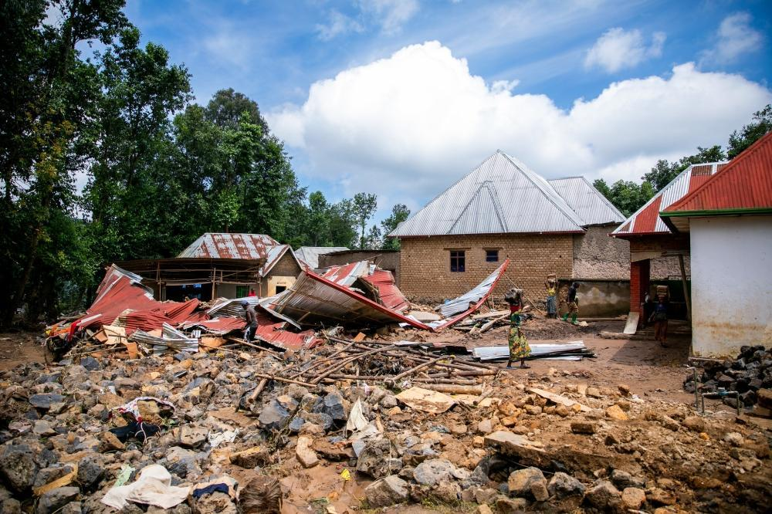
11 killed by rain-induced disasters in February
By Africa-Press – Rwanda.
At least 11 people have been killed and about 130 hectares of crops have been washed away by rain-indused disasters across the country between February 1 and 22, according to the Ministry of Emergency Management (Minema).
The data obtained by The New Times shows that eight people were killed by lightning strikes, two by landslides, while another person drowned in floodwaters.
Rutsiro District recorded the highest number of fatalities with five deaths, followed by Nyarugenge with three and Huye with two.
During the same period, 49 people were injured, while 147 houses were damaged. The worst-hit districts were Gasabo, Gicumbi, Kayonza and Nyabihu.
The rains also damaged nine classrooms, affected 10 road sections, and swept away 21 bridges. In addition, 12 head of cattle were lost, according to the ministry.
Rwanda Meteorology Agency has forecast above average rainfall for the period between late February and May.
Forecast for March to May indicates rainfall totals ranging between 280 and 800 millimetres, slightly higher than the long-term average of 270 to 770 millimetres.
Between February 21 and 28, the country is expected to receive 80 to 150 millimetres of rainfall, significantly above the 30-year average of 10 to 80 millimetres.
The ministry has warned disasters such as landslides, flooding, lightning, strong winds, and hailstorms, which often result in deaths, injuries, destruction of homes, damage to crops and infrastructure, and environmental degradation.
Rwandans were urged to check the homes and other buildings that show signs of structural weakness, especially old houses, those without foundations, homes built below embankments, near rivers, wetlands, and lakes, or those lacking proper drainage.
Residents were also advised to vacate homes exhibiting visible cracks, leaking walls, or any signs of collapse.
Minema also cautioned against attempting to cross overflowing rivers, streams, and bridges, and called on parents and guardians to assist children when commuting to and from school in flood-prone areas.
People were further advised to avoid using wetlands and waterlogged paths during heavy rainfall, drive with extra caution on slippery roads, keep children away from open water pits and trenches at home, handle electrical appliances carefully during thunderstorms, and stay away from fallen or exposed electricity lines and damaged poles.
Other recommended actions include clearing rivers and streams blocked by soil and waste, stabilising slopes and embankments near homes, avoiding dumping waste in drainage channels, and installing and maintaining lightning conductors where possible.
Local leaders were also called upon to intensify disaster prevention efforts by organising community work to clear drainage systems, temporarily relocating households in high-risk zones, preparing rapid response mechanisms for emergencies, identifying disaster-prone areas, and supporting residents to apply preventive measures.

