Report on Runyanya-Kiryandongo Public Education and Community Engagement


Runyanya Primary School, Kiryandongo District
Program: Education and Community Engagement
Dates: 11th – 12th August 2025
Prepared By: Godwin Atwiine, Education Coordinator
Edited By: Akantambira Barnabas, Country Coordinator
I. Introduction
Kiryandongo District, Uganda, is highly prone to lightning strikes, with notable incidents recorded in the past. On 28th June 2011, a tragic lightning strike at Runyanya Primary School resulted in the deaths of 18 children and injured 38 others, a nurse was injured by a lightning strike at the same school. These incidents raised the urgent need for lightning education and awareness program. The African Centres for Lightning and Education Network (ACLENet) is committed to reducing lightning-related damages through community sensitization and the installation of lightning protection systems. On 11th and 12th August 2025, the ACLENet team, including Mr. Barnabas Akantambira (Country Coordinator), Dr. Tony Lusambu (Board Representative), and Mr. Godwin Atwiine (Education Coordinator), visited Runyanya Primary School to conduct public education and engage with stakeholders such as district leaders, parents and teachers. This report details the activities and outcomes of the visit.
the program saw promising attendance across various groups, with
13 staff members, 6 PTA representatives,
52 parents, and
832 children participating.

II. Program Objectives
The visit aimed to achieve the following:
- Promote Lightning Safety Awareness: Educate pupils, staff, and the community on lightning safety measures.
- Community Sensitization: Engage district leaders to enhance community-wide lightning hazard awareness.
- Empower School Leadership: Build the capacity of school leaders and staff to sustain lightning safety initiatives.
- Expand Outreach: Extend lightning safety awareness to communities beyond the school level.
III. Activities
Day 1: 11th August 2025
A. Meeting with District Leaders
The ACLENet team met with Rev. Edward Kiirya, District Education Officer (DEO), to discuss lightning safety initiatives. The DEO acknowledged the significance of ACLENet’s installation of the district’s first standardised lightning protection system at Runyanya Primary School, which serves as a model for other institutions. Mr. Barnabas thanked the DEO for resolving past misunderstandings at the school, enabling ACLENet’s continued engagement. Dr. Tony emphasized ACLENet’s commitment to working with willing partners despite its limited budget and non-profit status. The team proposed an addendum to formalize collaboration with the district, which the DEO agreed to forward to the Chief Administrative Officer (CAO) for signing.
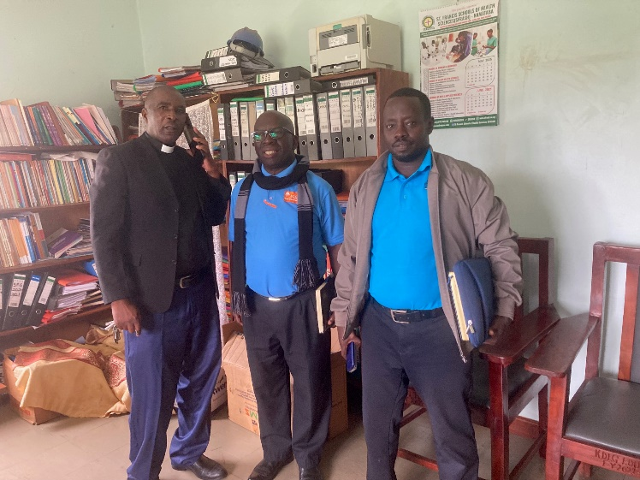
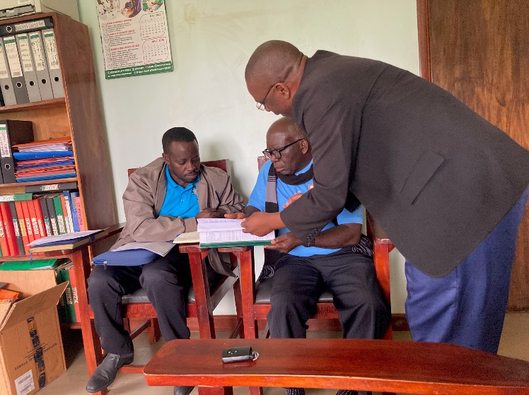
DEO Rev. Edward Kirya, Dr. Tony, Mr. Barnabas, reviewing and discussing the addendum
B. Meeting with the Chief Administrative Officer (CAO)
The team, accompanied by the DEO, met with Mr. Anselm Kyaligonza, the CAO. Mr. Barnabas provided an overview of ACLENet’s mission and its history in Kiryandongo, particularly the installation of the lightning protection system following the 2011 tragedy. The CAO expressed the district’s readiness to collaborate with ACLENet, noting that while district regulations require NGOs to pay a fee of one million shillings and submit work plans to the district, he would expedite the addendum’s approval to prioritize lightning safety initiatives.
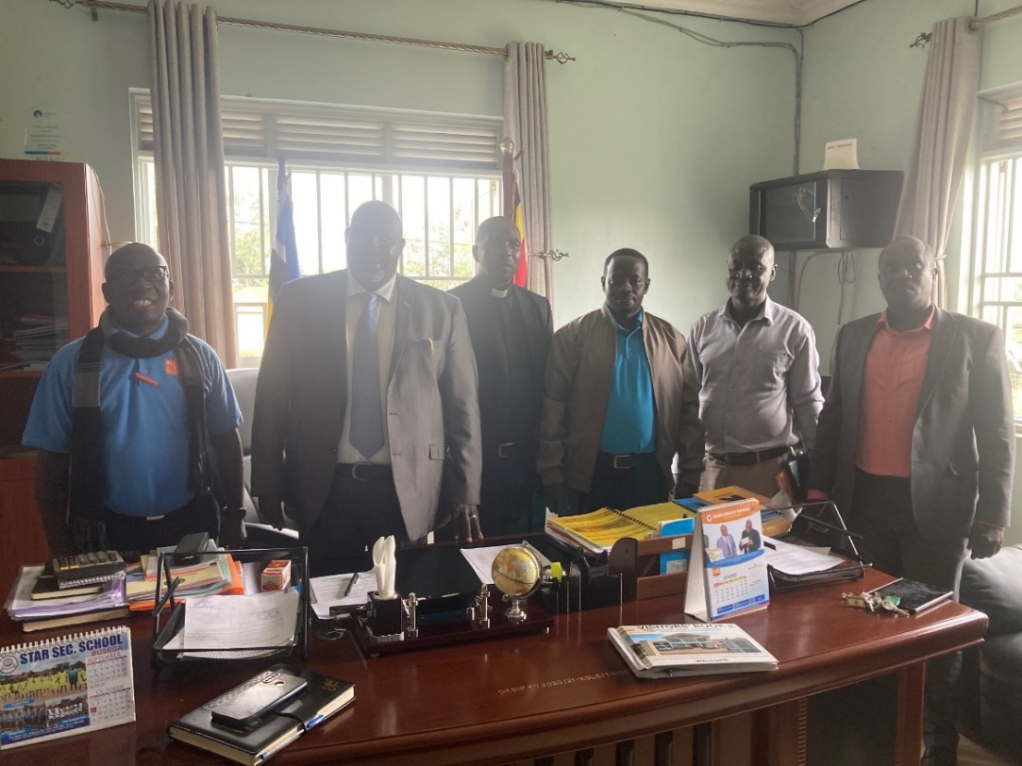
Left to right is, Dr. Tony Lusambu-ACLENet, Mr. Anslem CAO, Rev. Edward the DEO, Mr. Barnabas-ACLENet, Deputy chief Development officer Mr. Geofry and Mr. Muganga Dan RDC
C. Meeting with the Headteacher of Runyanya Primary School
The team met with Mrs. Sarah Ngozebwa, the headteacher, who highlighted ongoing lightning threats and community misconceptions, such as attributing lightning to witchcraft. She noted that some school buildings, including staff residences, lack functional lightning protection systems due to vandalism or damage. Mr. Barnabas clarified that buildings with intact systems remain safe and urged the use of these structures during storms. Dr. Tony commended the headteacher’s efforts and encouraged the school community to safeguard the installed systems.
Bellow Dr. Tony and Mr. Barnabas meeting with the headteacher Runyanya primary for official discussions.
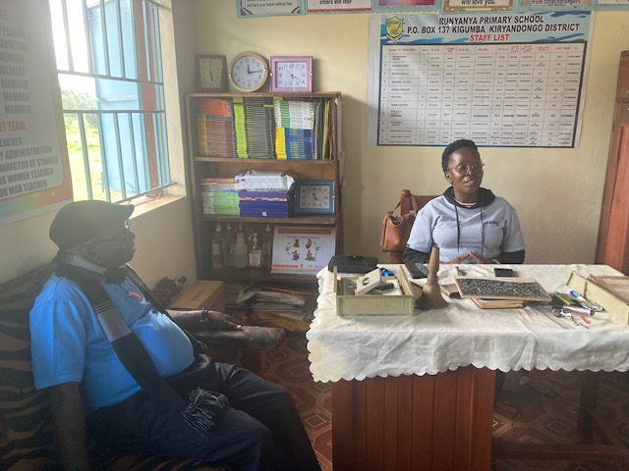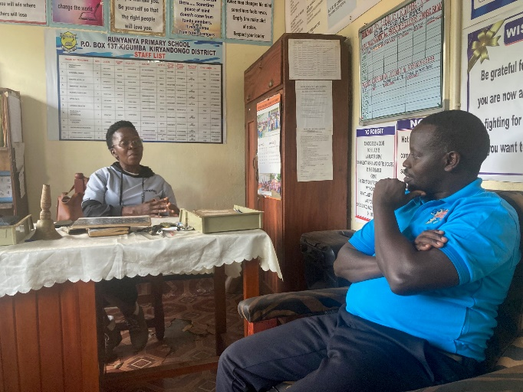
Dr. Tony and Mr. Barnabas Meeting with the headteacher Runyanya P/S
Day 2: 12th August 2025
A. Engagement with Staff and PTA
The team conducted a meeting with school staff and Parent-Teacher Association (PTA) members, covering:
- Understanding Lightning: Mr. Godwin explained lightning as a natural phenomenon, dispelling myths such as it being a curse or witchcraft. He emphasized the safety guideline: “When thunder roars, run indoors.”
- Role of Teachers and Leaders: Dr. Tony urged teachers to lead by developing safety plans, forming lightning safety groups, and integrating awareness into school activities like assemblies and extracurriculars.
- Lightning Protection Systems: Mr. Barnabas outlined the components and effectiveness of lightning protection systems, stressing that their maintenance is the responsibility of the school and community, with ACLENet providing support for installation and repairs where feasible.
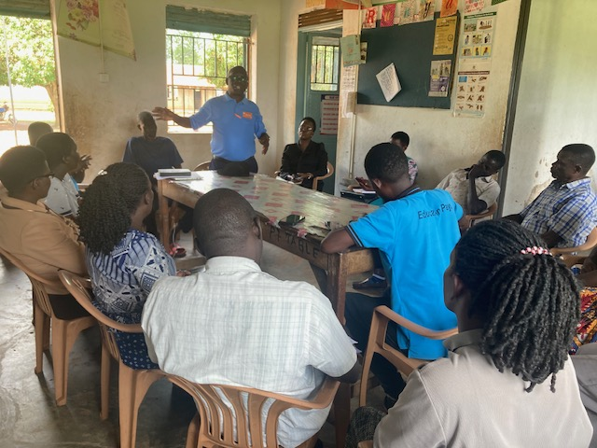
Dr. Tony delivering his speech to Teachers and parents association (PTA)
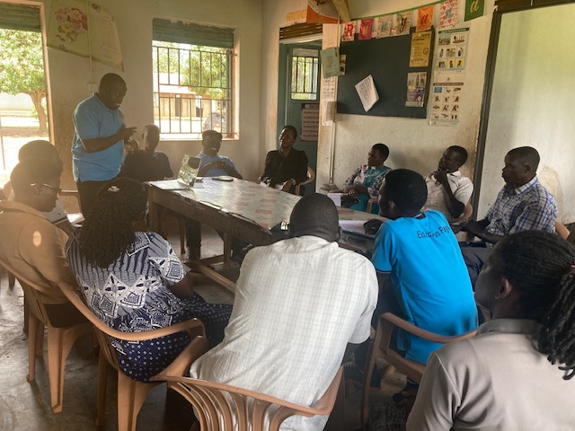
Mr. Barnabas giving the lightning teaching session to parents teachers association
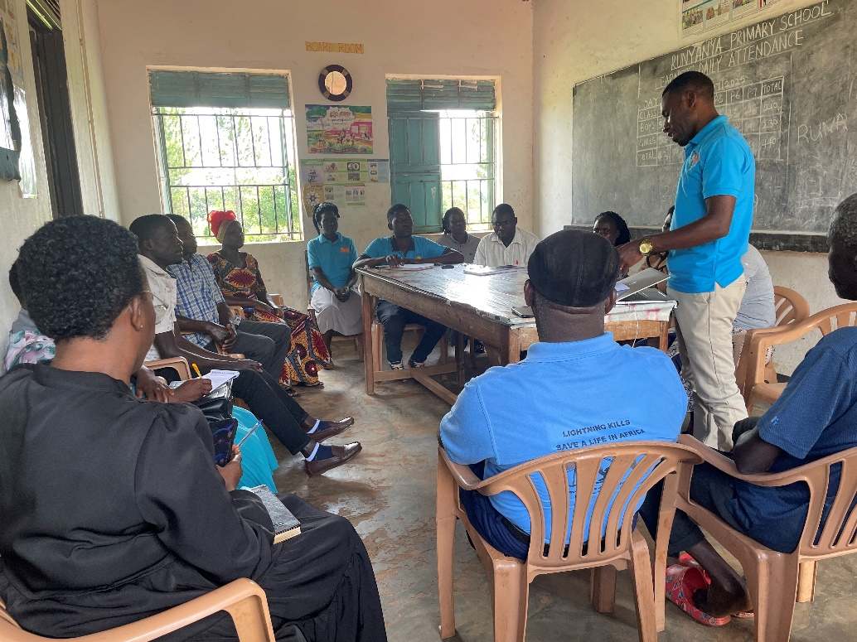
Mr. Godwin-Education Coordinator educating the Staff and parents leadership representatives during the visit.
B. Engagement with Parents
In an interactive session with parents, the team discussed:
- Parental Responsibility: Mr. Barnabas stressed the critical role parents play in keeping children safe by educating them about lightning dangers. He highlighted that lightning, a natural and potentially deadly phenomenon, requires awareness to ensure safety. Parents must teach their children to seek shelter indoors during rainstorms, as this is the only effective way to stay safe. By instilling this knowledge, parents empower their children to protect themselves and their friends. Mr. Barnabas emphasized that every parent, without exception, has a vital responsibility to inform their children about the life-threatening risks of lightning.
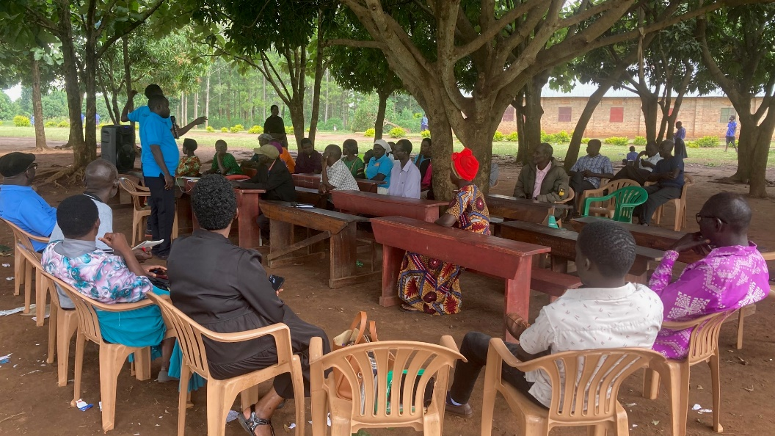
- Safety Guidelines at Home: Safety guidelines at home: Dr. Tony emphasized the importance of children being safe not only at school but even more so at home. He urged parents to remain vigilant and guide their children whenever there are signs of an approaching storm. He shared a key safety guideline to avoid lightning strikes: "When thunder roars, go indoors." He noted that most homes lack lightning protection systems, making it crucial to seek shelter indoors when it threatens to rain. Staying outside is not safe, as there is no secure place outdoors during a storm.
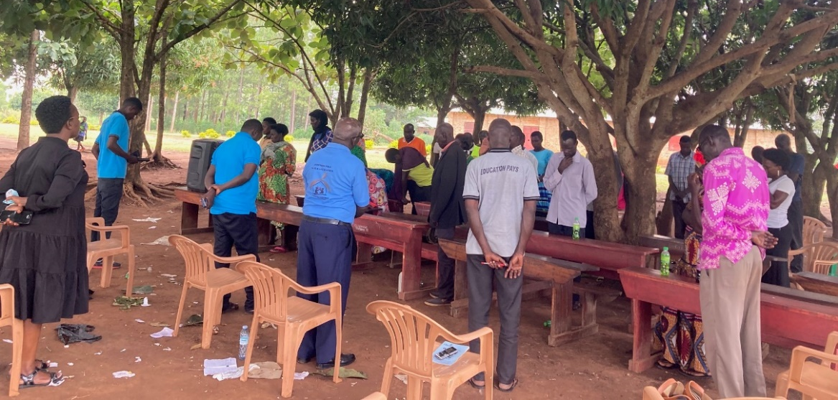

- Dispelling Myths: Mr. Godwin addressed common myths about lightning that are misleading and hinder lightning safety awareness. These myths include:
- Wearing certain colours, like red, attracts lightning.
- Some animals, such as sheep, attract lightning.
- Lightning is caused by witchcraft.
- Lightning strikes females more often than males.
- He emphasized that these misconceptions are not only inaccurate but also distract from understanding and prioritizing lightning safety.
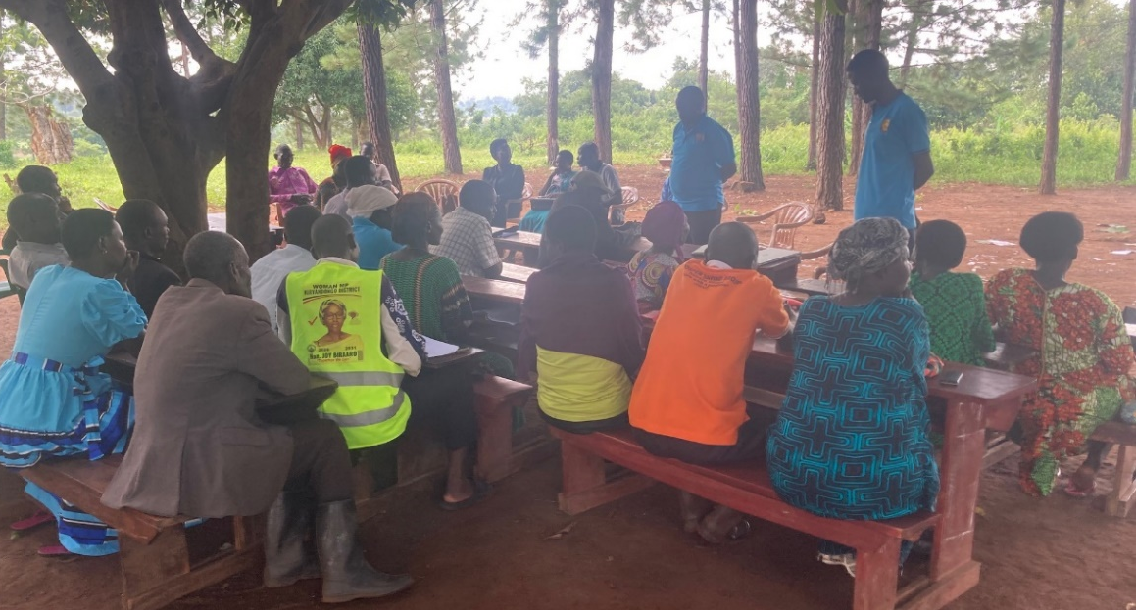
C. Education Program with Learners
With 832 pupils in attendance, the team used a speaker system to address the large group. Topics included:
- Lightning Formation: Mr. Godwin explained the science behind lightning.
- Risks and Effects: Mr. Barnabas highlighted the dangers of lightning strikes.
- Lightning Safety and Protection: Mr. Godwin shared practical safety measures, emphasizing the use of protected buildings during storms.
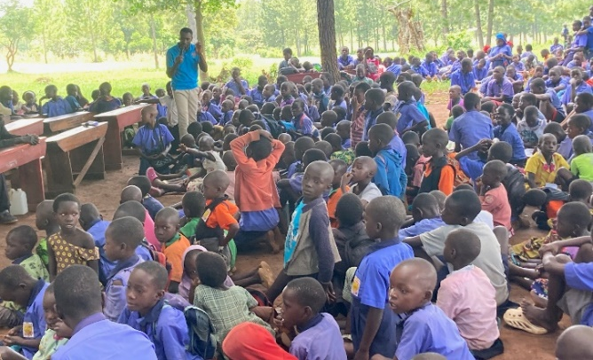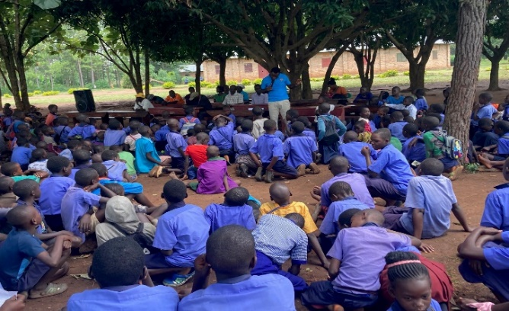
Godwin during education sesion with different groups of learnres.
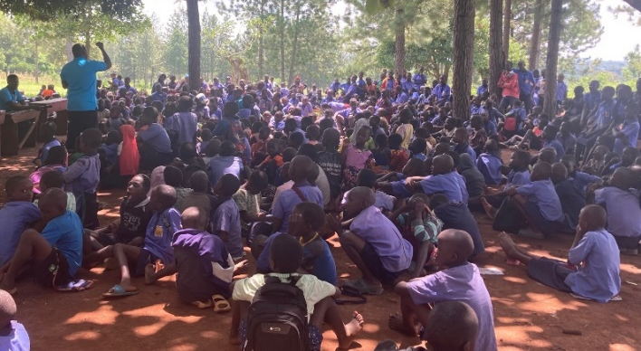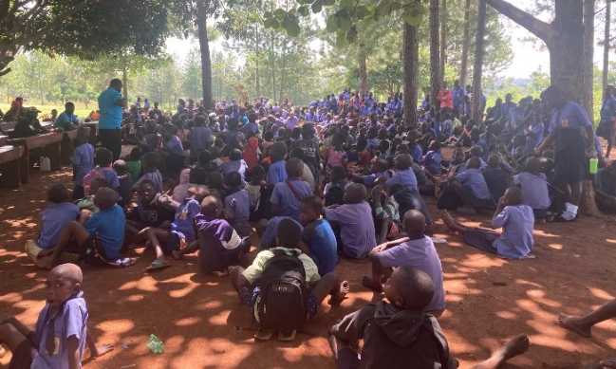
Barnabas taking the second sesion with learners.
IV. Key Outcomes and Recommendations
- Continuous Teachers’ Training: Teachers requested for more time of trainings to help them be equipped with vital knowledge about lightning. This will help them be able to guide students in lightning safety.
- Integrated school activities : the headteacher together with the chairperson lightning safety committee promised to include lightning safety related messages on school timetable.
- Lightning safety empowerment: There will be a cooperate working between ACLENet and the school administration to empower the lightning safety club by providing training resources.
- Follow-up Plan: A follow-up plan shall be made and activity reports and updates be made to help monitor the progress and sensitization of more new communities around.
- District Collaboration CAO will foster the signing of MOU with other district authorities to help ACLENet continue with other activities.
- Community Safety Group: Parents of Runyanya are to form lightning safety group that with mobilize other members and ensure the safety and protection of lightning protection system
- School Security: The school will hire and employ the security guard to watch out those who could attempt to steal the materials.
- District-Wide Sensitization: DEO will sensitize other headteachers of other schools so that they can also get knowledge about lightning safety guidelines.
- Media Engagement: the suggestion of empowering the media by adding all committee members and involving them in online sessions should be immediate since many members are committed to be part.
- Community outreaches: the community needs more sensitization programs. The chairperson SMC promised to arrange and mobilize the community for any education program that is arranged at any time.
- Formation of Safety Clubs: The school will by the beginning of next term form a lightning safety club and lightning safety committee to empower other parents and community members about lightning safety
V. Common Questions Raised
- is lightning having a special known path known where it passes, why is it striking one place many times?
- Apart from installing the lightning protection system, is their another way ACLENet cans support areas hit by lightning?
- Why are people or things struck by lightning considered a curse?
- How can one know that this area is prone to lightning?
- Is true that there are tree that attract lightning, if true what are they so that people should avoid planting them at home?
- What distance does lightning protection system cover from the protected building?
- Is it safe to stay in the house that has been struck by lightning before installing lightning protection system?
VI. Conclusion
The two-day engagement at Runyanya Primary School successfully advanced lightning safety awareness among district leaders, school staff, parents, and pupils. The collaborative efforts with the district and school administration, coupled with community involvement, lay a strong foundation for sustained lightning safety initiatives. ACLENet remains committed to supporting Kiryandongo District in creating safer environments through education and LPS maintenance.

VII. List of attendants
No. | First Name |  | Last Name | Affiliation | Email
1 | Dan | Muganga |  | RDC-Resident district commissioner | muganga78.dm@gmail.com
2 | Geofrey | Dabanja |  | D/CDO-community development officer | gdabanja@yahoo.com
3 | Caroline | Adong |  | Teacher | adongcaroline786@gmail.com
4 | Oliver | Mbabazi |  | Teacher | mbabazioliver08@gmail.com
5 | Harriet | Nabukalu |  | Teacher | nabukaluharriet63@gmail.com
6 | Richard | Byaruhanga |  | Teacher | byaruhangarichard@gmail.com
7 | Racheal | Wembabazi |  | PTA member | wembabaziracheal@14gmail.com
8 | Sylivia | Nyangoma |  | Teacher | sylivianyango55@gmail.com
9 | James | Baguma |  | PTA member | jamesbaguma076@gmail.com
10 | Rev. Joan | Abesiga |  | SMC C/Person | abesigajoan@gmail.com
11 | Sarah | Ngonzebwa |  | H/TR | ngozebwasarah19@gmail.com
12 | Evaline | Kabalimu |  | SMC Member | 770158363
13 | Zakaria | Wanyonyi |  | PTA member | 767535721
14 | Sam | Nyakoojo |  | Driver | 786259362
15 | David | Okech |  | Parent | 707816844
16 | Sarah | Birungi |  | Teacher | 763140867
17 | Joseph | Obua |  | S MC Member | 757110020
18 | James | Ssekintu |  | Parent | 773009365
19 | Sylivia | Nanyombi |  | Parent | 775248451
20 | Metrine | Namusomba |  | Parent | 781391682
21 | Doreen | Asiimwe |  | Parent | 790624812
22 | Monica | keji |  | Parent | 764843878
23 | Scovia | kabonesa |  | Parent | 775749596
24 | Josephine | Auma |  | Parent | 779678502
25 | Charles | Ngabo |  | Parent | 763130346
26 | Rose | Eyang |  | Parent | 779118322
27 | Annet | Alinda |  | Parent | 771978640
28 | stella | Imeje |  | SMC | 771296226
29 | Christopher | Sande |  | Parent | 782922762
30 | Patrice | Otim |  | PTA member | 777358758
31 | Paulina | Nyamusana |  | Parent | 777007562
32 | samson | Kasingwa |  | Parent | 777803993
33 | moses | Etyang |  | Parent | 760174848
34 | Fred | Asiimwe |  | PTA member | 776176052

Prepared By:
Godwin Atwiine
Education Coordinator
Edited By:
Akantambira Barnabas
Country Coordinator

