Man Reportedly Struck by Lightning in Taiama, Moyamba District – Sierra Leone
https://sierraloaded.sl/local/thunder-storm-leaves-man-injured-taiama/
27 October 2025
By Amadu Moimo
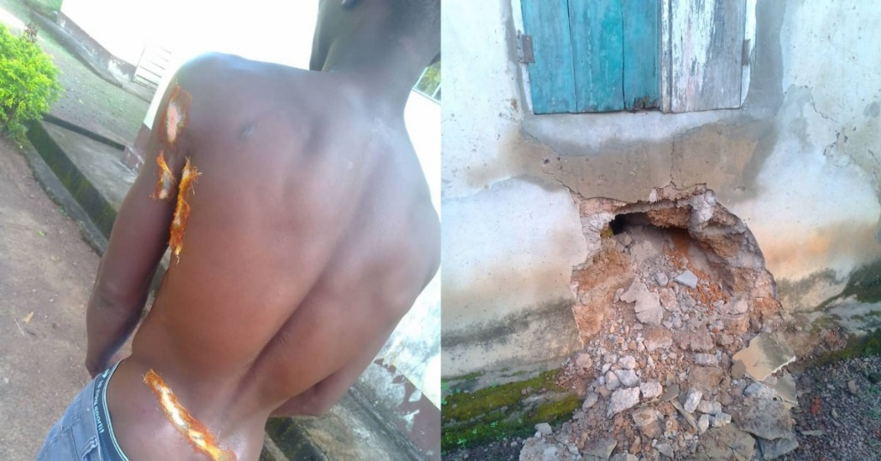
A young man narrowly escaped death in Taiama, Kori Chiefdom, Moyamba District, after being struck by lightning during a thunderstorm on Friday, October 24, 2025, at around 9:45 p.m.
According to the victim, he had gone to bed early after a long day working in his carpentry workshop when he was suddenly awakened by flames on his shirt and severe burns on his body.
He recounted that the lightning bolt entered through the door, damaged the electrical meter, struck him as he slept, and then exited through the window, hitting a nearby mango tree.
The victim is currently receiving treatment at the Taiama Community Hospital, where he is said to be responding to treatment. Community members have been rallying around him, offering support as he recovers from the terrifying incident.

