**Report on Public Education and Engagements in Lamwo District.**

Program: Education and Community Engagements

Duration: 17th February 2025 to 19th February 2025

Responsible Personnel:

1. Godwin Atwiine
2. Akantambira Barnabas

**Meeting District Officials (17th February 2025)**

On Monday, 17th February 2025, our team conducted a visit to Lamwo District. During this visit, we executed an addendum with the district leadership, which is effective immediately. The Chief Administrative Officer (CAO), representing the district's leadership, accepted ACLENet's request for community engagements and public education. The CAO assured us of timely cooperation and expressed the district's desire to extend lightning protection systems to other schools, despite current funding limitations.

We also addressed the promotion of public education. The CAO informed us that the District Disaster Management Committee is currently disorganized due to the transfer of its chairperson. However, he committed to reorganizing the committee to facilitate community mobilization and support our programs.

Additionally, we visited the offices of the District Education Officer (DEO) and the District Inspector of Schools. Although we did not meet the officials personally, we conveyed our educational programs to their secretaries, who promised to present our ideas to the officials and provide feedback.

Included below are photos of Barnabas (ACLENet Country Coordinator) and Mr. Obong Thomson, Chief Administrative Officer of Lamwo District, signing the Memorandum of Understanding (MoU) between ACLENet and Lamwo District.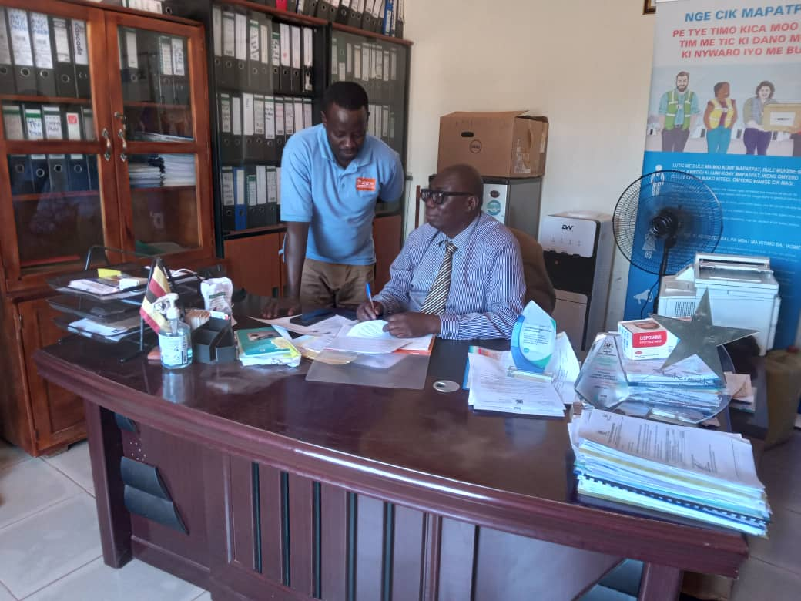

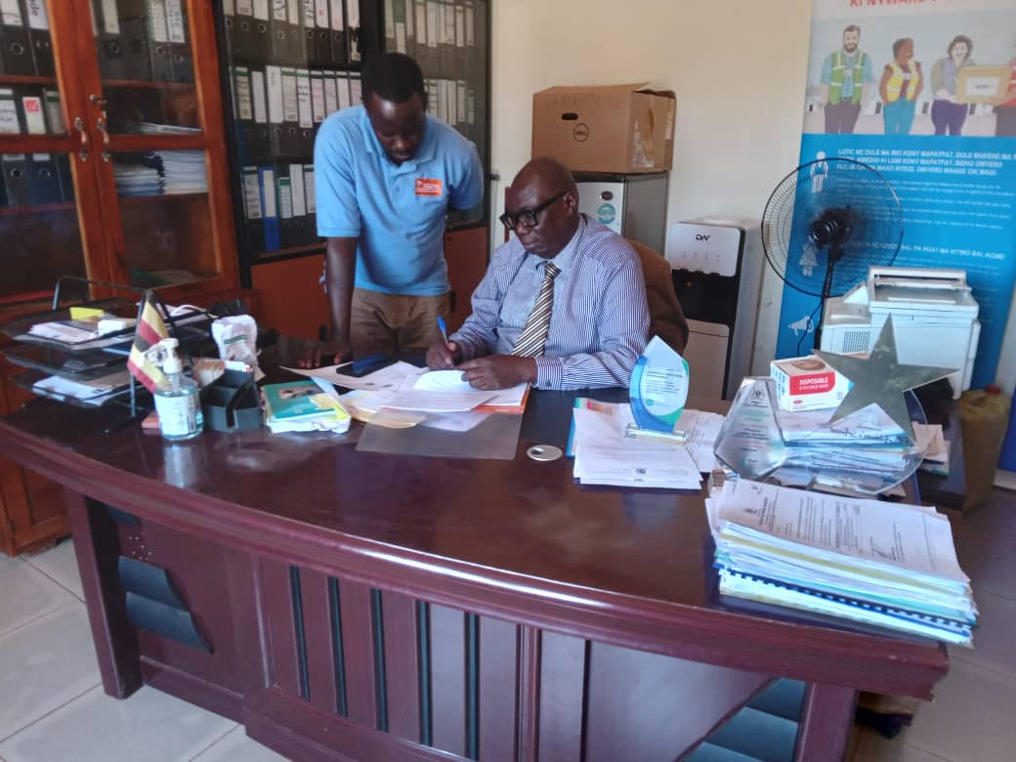

**Visit to Palabek Secondary School (18th February 2025)**

On Tuesday, 18th February 2025, we were received at Palabek Secondary School by the headteacher, who expressed gratitude for the installation work being undertaken at the school. During our discussion, the headteacher acknowledged the importance of sensitizing students and incorporated our program into the assembly schedule.

We addressed an assembly of over 600 students, along with 27 teachers and 7 non-teaching staff, on the topic of lightning safety. The headteacher emphasized the urgency of providing detailed lightning education to schools in the district. The students exhibited a keen interest in the subject, posing critical questions about lightning safety such as:

1. Can someone be struck when there is no rain?
2. What should one do if he/she is caught outside during storm?
3. Is it safe touch/ Barry someone struck by lightning? Do you mean bury or carry?

In a subsequent meeting with the staff, the Deputy in charge of Education thanked ACLENet for enhancing the school's safety and suggested the formation of a lightning safety club. The headteacher expressed willingness to welcome any programs from ACLENet and proposed an intensified partnership.

Mr. Barnabas, ACLENet’s Country Coordinator, thanked the teachers for their cooperation and reaffirmed ACLENet's commitment to supporting lightning safety initiatives. The teachers formed a lightning safety committee comprising 11 members, led by Tr Opio James, a senior teacher in the physics department. Tr James accepted the role and committed to submitting the committee members' names to Mr. Godwin within a week.

**Purpose of the Visit:**

1. To sign an addendum with the district leadership for community engagements and public education.

2. To discuss the extension of lightning protection systems and the promotion of public education.

3. To sensitize students and staff at Palabek Secondary School about lightning safety.

**Recommendations:**

1. Extend lightning protection systems to additional schools in the district.

2. Reorganize the District Disaster Management Committee to support community engagements.

3. Establish a lightning safety club at Palabek Secondary School and encourage similar initiatives in other schools.

4. Conduct regular public education sessions on lightning safety in schools and communities

**Pictures during the activity.**

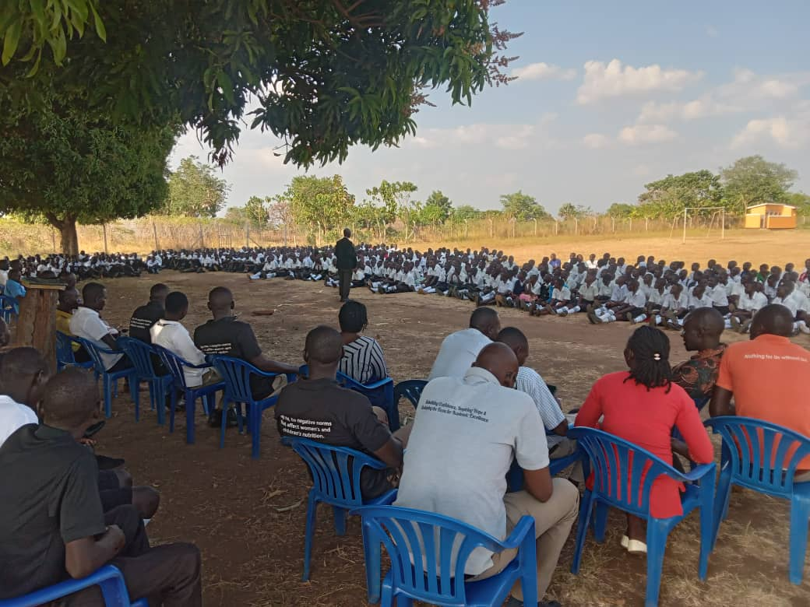

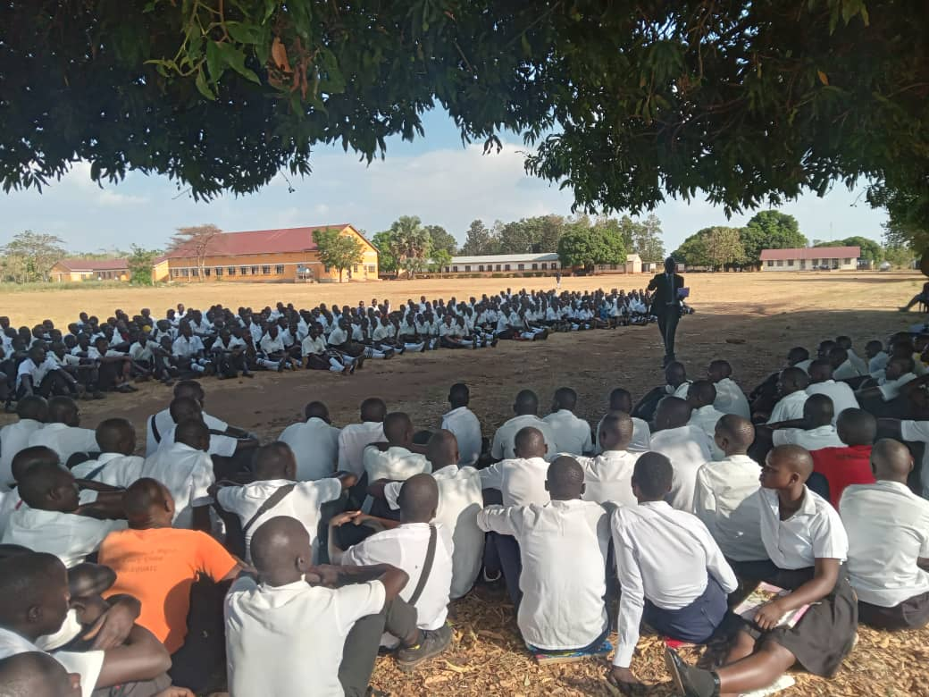

Head teacher welcoming ACLENet staff and addressing the students on the purpose of the assembly.

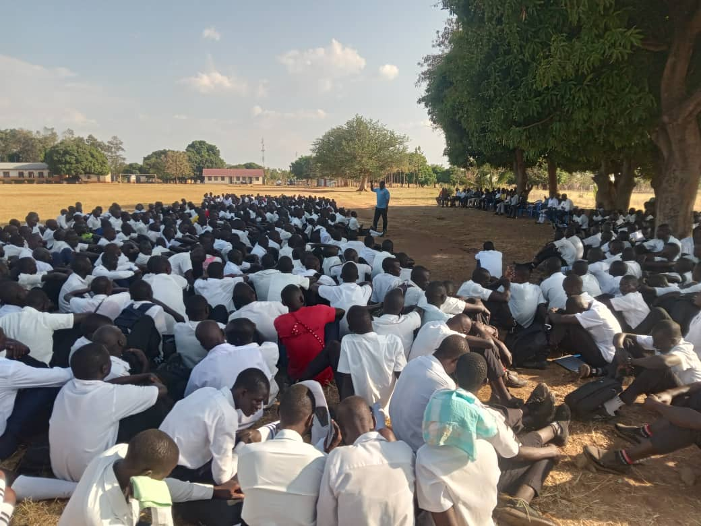

Mr. Barnabas, ACLENet country Coordinator giving highlights on lightning to students and teachers.

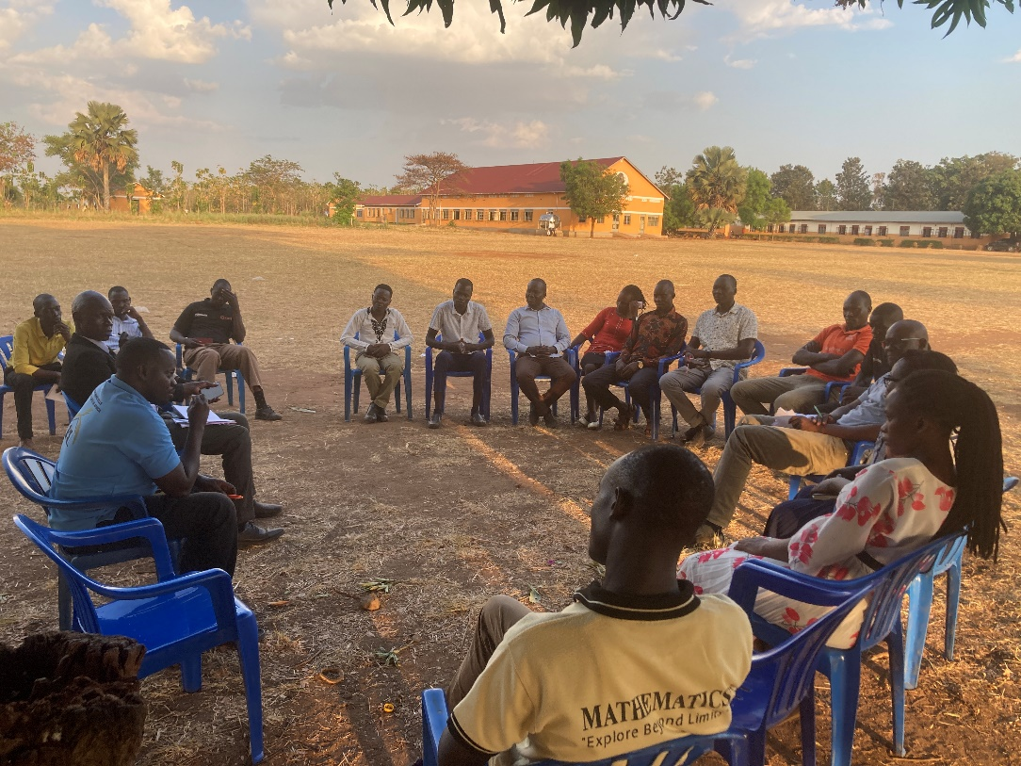

Teachers are discussing how to promote lightning safety in the school.

**Attendance.**

|  |  |  |  |
| --- | --- | --- | --- |
| NAME | TITTLE | TEL. | Email |
| Canogura Ravasco | Teacher | 0789990272 | [ravascocanagura@gmail.com](mailto:ravascocanagura@gmail.com) |
| Apio Neume | Teacher | 0771858058 | [Naumeapio12@gmail.com](mailto:Naumeapio12@gmail.com) |
| Latigo Florence | Deputy H/M | 0782451305 | [latigoflo@gmail.com](mailto:latigoflo@gmail.com) |
| Kidega Nelson | Teacher | 0779707636 | [Nelsonkidega@gmail.com](mailto:Nelsonkidega@gmail.com) |
| Onekalit Tonny | Teacher | 0785494004 | [Onekaliti2@gmail.com](mailto:Onekaliti2@gmail.com) |
| Ochola Michael | Teacher | 0788850585 | [Michaelochola170@gmail.com](mailto:Michaelochola170@gmail.com) |
| Opiyo James | Head science Dept | 0771627009 | [Jamesopiyo60@gmail.com](mailto:Jamesopiyo60@gmail.com) |
| Canwat Bosco | Deputy Admin. | 0770710277 | [Canwatbosco5@gmail.com](mailto:Canwatbosco5@gmail.com) |
| Akot Evelyne Odero | Teacher | 0783842238 | [akotevelyneodero@gmail.com](mailto:akotevelyneodero@gmail.com) |
| Langoya Jikirani | Teacher | 0773632860 | [Jikirani22@gmail.com](mailto:Jikirani22@gmail.com) |
| Okema Dick | Teacher | 0773381650 | [Dickens2026@gmail.com](mailto:Dickens2026@gmail.com) |
| Sengoba Emmanuel | Teacher | 0775288693 | [emmanuelsengoba@gmail.com](mailto:emmanuelsengoba@gmail.com) |
| Ocira Alex | Head Arts Dept | 0774140800 | [lastborn1982@gmail.com](mailto:lastborn1982@gmail.com) |
| Akena Alfred | Teacher | 0779264778 | [Akenaalfred24@gmail.com](mailto:Akenaalfred24@gmail.com) |
| Okema Emmanuel | Games Teacher | 0778657283 | [Emmanueljason005@gmail.com](mailto:Emmanueljason005@gmail.com) |
| Olaa Peter | Headteacher | 0780232835 | [olaapeter@gmail.com](mailto:olaapeter@gmail.com) |

**Prepared By:**

GODWIN ATWIINE

Education Coordinator.

**Edited By:**

Akantambira Barnabas