Lightning tragedy: Sister dies after building 600k home - South Africa
https://www.snl24.com/dailysun/news/teacher-kenosi-mashishi-killed-by-lightning-at-dertig-troupes-festival-in-north-west-20260107
7 January 2026
By Aaron Dube
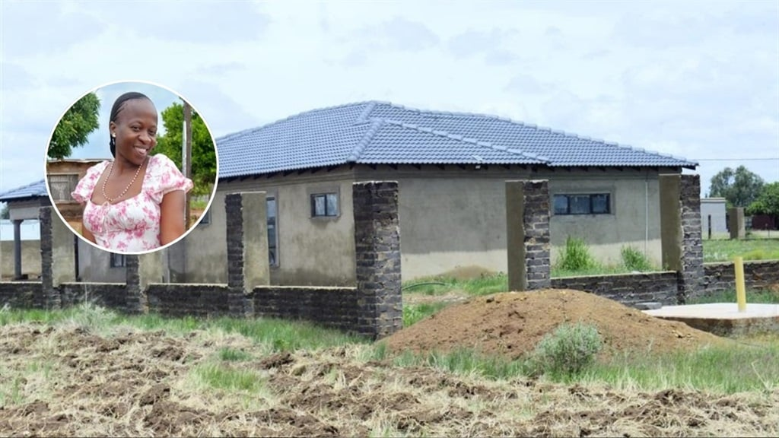
The house that was built by teacher Kenosi Mashishi (inset), who lost her life on Saturday, 3 January. Photo by Raymond Morare
The whole village of Moretele Local Municipality in the North West is mourning the death of their beloved sister, Kenosi Mashishi.
Kenosi (35) from Lefatlheng in the North West was struck and killed by lightning at Mphebatho Sports Ground in Dertig, Moretele while watching a troupes festival on Saturday, 3 January 2026.
Kenosi was a teacher at a local primary school in Dertig.
According to the grieving family, Kenosi had built a big, beautiful house which she was supposed to move into in February 2026. She died just a month before moving into her dream home.
Kenosi's brother Tshepo Mashishi (45) said: "My sister built this house for almost R600 000 and didn't live in it."
The family also said she bought a Toyota Starlet Xs four days before her death and left it still brand new. The family is still in shock about how Kenosi died.
Musa Baloyi (21), the aunt, said her niece always attended troupes every year.
"It was rare that she would miss the troupes festival in Dertig. During the festive season, we went shopping at the malls that are not around here. We were spending time together," she said.
She said she's devastated by the loss of her beloved niece.
Nkele Mokotedi (49), her cousin, said there was a first lightning strike, and the second lightning strike had a loud sound, and everyone inside the tent fell.
"My feet were not moving. I was struggling to stand. It was traumatising," she said.
Her family is too traumatised and struggling to cope because of the incident.
Community leader Zebra Motshegwa (79) is heartbroken after the death of Kenosi.
"I struggled to sleep because this teacher was a darling in the community," she said.
Moretele municipal spokesman Mothupi Malebye said Mayor George Manyike paid tribute to two bereaved families who lost their loved ones as a result of the incident.
Acting Government spokeswoman Nomonde Mnukwa said the government extends its heartfelt condolences to the families and loved ones of those who have passed on and wishes the injured a speedy recovery.
North West police spokesman, Lieutenant-Colonel Sam Tselanyane said: "We can confirm that two inquests were registered with the police following this incident. Two females aged 28 and 35 years, respectively, were declared dead at a local clinic.
"The incident happened at Dertig Sports Ground in the policing precinct of Makapanstad on Saturday, 3 January 2026 at about 5.30pm."
He further said that allegations are that about 40 people were struck by lightning but upon arrival of the police at the scene, many were already transported to the clinics and local hospitals.
"We are busy investigating to confirm the total number of those who were injured, and thereafter, we will issue a factual statement during the day regarding the matter," said Tselanyane.

