Three struck by lightning: Two dead, one critical – South Africa
https://www.citizen.co.za/middelburg-observer/news/2026/02/01/three-struck-by-lightning-two-dead-one-critical/
1 February 2026
By Carmia Jansen van Vuuren
Three people were struck by lightning during thunderstorms in Hendrina and Belfast over the past week resulting in two confirmed fatalities.
Hendrina lightning strikes two
The first incident occurred on Sunday, January 25, at approximately 15:55, near the dam at Cosmos Park in Hendrina. Two men were fishing as stormy weather moved into the area.
Lightning strikes! Thunderstorms in Middelburg and surrounding areas left families in shock. Photo: Screenshot.
According to Col Jabu Ndubane (Provincial media spokesperson), the men left the water when the storm started and sought shelter under a tree.
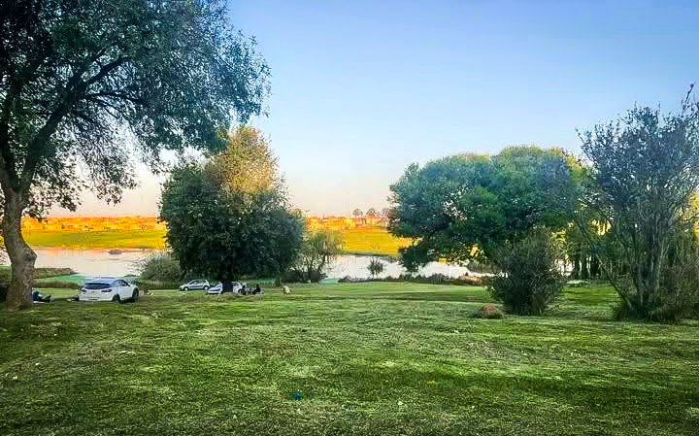
The two men were fishing at a dam in Cosmos Park, Hendrina. Photo: Supplied.
“Lightning struck while the two were standing under the tree. One man died at the scene, while the second victim was transported to hospital for urgent medical treatment,” Col Ndubane confirmed.
Belfast thunderstorm fatality
A second fatal lightning strike was confirmed in Belfast yesterday (January 31).
According to Col Ndubane initial reports received by Belfast Police indicated that a man was found lying near the Belfast landfill site in the Siyathuthuka area. However, further investigation revealed that the man had been struck by lightning.
A witness later informed police that she saw the man being struck by lightning while walking on a sidewalk. Police confirmed that the victim did not survive.
An inquest docket has been opened at the Belfast Police Station to investigate the circumstances surrounding the death.
Public urged to exercise extreme caution
Authorities has urged the public to exercise extreme caution during thunderstorms, warning that standing under trees, walking in open areas, or remaining near water significantly increases the risk of lightning strikes.
Residents are advised to seek shelter inside enclosed buildings or vehicles when storms approach.
As Middelburg and surrounding areas continue to experience volatile summer weather, police and emergency services stress that lightning strikes are unpredictable and often fatal, leaving little chance for escape once conditions turn dangerous.

