**Lightning Protection System Maintenance Report**

**Rock View Primary School, Tororo District**

**Location:** Rock View Primary School, Tororo Municipality, Tororo District, Uganda  
**Date of Maintenance:** 22-25/04/2025  
**Conducted By:**

* Tumuhimbise Isaac – Chief LPS Installer
* Martin Omara – Finance/ project manager.
* Akantambira Barnabas – Country coordinator.

**1. Introduction**

This report details the maintenance activities carried out on the Lightning Protection System (LPS) at Rock View Primary School. The maintenance was necessary to ensure the safety of the school buildings, staff quarters, and occupants, following signs of vandalism and environmental wear.

**2. Scope of Work**

The maintenance work included inspection, repair, replacement of damaged components, and reconnection of down conductors where necessary. Special attention was given to areas around the staff quarters and lower class where the LPS had been vandalized.

**3. Materials Used**

The following materials were used during the maintenance and repair activities:

* KS Connector 6–10mm Single Pole
* Round Wire DEHN AL 8mm
* Uni Disconnecting Clamp
* MV Clamps ST/TZN F.RD8–10mm with Hexagon
* ¾ inch PVC Conduits
* ¾ inch PVC Saddles
* S8 Wall Plugs

**4. Activities Undertaken**

* Inspection of the entire LPS network across all school buildings and staff quarters.
* Replacement of damaged or missing conductors using DEHN AL 8mm round wire.
* Installation of new KS connectors and uni disconnecting clamps.
* Use of MV clamps for proper earthing connections.
* Protection of down conductors using ¾ inch PVC conduits and securing with PVC saddles and S8 wall plugs.
* Digging of trenches to reconnect down conductors at points where reconnection was necessary.

**Photos of Activities During LPS maintenance at Rock view**

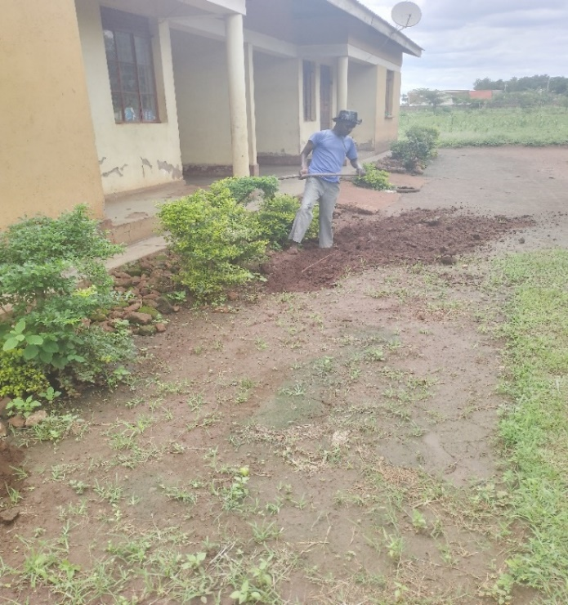

*one of the casual labor digging trenches*

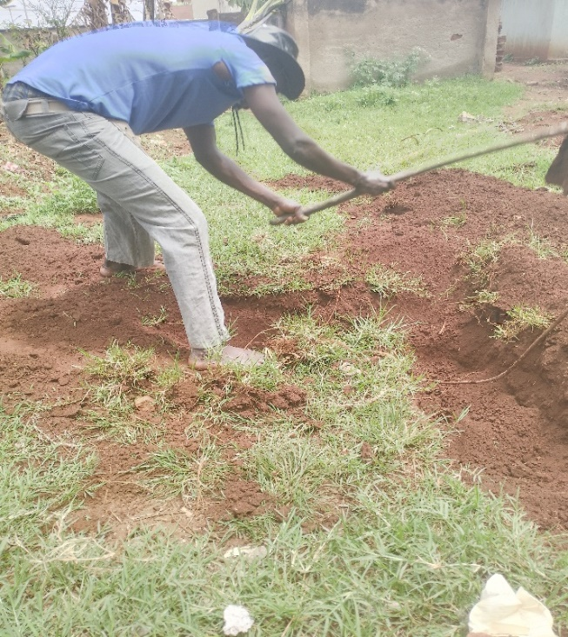

*Casual laborer digging trenches*

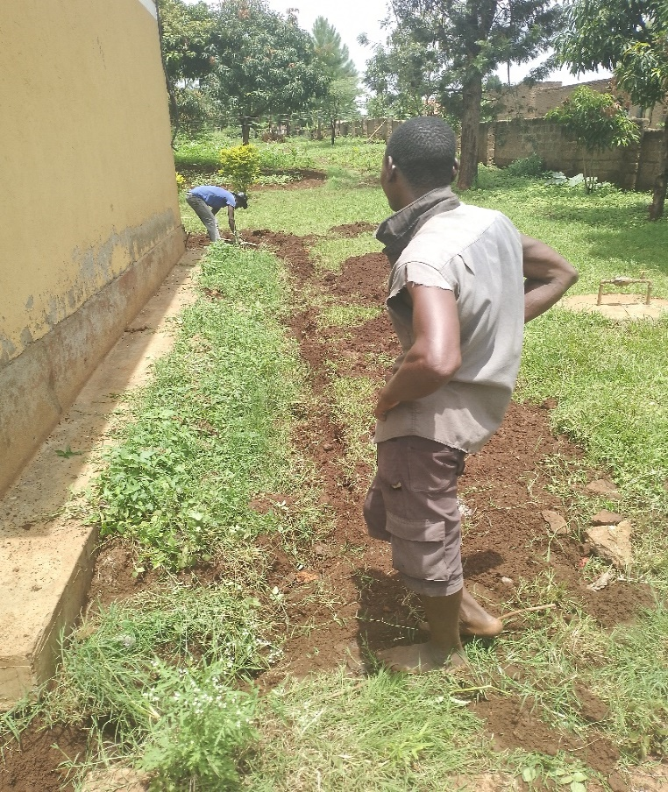

*Staff quarter that was Vandalized*

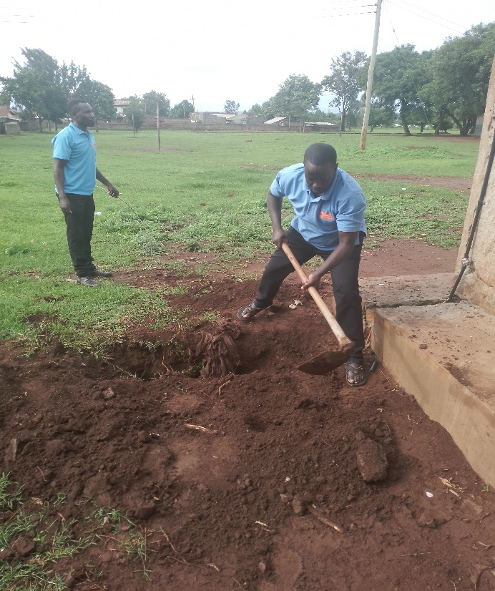

*Mr. Barnabas backfilling trenches*

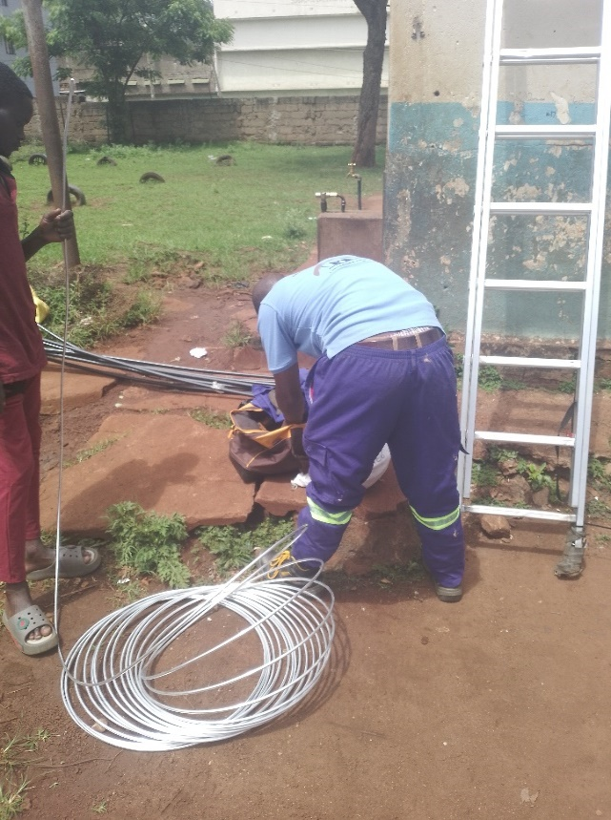

*chief installer doing the maintenance*

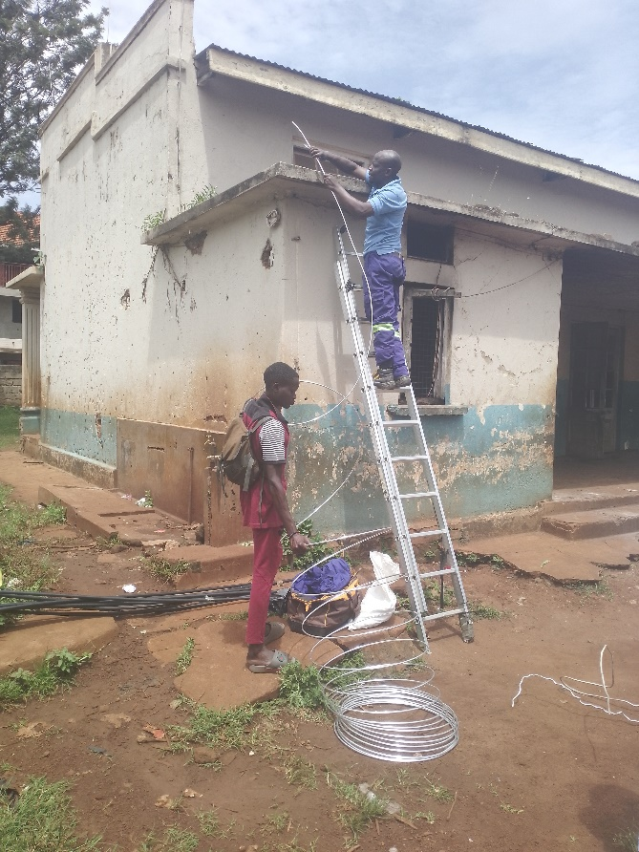

*Chief installer & casual laborer doing maintenance*

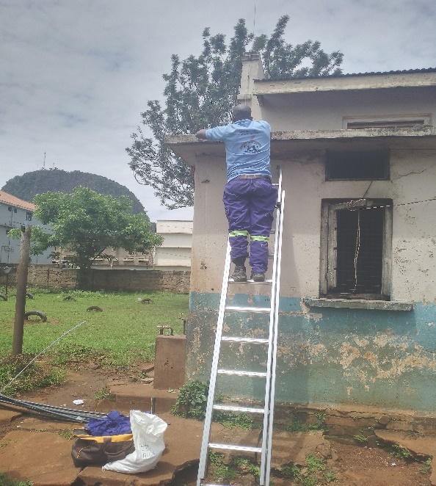

**5. Challenges Encountered**

* **Heavy Rainfall:** Persistent rains delayed digging activities and made trenching difficult.
* **Ground Conditions:** Trenches had to be re-dug at multiple points due to soft and collapsing soils caused by rain.
* **Vandalism:** The staff quarters’ LPS had been vandalized, reportedly because some teachers house children with disabilities at home, which created security vulnerabilities.
* **Accessibility Issues:** Some areas around the staff quarters were hard to access due to structural layouts and waterlogged grounds.

**6. Conclusion and Recommendations**

The maintenance work was successfully completed despite the challenges. The LPS at Rock View Primary School is now restored to operational standards.  
**Recommendations:**

* Routine inspection every 6 months to ensure system integrity.
* Secure staff quarters’ LPS components against vandalism, possibly by involving community security structures.
* Conduct community sensitization on the importance of LPS, especially around special needs areas.
* Implement additional protection for exposed conductors using stronger casing and lockable covers where feasible.

**Complied by:**  
Tumuhimbise Isaac – Chief LPS Installer  
Martin Omara – Finance/ Project Manager

**Edited by:** Akantambira Barnabas – Country coordinator.